Name ___________________________ The Great War: WWI (1914-1918)
The MANIA the Causes WWI (1870-1914)
Militarism | Alliances systems | Nationalism | Imperialism | Assassination
Nations created and stockpiled more and more weapons and added soldiers to their armies | to balance the power – nations joined sides with other nations to protect one another | Competitive relationships between European powers - “Balance of Power” - | Economic competition Imperialism in Africa, India and China | Archduke Ferdinand’s assassination sparked the alliances into starting World War I
- Militarism led to the development of fear and suspicion between nations as countries  - Germany challenged Britain as the world’s most powerful nation  Germany Militarism  - 1870- 1.2m soldiers  - 1914- 5m soldiers | Triple Alliance: Central Powers  - Germany  - Austria-Hungry  - Italy  Later Ottoman Empire  Triple Entente: Allied Powers  - Britain  - France  - Russia  Later United States, Italy | Large areas of both Austria-Hungary and Serbia were home to differing nationalist groups, all of whom wanted freedom from the states in which they lived.  Theses tension came to their high point in the Balkans and lead to the assassination of AD FF. | Britain, France, Germany and various other nations competed for colonies and trading power around the globe. The race for colonies created tension between the nations. | Archduke Ferdinand’s was assassinated for nationalist reasons by Serbian Nationalists. This started a chain reaction that started WWI.
Why each side fought?
Germany | Austria-Hungary | Russia, England and France
Kaiser Wilhelm wanted the world to know how strong the German army had become.  Backed Austrian against Russia | Demanded revenge for the assassination of Archduke Franz Ferdinand | Defending their alliances.
The War: Europe’s Powder Keg Explodes
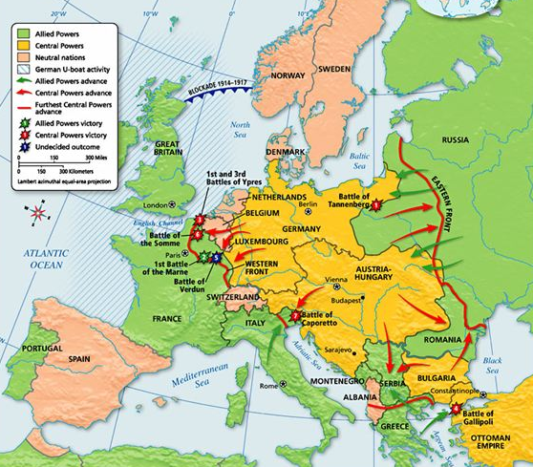
Balkans
Main Idea
With the introduction of new types of warfare and new technologies, World War I resulted in destruction on a scale never before imagined.
Warfare: - Trench Warfare: fighting took place in “trenches” (long ditches that hardly moved throughout the war)
Trenches were HORRIBLE – muddy, rat filled sleep was impossible, fresh food was nonexistent ‘When officers ordered attacks the soldiers would have to go over the top of the trench into bomb ridden ‘no man’s land’ where machine gun fire was shot
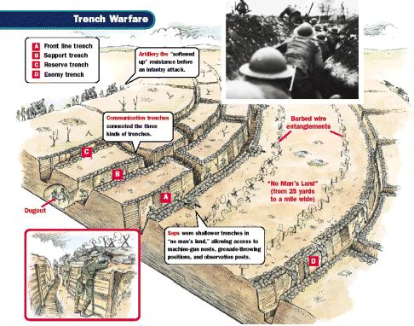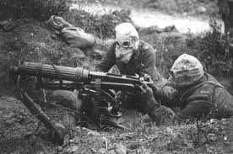
Technology - New Weapons of the war.
Invention | Description | Use in WWI
Automatic Machine gun | most important reason for the frightful casualties that occurred compared to previous wars  1 Machine gun = 40 rifle | Gunners could shot a line of men at the same time
Tank | Armored vehicle that could travel over different types of land | Help protect troops as they broke through enemy defenses
Submarine/ U-boats | Underwater vessel that could shoot torpedoes and guided bombs | Germans used this to destroy Allies ships.
Airplane/ Zeppelins (blimps) | Small plane that had machine guns or bombs | - Observation  - Air combat
Poison gas; gas mask | Gases that cause choking and blinding; mask protected someone from the gas | Gas launched into enemy trenches killing and disabling soldiers
Propaganda – Governments used one – sided information designed to persuade – to keep morale and support for the war  Major form of propaganda used was the poster | 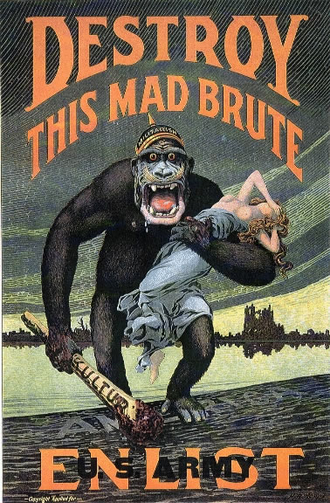 | The War’s Impact on Women  Thousands of women replaced men in factories  Women built tanks and munitions, plowed fields, paved streets and ran hospitals  Kept troops supplied with food, clothing and weapon

Major Turning Points of the War
Entry of the United States | Russian defeated/ Withdrawal
The United States tried to stay neutral until the sinking of the Louisiana (by German U-Boats) and the Zimmerman Telegram- attempt to bring Mexico into the war against the US. | By March 1917 civil unrest in Russia, due in part to war related shortages of food and fuel had brought the Czar’s government to the brink of collapse. Russia out of the war but was forced to give Germans 1/4 of Russian territory
The Treaty of Versailles: A Harsh, Flawed and Dictated Peace treaty
Treaty of Versailles | The Legacy and cost of the War
‘Big Four’: Wilson’s Plan for Peace- Fourteen Points –self-determination (end of Imperialism), league of Nations Anti-MANIA.  Germany –War Guilt Clause- they lost substantial territory (colonies)  The treaty placed sole responsibility of the War on Germany – as a result Germany had to pay repartitions to the allies | - Human life - 8.5 + million are died/ 17 + are wounded  - League of Nations: created to keep peace in the world – ended up being very ineffective  - Factories, farms and homes in European had been destroyed  - Nations had huge war debts to repay  - Severely punished Germany it indirectly led to some of the causes of World War II

