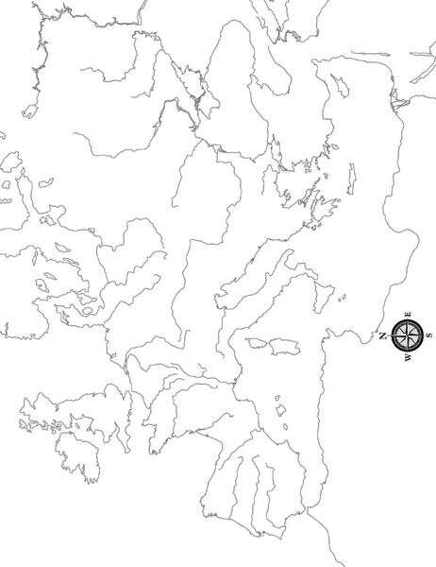

1
10
2 3
8
8v888888
4

5 9 6 7

Cities- Geneva Florence Antwerp
Countries- France Spain/ Portugal, England, Holy Roman Empire, Switzerland

