Name ______________________
Unit 9- Revolutions | French and Latin American Rev. and Nationalism
The French Revolution and Napoleon (1789-1815)
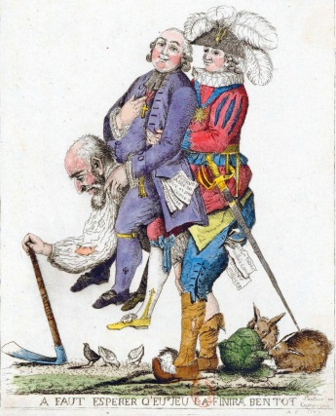
A) The French Revolution was the event in which the people of France overthrew their king (Louis XVI) and fought for more rights.
Causes of the French Revolution
1) American and French Revolutions= inspired other peoples seeking democracy and independence
2) French society was divided into three estates (social classes). The people of the Third Estate were mostly peasants. They were angry that they had very few rights and paid the highest taxes (even though they had the least money).
3) France was ruled by absolute monarchs. The French people believed that these kings abused their power and denied (took away) the rights of the people.
4) The ideas of the Enlightenment inspired the French people to overthrow their unfair kings and to create a new government that protected their rights.
5) France was in an economic crisis- The kings spent too much money and put France in debt.

Key events of the French Revolution:
- Louis XVI called the Estates General into  session.  Declaration of the Rights of Man-  This was a document written during the French Revolution that gave equal rights to the men of France and created a fair system of taxation. | Reign of Terror-  This was an event where the leaders of the French Revolution executed thousands of people that they believed were loyal to the king. The Jacobins were the radical (extreme) group leading this event and Robespierre was the leader of the Jacobins. | Napoleon Coup D’état  1)Napoleon Bonaparte was the ruler who came to power at the end of the French Revolution.  2) He expanded (enlarged) French territory by conquering neighboring lands in Europe. By doing so, he made French people feel nationalism (pride in their country). | - The French people supported Napoleon  Bonaparte because they hoped he would  provide stability for the nation

- Robespierre and Napoleon= increased their power during the French Revolution  - Reign of Terror/ French Revolution = Cultural Revolution/ China- used violent methods to eliminate their opponents | - Napoleon= Hitler- failed invasion of Russian- climate/ Weather killed soldiers  - the Twelve Tables, the Justinian Code, and the Napoleonic Code- written set of laws

Congress of Vienna
- encourage nationalist movements
- establish a balance of power in Europe after the defeat of Napoleon
restore old regimes to power

1)
2)
D) Key effects (results) of the French Revolution:
1) King Louis XVI of France was executed by Robespierre and the Jacobins.
2) The middle class of France gained more power and rights.
E) Napoleon Bonaparte
1)
3) NOTE: The Regents wants you to know that Napoleon was finally defeated in 1812 because he made a big error (mistake): He invaded Russia during the winter and the freezing climate (weather) of Russia killed thousands of his soldiers. The same mistake was later made by Hitler during WWII.
IV. The Latin American Revolutions (1800-1830)
A) The Latin American Revolutions were the events where the colonies of Latin America (Central America, South America, and the Caribbean) fought to gain independence (self-government) from Spain, Portugal, and France.
B) Key causes of (reasons for) the Latin American Revolutions:
1) The governments of Latin America were controlled by Peninsulares (people born in Spain and Portugal) who treated the people of Latin America poorly. Creoles (Europeans born in Latin America), Mestizos (mixed Europeans/Native Americans), Native Americans, and African slaves demanded more rights.
2) The ideas of the Enlightenment inspired the Latin Americans to fight for independence (self-government) and overthrow their unfair governments.
3) The American Revolution and the French Revolution inspired Latin Americans to fight for independence (self-government) and overthrow their unfair governments.
C) Below is a list of leaders that helped gain independence (self-government) for the colonies of Latin America:
1) Simon Bolivar
2) Jose de San Martin
3) Miguel Hidalgo
4) Toussaint L’Ouverture
5) NOTE: All of these men are considered nationalists since they loved their nations and wanted to free them from European control.
D) NOTE: After gaining independence, attempts were made to unify (combine) the different areas of Latin America in order to form one country. These attempts failed because Latin America has
many natural boundaries (i.e.- Andes Mountains, Amazon Rainforest, etc.) that prevent communication between regions.

