Period 1 Questions
Part I (Revised Multiple Choice Set) Directions: Each of the questions or incomplete statements below is followed by four suggested answers or completions. Select the one that is best in each case and then enter the appropriate letter in the blank next to each question. Answer all questions on the answer sheet- DON’T Share ANY INFORMATION FROM THIS TEST WITH OTHERS STUDENTS
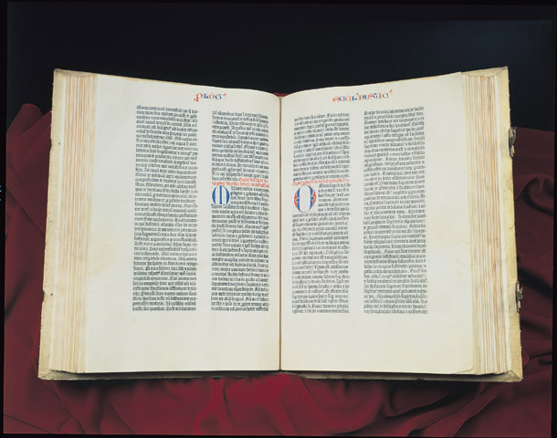

Gutenberg Bible
Questions 1-4 refer to the above picture
1. The invention of the printing press that led to the above picture aided in?  A. Spreading the Renaissance beyond Italy.  B. Halting the rise of the Reformation.  C. Beginning the artistic period known as mannerism.  D. Exploring overseas colonies.  2. This invention greatly contributed to the growth of?  A. The visual arts of the Renaissance.  B. The Scholastic Movement.  C. The growth of vernacular literature.  D. The Catholic Reformation. | 3. Which of the following might have resulted from the invention of the printing press?  A. The development of absolutism in Europe  B. The emergence of scientific socialism  C. The emergence of polytheism in Eastern Europe  D. The development of religious groups such as Lutherans and Calvinists.  4. Which of the following developments most likely explains the reason for the production of documents such as the one above?  A. The need to disseminate new ideas.  B. The belief that the Catholic Church was above all secular institutions.  C. The desire to create a unified religious system throughout Europe.  D. The use of Scholasticism as the primary means of delivering instruction at the university level.

Finally, the Great Artisan mandated that this creature who would receive nothing proper to himself shall have joint possession of whatever nature had been given to any other creature. He made man a creature of indeterminate and indifferent nature, and said to him "Adam, according to your desires and judgment, you will have and possess whatever place to live, whatever form you yourself choose. All other things have a limited and fixed nature. We have made you so that with free choice you may fashion yourself into whatever form you choose. To you is granted the power of degrading yourself into the lower forms of life and to you is granted the power to be reborn into the higher forms, the divine."
“Oration on the Dignity of Man” Giovanni Pico della Mirandola, 15th Century
5 The passage above represents the shift in European thinking from relying totally on the teachings of Scholasticism to what type of thinking?  A. deductive reasoning  B. Renaissance humanism  C. inductive reasoning  D. Catholic reformation | 6. Values that were important to Mirandola and others like him included?  A. secularism and individualism  B. nationalism and liberalism  C. alchemy and astrology  D. universal Christendom

Against the Murderous, Thieving Hordes of Peasants (1525) Martin Luther

In my preceding pamphlet I had no occasion to condemn the peasants, because they promised to yield to law and better instruction, as Christ also demands But before I can turn around, they go out and appeal to force, in spite of their promises, and rob and pillage and act like mad dogs… They practice mere devil's work, and it is the arch-devil himself who reigns at Mühlhausen, Thomas Münzer, indulging in nothing but robbery, murder, and bloodshed. Since those peasants allow themselves to be led astray and act differently from what they declared, I likewise must write differently concerning them; and first bring their sins before their eyes, as God commands.
Questions 7-10 refer the passage above
7. The passage above represents a conflict over?  A. the purpose of the Protestant Reformation.  B. the purpose of the Renaissance.  C. the purpose of the Scientific Revolution.  D. the purpose of European exploration  8. Which Protestant leader might well have disagreed with Luther on this issue?  A. Henry VIII  B. John Calvin  C. Henry IV  D. Elizabeth I | 9. Which of the following might have occurred as a result of groups such as the nobility challenging monarchial authority based on religious reform?  A. The Catholic Reformation  B. The Edict of Nantes  C. The French Wars of Religion  D. The Council of Trent  10. Which of the following developments most likely explains the reason for the conflict that led to the production of the above document?  A. The refusal of accepting protestant teachings.  B. The belief that the Catholic Church was above all secular institutions.  C. New interpretations of Christian doctrine and practice.  D. The use of Jesuit teachings.

Council of Trent
The Church has always understood that confession of sins was instituted by the Lord, and necessary for all who have fallen into sin after baptism; Lord Jesus Christ, when about to ascend from earth to heaven, left his own vicars, before whom all mortal offenses into which the faithful have fallen should be carried, so that they may pronounce forgiveness or retention of sins.

Venial sin whereby we are not excluded from the grace of God, into which we fall more frequently may be omitted without guilt and expiated by other remedies. But since all mortal sins, even those of thought, render men enemies of God; it is necessary to seek pardon from God for every mortal sin, by a full confession…
Questions 11-13 refer to the Document above
11. The event that was most likely responsible for the Council of Trent was the?  A. Protestant Reformation.  B. Scientific Revolution.  C. English Civil War.  D. Catholic Reformation.  12 Which of the following statements is most likely to be true based on the above document?  A. Habsburg rulers were successful in reinstituting Catholicism in their lands.  B. Protestant leaders quickly reconverted to Catholicism based on this document.  C. There was a revival of the Catholic Church, but Christianity remained divided.  D. The Holy Roman Empire was able to regain territory lost as a result of the division in Christianity. | 13 Based on the document and your knowledge which of the following would be the most likely to agree with the general tone of the document?  A. Martin Luther.  B. John Calvin.  C. Henry VIII.  D. Jesuits.
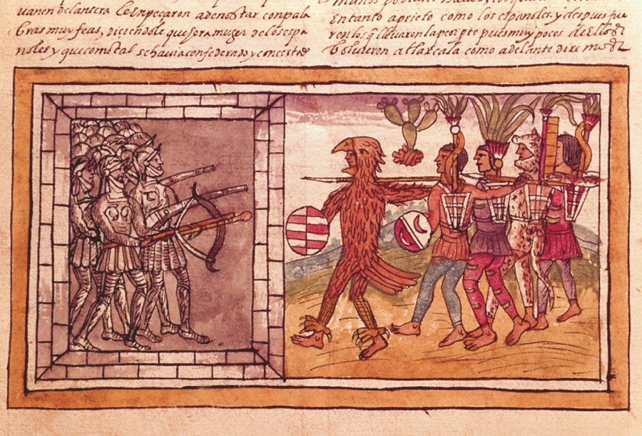
Armored Spanish soldiers engage crudely armed Aztecs
Questions 14-17 refer to the picture above
14. The event that most likely led to the process seen above was the?  A. The Spanish established colonies in the Americas.  B. The Portuguese established a commercial network along the African coast.  C. Protestant Reformation.  D. Development of absolutism in France.  15 Which of the following countries competed with Spain for control of colonies in Central and South America?  A. Prussia  B. Russia  C. Portugal  D. Italy | 16. Based on the map and your knowledge which of the following would be the most likely result of what is seen in the picture?  A. A period of cooperation among European powers as they settled the New World.  B. The domination of South America by England and France.  C. The domination of North America by the Spanish and Portuguese.  D. The competition for trade leading to conflicts and rivalries among European powers.  17. Which of the following developments occurred that facilitated the subjugation and destruction of these indigenous peoples?  A. The Columbian Exchange.  B. Advances in military technology.  C. Conflict between Spanish monarchs and the Catholic Church.  D. Efforts by Spanish monarchs to limit exploration and trade.
Questions 19-20 are based on the following passage:
Christopher Columbus took his fantastic proposal to the king of Portugal and his advisers just after Bartholomew Diaz had returned to Lisbon in 1488 with news that there was definitely a sea passage between the Atlantic and Indian Ocean… When eventually they too discovered America, sending their fishermen and whalers to Newfoundland in about 1497, and landing on the coast of Brazil in 1501, they were already years behind. But who could have foretold that they made a major miscalculation, when Vasco de Gama’s return in 1498 meant that the race for the pepper trade had been won and could be exploited immediately, when all the merchants of Europe were hastily sending their most energetic representatives to Lisbon; when Venice, hitherto the queen of eastern trade seemed to be staggering as if stabbed in the back? In 1504, when the Venetian galleys arrived in Alexandria, Egypt, they found not a single sack of pepper waiting for them.”
- Fernand Braudel (1982). Civilization and Capitalism, 15th-18th century: the perspective of the world. University of California Press
- According to the passage, which nation was primed for economic supremacy by 1498?  - Spain  - Venice  - Portugal  - Egypt | - Which of the following economic patterns does the passage describe?  - Shifting of economic power in Europe from the Mediterranean to the Atlantic states  - Increase in tensions between Portugal and Spain  - The decline of Asia in international trade  - The increasing importance of trade in the Americas over Asian trade
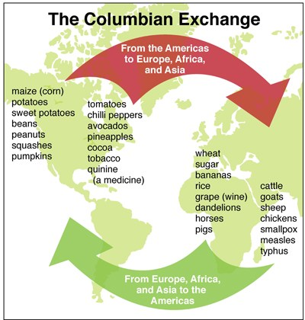
20 The event that most likely led to the process seen above was the?  A. exploration of overseas territories by the Europeans.  B. rise of mercantilism in the major powers of Europe.  C. beginning of the Wars of Religion in Europe.  D. development of absolutism in Russia.  21. Which of the following countries was the least likely to have been involved in the process seen on the chart?  A. Portugal  B. England  C. Italy  D. Spain | 22. Based on the map and your knowledge which of the following would be the most likely result of what is seen on this chart?  A. A period of cooperation among European powers as they settled the New World.  B. The domination of trade Asia as a result of this exchange.  C. The subjugation of Europeans by the indigenous peoples.  D. The destruction of indigenous peoples.  23. Which of the following developments occurred as result of events that took place because of this chart?  A. The domination of the European continent by a religious revival.  B. The expansion of the African slave trade.  C. A period when the Catholic Church stepped in and halted the settling of the Americas.  D. Efforts by monarchs to limit exploration and trade.
Questions 24-27 are based on the following passage:
JULIUS:  What's the trouble here? Won't the gates open? I believe the lock has been changed.  GENIUS:  Better check to see if you've brought the right key. The one for the treasury won't open this door, you know. Why didn't you bring both keys? This is the key of power, not of knowledge.  JULIUS:  Why, this is the only one I've ever used! I've never seen what good the other one was.  GENIUS:  Meanwhile we're locked out.  JULIUS:  I'm losing my temper. I'm going to beat on the gate. Hey there! Somebody open this door instantly! What's holding up the doorman? Asleep, I suppose, probably drunk.  GENIUS:  (Aside) This fellow judges everyone by himself.  - Dialogue: Julius Locked Out of Heaven; Desiderius Erasmus | 24. The passage above represents the employment of Renaissance learning in the service of?  A. religious reform C. civic humanism  B. state building D. absolutism  25. Based on the passage above and your knowledge Christian Humanism led most directly to which of the following?  - The Catholic Reformation  - Development of National Monarchies  - The Protestant Reformation  - The Thirty Years War  26. Which of the following would be most likely to disagree with the views represented in the document?  A. Protestant reformers C. Anabaptists  B. Protestant monarchs D. Habsburg rulers  27. Which of the following groups would be most likely to use the document to support their political beliefs?  A. The Jesuit Order C. Catholic bishops  B. The Anabaptists D. Nicolo Machiavelli

Name _____________________ | Period 1: 1450-1648 Test 1 | MC___ /27pts SAQ _____/ 9pts
Write you’re the Answers to all of the multiple choice questions in the chart below.
- Answer the task

C. Cite specific evidence
E. Explain, analyze, evaluation (PRIDE)
Read the passage below and answer the following questions. Label your answers. FOLLOW: ACE
- Each answer should be a minimum of 2 well developed sentences.
- You may only use this sheet to answer the questions
- Explain one specific similarity between the Italian renaissance and the northern renaissance.
- Explain one specific difference between the Italian renaissance and the northern renaissance.
- Account for the similarity or difference you mentioned in (a) or (b).
_______________________________________________________________________________________________________________________________________________________________________________________________________________________________________________________________________________________________________________________________________________________________________________________________________________________________________________________________________________________________________________________________________________________
______________________________________________________________________________________________________________________________________________________________________________________________________________________
______________________________________________________________________________________________________________________________________________________________________________________________________________________
______________________________________________________________________________________________________________________________________________________________________________________________________________________
______________________________________________________________________________________________________________________________________________________________________________________________________________________
______________________________________________________________________________________________________________________________________________________________________________________________________________________
______________________________________________________________________________________________________________________________________________________________________________________________________________________
______________________________________________________________________________________________________________________________________________________________________________________________________________________
______________________________________________________________________________________________________________________________________________________________________________________________________________________
______________________________________________________________________________________________________________________________________________________________________________________________________________________
______________________________________________________________________________________________________________________________________________________________________________________________________________________

