AP European History
Exam--Unit 2

1. "In conformity, therefore, to the clear doctrine of the Scripture, we assert, that by an eternal and immutable counsel, God has once for all determined, both whom he would admit to salvation, and whom he would condemn to destruction." The idea expressed in the above passage is most closely associated with the theological views of:
a. Erasmus
b. Pope Leo X
c. Pico della Mirandola
d. John Calvin
e. Ignatius Loyola

2. The Roman Catholic Council of Trent (1545-63) had as its primary result:
a. a compromise with Protestants to reunite Christians
b. a political compromise with the Protestant princes of Central Europe
c. reform within the Catholic Church and a reaffirmation of Catholic doctrine
d. the firm reestablishment of conciliar power over the papacy
e. creation of a balance of power between the papacy and the heads of the Catholic states

3. A major difference between Calvinism and Lutheranism relates to:
a. clerical marriage
b. the place of women in society
c. emphasis on predestination
d. infant baptism
e. monasticism

4. Advocates of northern humanism believed which of the following?
a. A fusion of Christian and classical ideals provides the best definition of virtuous conduct.
b. The conventions of romantic love enhance the social respect for women.
c. Education and scholarship should be equally open to men and women.
d. The new poetic forms, such as the sonnet, could be used to articulate their beliefs.
e. Political rights should be extended to all men.

5. Which of the following is true of Gustavus Adolphus of Sweden?
a. He was a devout Roman Catholic.
b. He was a major participant in the Thirty Years War.
c. He defeated the Russian army at the battle of Borodino.
d. He established Calvinism as the Swedish state religion.
e. He set up an organization to mediate international disputes.

6. The Edict of Nantes issued by Henry IV of France did which of the following?
a. Recognized the rights of French Protestants.
b. Made public the king’s conversion to Roman Catholicism.
c. Settled the Bourbons on the French throne.
d. Ordered the Spanish out of France.
e. Announced French entry into the war between the Spanish and the Dutch.

7. Martin Luther’s response to the German Peasants’ War of 1524-25 demonstrated his:
a. ignorance of the economic plight of the peasantry
b. emphasis on the social aspects of Christ’s teaching
c. refusal to comment on social or political issues
d. belief in the necessity of a unified German state
e. support of the prevailing social and political order

8. In the sixteenth century, all of the following experienced religious civil wars EXCEPT:
a. Russia
b. England
c. the Low Countries
d. France
e. the German states

9. Which of the following describes a major difference between northern humanists and Italian humanists?
a. Italian humanists focused on human intellect and achievements, whereas northern humanists focused on nature and emotion.
b. Italian humanists focused on national consciousness, whereas northern humanists rejected politics.
c. Italian humanists viewed human nature as corrupt and weak, whereas northern humanists viewed human nature as generally good.
d. Both concentrated on spiritual concerns, but northern humanists also focused on secular matters.
e. Both looked to classical sources, but northern humanists also emphasized Christian sources.

10. The long-term effect of the Thirty Years War on the German states was to:
a. restrict Lutheranism to southern German states
b. initiate a long era of peace and recovery
c. encourage unification
d. devastate the German states’ economies
e. increase the power of the Holy Roman Emperor

11. Martin Luther initially criticized the Roman Catholic Church on the grounds that it:
a. supported priests as religious teachers
b. sponsored translations of the Bible into the vernacular
c. reduced the number of sacraments
d. use indulgences as a fund-raising device
e. formed close associations with secular rulers

12. The response of the Roman Catholic Church to the Protestant Reformation included all of the following EXCEPT:
a. the abolition of the Index of Prohibited Books
b. the establishment of the Society of Jesus (Jesuits)
c. the convening of the Council of Trent
d. the founding of women’s orders active in education and care for the sick
e. an increased in the number of parish grammar schools

13. Which of the following was the primary cause of the Habsburg-Valois feud, which dominated European international politics in the sixteenth century?
a. The differences in the religious positions taken by the two families during the Protestant Reformation.
b. The refusal of Charles of Habsburg to marry a Valois princess.
c. Competition for overseas colonies.
d. The conflicting political ambitions of the two families.
e. Clashing territorial interests in southern Germany.

14. Which of the following was NOT true of the Edict of Nantes (1598)
a. It was issued by Henry IV of France.
b. It allowed the practice of Protestantism in France.
c. It was responsible for the St. Bartholomew’s Day massacre.
d. It ended the French religious wars.
e. It was accepted by the French Huguenots.

15. All of the following were factors in the spread of literacy during the fifteenth and sixteenth centuries EXCEPT:
a. the invention of printing
b. the Protestant Reformation
c. the rise of state bureaucracies
d. the establishment of compulsory education
e. a decline in the use of Latin

16. Which of the following best describes the Christian humanism of Erasmus?
a. A complete break with Roman Catholic theology
b. A defense of individual interpretation of the Bible
c. The application of Renaissance scholarship to questions of ecclesiastical and moral reform
d. A return to the Scholastic theology of Thomas Aquinas
e. A plea for a return to monasticism as the Christian ideal
17. Major Protestant and Catholic leaders of the sixteenth century condemned the Anabaptists because Anabaptists:
a. rejected the Bible as a source of religious truth
b. favored government enforcement of morality
c. advocated the complete separation of church and state
d. restored the privileges of the clergy
e. tried to reconcile Protestant and Catholic teachings

18. The leadership of the Dutch revolts (1566-1648) sought all of the following EXCEPT:
a. an alliance with English Catholics
b. the end of the Inquisition
c. the end of excessive taxation
d. the elimination of the rule of foreign officials
e. an alliance with French Protestants

19. Martin Luther believed that the most important role for a Christian woman was to:
a. minister to the sick and poor
b. preach the word of God in church on Sunday
c. maintain her role within the domestic sphere as wife and mother
d. lead a life devoted primarily to prayer and contemplation
e. teach reading and writing in a religious school

20. John Calvin established the center of his reformed church in:
a. Paris
b. London
c. Wittenberg
d. Geneva
e. Basel

21. The primary purpose of the Peace of Augsburg was to:
a. end the wars between the Hapsburg and Valois
b. end the civil war between the Lutherans and Roman Catholics in the German states
c. end the Thirty Years' War
d. create better trade relations among the German states
e. facilitate diplomatic relations between the Holy Roman Empire and Ottoman Turks

22. The Council of Trent (1545-63) was the major body through which:
a. Spain strengthened its position against the Turks
b. the house of Habsburg gained control over Italy
c. the Roman Catholic Church reformed itself
d. European states entered into economic cooperation
e. Puritans and Catholics were reconciled

23. A major goal of Philip II (1556-98) was to:
a. grant independence to the United Provinces
b. obtain a divorce from Mary Tudor
c. support the cause of European Catholicism
d. lead a life given to pleasure and indulgence
e. defeat the Spanish Armada

24. The Society of Jesus (Jesuits) won converts to Catholicism primarily through:
a. torture
b. education
c. espionage
d. military conquest
e. burning books

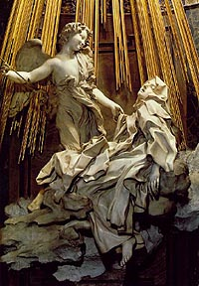

25. The sculpture by Bernini shown above celebrates:
a. a new interest in secular themes
b. Lutheran veneration of the saints
c. the Calvinist cult of beauty
d. the Renaissance preoccupation with symmetry and order
e. Catholic Reformation mysticism

26. Who reportedly said, "Paris is worth a mass"?
a. Henry Valois
b. Catherine de Medicis
c. Philip II
d. Henry Bourbon
e. Mary Tudor

27. Under whose rule in England was religious reform pushed the furthest?
a. Henry VIII
b. Edward VI
c. Mary Tudor
d. Elizabeth I
e. Henry VII

28. Which of the following shows the correct sequence of the phases of the Thirty Years War?
a. Danish, Swedish, French, Bohemian
b. German, Swedish, Danish, Bohemian
c. Bohemian, Danish, Swedish, Franco-Swedish
d. Franco-Swedish, Danish, Bohemian, German
e. German, Bohemian, French, Swedish

29. Which of the following developments allowed northern Renaissance painters to experiment in the areas of light and shadow?
a. perspective geometry from Italy
b. the elimination of Gothic style
c. the use of oil-based paints
d. the rejection of religious themes
e. the adoption of Giotto's methods

30. Which of the following was LEAST important in promoting exploration?
a. the centralized organization of a nation-state
b. technological advances in shipbuilding and navigation
c. patronage of religious authorities
d. use of gunpowder and iron weapons
e. ruthless determination
31. What was the name of the union of Protestant princes opposed to Charles V's policies?
a. Schmalkaldic League
b. Hanseatic League
c. Protestant Union
d. Union of Hanover
e. Bund of Luther

32. The House of Hapsburg greatly strengthened its power and position in Europe by:
a. buying up vacant thrones from penniless royal families
b. conquering opponents in a series of major wars
c. conquering the Balkan peninsula from the Turks
d. negotiating a series of strategic marriages
e. controlling the profitable trade with the East

33. In which area did women gain the most from the Protestant Reformation?
a. job opportunities
b. legal status
c. influence in churches
d. social mobility
e. education
34. Which of the following statements about Michel de Montaigne (1533-92) is true?
a. he was a staunch advocate of violent revolution
b. he was the greatest scientist of his age
c. he was the leading atheist of his century
d. he was the best known skeptic of his time
e. he was the leading military strategist of his era

35. Which of the following resulted from the English Reformation?
a. immediate wholesale persecution of Catholics in England
b. establishment of the English monarch as head of the Church of England
c. the pope's naming Henry VIII as "Defender of the Faith"
d. papal recognition of the English church as independent, but still affiliated with Rome
e. a revolt by members of the English aristocracy opposed to the Reformation

36. The major political opponent of Charles V was:
a. Pope Clement VII
b. Henry VIII of England
c. Gustavus Adolphus of Sweden
d. Francis I of France
e. Philip II of Spain

37. The primary goal of France in entering the Thirty Years' War was to:
a. defend Catholicism against German Protestants
b. reduce the power of the Habsburgs
c. punish the Swedish king, Gustavus Adolphus
d. conquer Brandenburg-Prussia
e. place a Bourbon on the Spanish throne

38. Elizabeth I of England and her contemporary, Henry IV of France, have been called politiques because they believed that:
a. doctrinal unity was necessary to political unity
b. religious questions were as important as political questions
c. religion was the most important part of politics
d. political leaders should not be involved in religious questions
e. theological controversy should be subordinate to political unity

39. Salvation by faith alone, the ministry of all believers, and the authority of the Bible are principles basic to:
a. the Christian humanism of Erasmus
b. the Church of England
c. Catholicism during the Counter-Reformation
d. Lutheranism in the early sixteenth century
e. the Society of Jesus (Jesuits)

40. "You venerate the saints and delight in touching their relics, but you despise the best one they left behind, the example of a holy life....If the worship of Christ in the person of His saints pleases you so much, see to it that you imitate Christ in the saints." The quotation above expresses the views of which of the following?
a. Henry VIII of England
b. Catherine de Medici
c. Erasmus of Rotterdam
d. Leonardo da Vinci
e. Niccolo Machiavelli

41. Which of the following is generally considered the first Counter-Reformation Pope?
a. Leo X
b. Paul III
c. Julius II
d. Alexander VI
e. Paul IV

42. Which of the following was a major result of the Thirty Years' War?
a. long-term strengthening of the power of the Holy Roman Emperor
b. the banning of Calvinism in the German states
c. the establishment of strong Russian influence in the northern German states
d. a major loss in Germany's population and damage of its countryside
e. the rapid economic development of Germany

43. Which of the following most clearly distinguishes the Northern from the Italian Renaissance?
a. interest in science and technology
b. greater concern with religious piety
c. cultivation of Latin
d. use of national languages in literature
e. admiration for Scholasticism

44. Which of the following is the best characterization of military developments in the seventeenth century?
a. an increased reliance on heavy cavalry
b. an increase in war’s cost, scope, and organization
c. decisive battles, brief military campaigns, and short wars
d. the emergence of Spain as the leading power
e. the reluctance of monarchs to personally lead their armies

45. As a result of the Protestant Reformation, the ___________ became the center of social life.
a. monastery
b. family
c. nation
d. priest
e. guild

46. Which was NOT a criticism of the Catholic Church in the early sixteenth century?
a. absenteeism
b. simony
c. pluralism
d. support for Ockam's nominalism
e. a worldly papacy

47. A major impact of the development of printing was
a. the widespread education of poor women
b. a decline in the reading of religious texts
c. a condemnation of the invention by the Catholic Church
d. spreading of Reformation ideas
e. a disinterest in economic activities

48. Over what issue did Luther and Zwingli break?
a. music in church
b. clerical celibacy
c. the church's relationship to the state
d. the meaning of the Lord's Supper
e. the center of the Reformation being in Switzerland or Germany

49. Which of the following was NOT a cause of Spain's decline?
a. a crusading mindset
b. the ending of the Habsburg line
c. lack of a diverse economic base
d. persecution of talented religious minorities
e. bankruptcy due to constant warfare

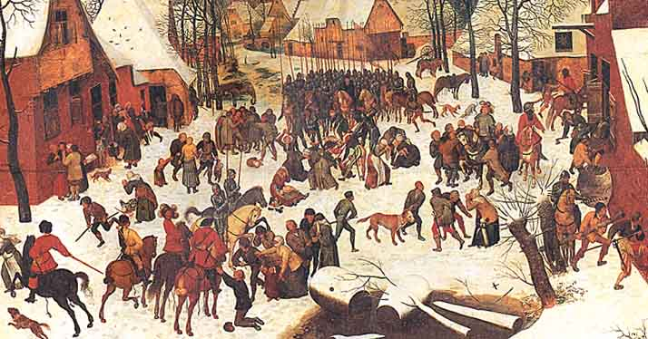

50. The Pieter Brueghel painting (circa 1569) shown above depicts the massacre of villagers in
a. the Netherlands by Spanish troops
b. Russia by Ottoman troops
c. Spain by English troops
d. France by Swedish troops
e. Hungary by Austrian troops

51. Place the following in chronological order: 1) Charles V elected Holy Roman Emperor, 2) Defenestration of Prague, 3) Peace of Westphalia, 4) Peace of Augsburg, 5) Diet of Worms.
a. 1, 2, 3, 4, 5
b. 2, 4, 5, 1, 3
c. 5, 1, 3, 4, 2
d. 1, 5, 4, 2, 3
e. 2, 5, 1, 4, 3

52. Charles V can be said to BEST represent a medieval view of the world in which way?
a. he attempted to strengthen his control of his various territories
b. he assigned rule of his territorial possessions to capable female relatives
c. he traveled on horseback portrayed as a chivalrous knight
d. he attempted to maintain the political unity of Catholicism
e. he admired Charlemagne and divided his empire among his sons

53. Mannerism is best described as:
a. Castiglione's effort to enhance manners in his Book of the Courtier
b. Michelangelo-inspired art movement using distortion, emotion, and color contrasts
c. an artistic movement of the Northern Renaissance that focused on scenes of everyday life
d. an intellectual attack on Scholasticism during the Renaissance
e. a new theory of optics

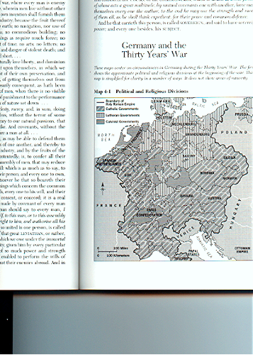

54. The map above indicates:
a. the religious situation in Germany before the outbreak of the Thirty Years' War
b. Germany after the signing of the Peace of Westphalia in 1648
c. Germany upon Charles V's election as Holy Roman Emperor
d. Philip II's plan for the partition of Habsburg lands with his uncle Ferdinand
e. central Europe following the 80 Years War

55. Which best characterizes the focus of the Catholic Reformation?
a. abolishing indulgences and other abuses
b. restoring the pastoral mission of the Church
c. patronizing Baroque architecture
d. increasing the power of the Papacy
e. attacking Scholastic philosophy

56. Which of the following pairs of dinner guests would make for the tensest situation?
a. Charles V and Philip II
b. Elizabeth I and Henry VIII
c. John Calvin and Ignatius Loyola
d. Henry Bourbon and William the Silent
e. Martin Luther and Philip Melancthon
57. "To promote a woman to bear rule, superiority, dominion or empire above any realm, nation, or city is repugnant to nature, contumely to God, and then subversion of good order, of all equity and justice." John Knox wrote The First Blast of the Trumpet Against the Monstrous Regiment of Women to condemn which female ruler?
a. Mary Tudor
b. Elizabeth I
c. Margaret of Parma
d. Mary, Queen of Scots
e. Jeanne d'Albret of Navarre

58. "If anyone saith that in the sacred and holy sacrament of the Eucharist, the substance of the bread and wine remains conjointly with the body and blood of our Lord Jesus Christ and denieth that wonderful and singular conversion of the whole substance of the bread into the Body, and the whole substance of the wine into the Blood--let him be anathema." The author of this passage would be in sympathy with which of the following positions?
a. Roman Catholicism
b. Calvinism
c. Zwinglianism
d. Anabaptism
e. Anti-trinitarianism

59. "They preach that the soul flies out of Purgatory as soon as the money thrown in the chest rattles. I believe when the money rattles in the chest, avarice and gain may be increased, but the effect of the intercession of the Church depends on the will of God alone." This statement was made by:
a. Pope Paul III
b. Martin Luther
c. John Tetzel
d. Ignatius Loyola
e. Thomas More

60. The Protestant Reformation encouraged all of the following changes in the status of women EXCEPT:
a. elevating marriage as the highest calling of women
b. more grounds for divorce if husbands violated the laws of marriage
c. increased opportunities for religious vocations
d. lessening female control of religious education in the home
e. better education for women so they could read the Bible

61. Charles V had difficulty responding to the Protestant Reformation because:
a. he had to make too many concessions to become Holy Roman Emperor
b. of the far-flung nature of his possessions
c. he was preoccupied with conquering Russia
d. his empire in the New World produced too little income
e. his aunt was Queen of England

62. Queen Mary I of England married which of the following?
a. Philip II of Spain
b. Charles V of Austria
c. Philip of Hesse
d. Henry VIII of England
e. James V of Scotland

63. All of the following were part of or reflected in the Peace of Westphalia EXCEPT:
a. the ruler of each state could establish his or her own religion as dominant
b. the independence of the Dutch Republic was guaranteed
c. Brandenburg-Prussia emerged as the most powerful north German state
d. France became Europe's dominant power
e. Russia absorbed all of Sweden

64. Most of the Thirty Years' War was fought in:
a. France
b. Germany
c. Italy
d. Spain
e. England

65. The St. Bartholomew's Day massacre in 1572:
a. was approved by Catherine de Medicis
b. created relief among the Protestant community in Europe
c. succeeded in establishing the Guise family in control of France
d. was organized by Henry of Navarre
e. eliminated all the Huguenots of France

66. Which of the following was NOT generally a way in which women participated in the Protestant and Catholic Reformations in the sixteenth century?
a. founding new Catholic religious orders like the Carmelites
b. preaching the gospel in Anabaptist congregations
c. making religious policy as monarchs and regents
d. attacking the institution of marriage on scriptural grounds
e. winning new educational opportunities in Protestant nations

67. All of the following were problems faced by Charles V (1519-56) during his reign as Holy Roman Emperor EXCEPT:
a. war with France
b. invasion by the Ottoman Turks
c. conflict with the Pope over religious reform
d. inability to produce a male heir
e. rebellion by the German princes

68. Which of the following led to the conflict in the 1530s between Henry VIII and his Lord Chancellor, Sir Thomas More?
a. More's unwillingness to agree to Henry's assertion of royal supremacy over the Catholic Church
b. More's publication of Utopia, which attacked social and economic conditions in England
c. Henry's desire to purge former officials as he advanced the power of the monarchy
d. Henry's fear that humanist writings might provoke another dynastic conflict like the War of the
Roses
e. More's secret assistance to the Holy Roman Emperor in a planned invasion of England

69. Which of the following was central to Martin Luther’s religious philosophy?
a. Salvation by faith alone
b. Saints as intermediaries between the individual Christian and God
c. The sacrament of penance
d. The priesthood defined as distinct from the laity
e. The equality of men and women

70. During the Thirty Years’ War, France pursued a policy of:
a. supporting the Habsburgs against the Protestant princes and rulers
b. allowing French Protestants to fight for the Protestants even though the monarchy supported Roman Catholics
c. supporting the Protestant princes and rulers against the Habsburgs
d. remaining neutral
e. opposing England in order to recapture Normandy

71. A primary goal of Philip II of Spain was to:
a. grant toleration to religious minorities
b. create a monarchy accessible to the people
c. reunite the Spanish and Austrian Habsburg empires
d. strengthen the Spanish economy
e. maintain Spanish control of the Netherlands

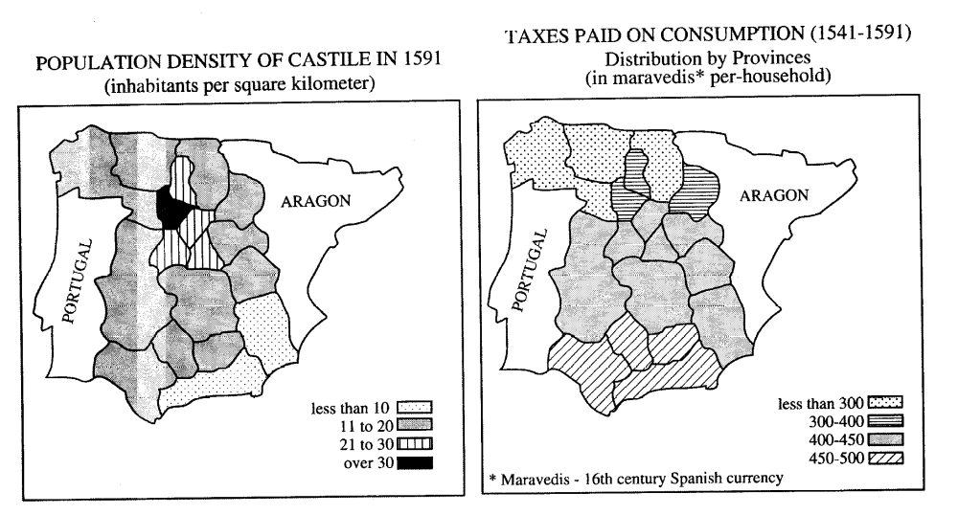

72. Which of the following can be deduced from the maps above, which chart population density and taxation in sixteenth-century Castile?
a. Southeastern Castile was sparsely populated and paid proportionally more taxes.
b. Northern Castile was densely populated and heavily taxed.
c. The rural areas of Castile were densely populated, heavily taxed, and had higher mortality rates.
d. The poor lived in the northern urban areas and were heavily taxed.
e. The consumption tax distributed evenly across the population.

73. The most important goal of the Council of Trent was the:
a. strengthening of internal Church discipline
b. organization of military opposition to the Reformation
c. establishment of new religious orders
d. reduction of papal control of doctrine
e. preparation of a revised prayer book

74. Which of the following regularly allowed women to preach in seventeenth-century England?
a. Roman Catholics
b. Puritans
c. Presbyterians
d. Quakers
e. Anglicans

75. The Peace of Westphalia (1648) resulted in which of the following?
a. Undisputed control over central Europe by the Habsburgs
b. The creation of a strong central government to rule the Holy Roman Empire
c. The guaranteed independence of numerous small German states
d. An end to the persecution of Protestants in the Habsburg Empire
e. An end to the Hundred Years’ War

76. Which of the following affected the status of women during the Reformation?
a. The suppression of nunneries and the institution of a married clergy.
b. Papal agreement allowing the ordination of women.
c. Permission from secular rulers permitting women to own property.
d. The abolition of primogeniture and institution of equal inheritance for men and women.
e. The establishment of equal access to education for men and women.

77. Sixteenth- and seventeenth-century European political leaders generally viewed religious toleration as:
a. leading to dangerous civil disorder
b. resulting in economic prosperity
c. restricted to Christians and Jews
d. commanded by God in the Bible
e. promoted by Protestant denominations

78. The massacre of Saint Bartholomew’s Day (1572) was directed against
a. Catherine de Médicis and her followers in Paris
b. Anabaptists in the Netherlands
c. Roman Catholics throughout the German states
d. peasant rebels in the southern German states
e. Huguenots in France

“Our sins have their source in Adam, and because Adam ate the apple, we have inherited sin from him. But Christ has shattered death in order that we might be saved by His works and not by our works. Christ says: I am your justification.” --Martin Luther

79. Which of the following best describes Luther’s meaning in the excerpt above?
a. Only faith in Christ will bring salvation, not good works.
b. “Justification” is different from “salvation.”
c. Faith means nothing without good works to demonstrate belief.
d. Good works are necessary for justification, but only faith in Christ will bring salvation.
e. Neither faith nor good works will bring salvation.

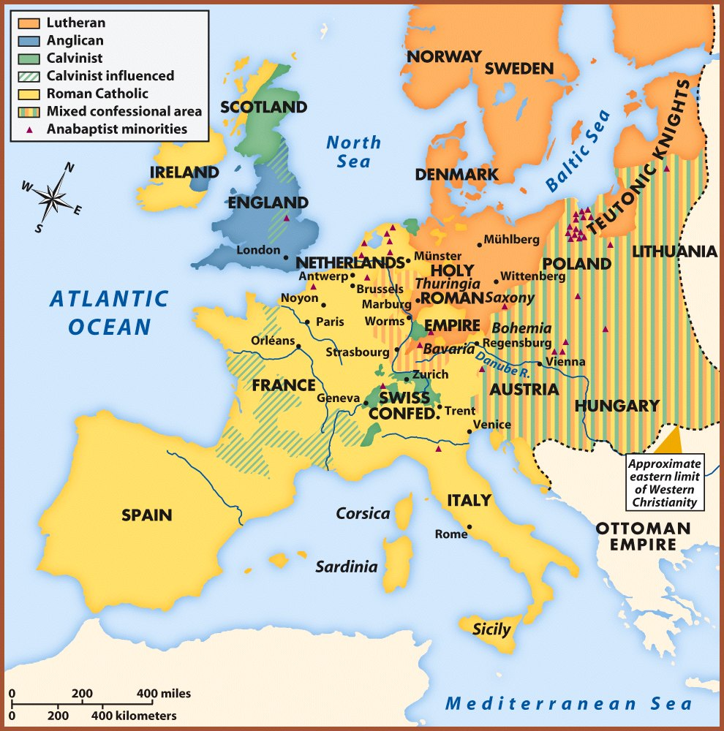

80. The map above, showing religious divisions in Europe around 1600, illustrates which of the following differences between Lutheranism and Calvinism?
a. Lutheran areas were more densely populated and urbanized than were Calvinist areas.
b. Lutheran areas were geographically closer to papal influence than were Calvinist areas.
c. Calvinist areas were more likely to be influenced by minor sects than were Lutheran areas.
d. Calvinists were more likely to share a common language than were Lutherans.
e. Calvinists were more likely to be a minority within a state than were Lutherans.
81. Which of the following best describes the results of the Peace of Augsburg (1555)?
a. It empowered German rulers to impose Lutheran, Calvinist, or Zwinglian Protestantism.
b. It was rejected by Emperor Charles V.
c. It released all German-speaking states from papal authority.
d. It established toleration for Anabaptists in the Holy Roman Empire.
e. It provided a legal basis for the existence of Lutheranism.

82. The conversion to Catholicism of King Henry IV of France is an example of the policies of the
a. Jansenists
b. politiques
c. philosophés
d. physiocrats
e. Jacobins

83. Which of the following best describes the French Edict of Nantes (1598)?
a. It provided limited political and religious liberties for French Huguenots.
b. It signaled the end of French territorial expansion for a century.
c. It led to the establishment of French colonies in North America.
d. It granted legal equality to all classes of France.
e. It led to fifty years of violent peasant rebellions.

84. The most influential religious order associated with the Catholic Reformation (Counter-Reformation) was the
a. Brothers and Sisters of the Common Life
b. Dominican
c. Franciscan
d. Jesuit
e. Oratory of Divine Love

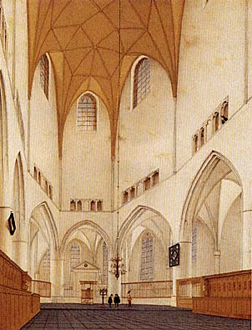

85. The Dutch church represented in the painting above can be identified as Protestant because of
a. its high vaulted ceiling
b. the small number of people in attendance
c. the absence of pews or chairs
d. the plainness of the interior
e. its windows at different levels
86. The most important political and military result of the Thirty Years’ War and the Peace of Westphalia was the
a. decline of Denmark as a Baltic power
b. decline of the Ottoman Empire as a great power
c. rise of England as a naval power
d. rise of Russia as a great power
e. rise of France as a great power

