Model of a Traditional Society/ Ancien Régime
Large Proportion of societal Resources used for raising the next generation  Low Income Levels  - All factors of production are underutilized  - Inadequate investment in education, health, transportation facilities  - Economy based on barter rather than trade  - Wide gap between rich and poor  - Heavy taxation  - Religion is very important  - Local landlords hold much political and social power  - Ceiling on productivity  - Family and clan very important  - Nationalism lacking  - Science in pre-Newtonian  - Caste System exists  - Warfare endemic  - Personal horizons very limited  - Knowledge of the universe very limited  - Sense of “Changelessness” | 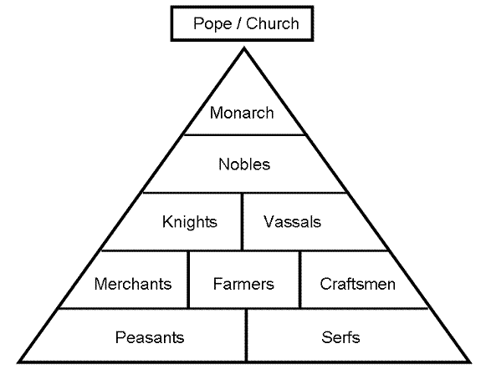

Cracks in the Traditional Society Paradigm: The Path to modernity
Renaissance (1300s-1527) | Reformation (1517-1648) | Religious Wars
Changes to the TSP  Low Income Levels  - Economy based on barter rather than trade  - Knowledge of the universe very limited  Changes-  Humanists- life was important and should be enjoyed while the church did not, and felt that people should focus on awaiting the afterlife instead.  - Strong belief in individualism and the great potential of human beings  Arts- intense study of the physical world  Women- enjoyed increased access to education  - However, lost some status compared to women in the Middle Ages; many women now functioned as ―ornaments to their middle-class or upper-class husbands  Element for change- Printing press: Johann Gutenberg  - Niccolo Machiavelli- The Prince (1513) guide for Absolutism- decline in Churches power  Status Quo-  Women controlled- few ruler- Isabella I-Spain  Pope’s Corrupt and influence European politics  - Pope Alexander VI (1492-1503)  - Pope Julius II (1503-1513) | Changes to the TSP | Changes to the TSP  - Religion is very important  - Local landlords hold much political and social power  - Nationalism lacking  - Warfare endemic  Changes-  New Monarchs (c. 1460-1520) (Henry IV)  Reduced the power of the nobility through taxation, confiscation of lands (from uncooperative nobles), and hiring of mercenary armies or the creation of standing armies  - The advent of gunpowder increased the vulnerability of noble armies and their knights   ▪ Reduced the political power of the clergy  Status Quo-  Protestants gain power- League of Schmalkalden & Peace of Augsburg (HRE)  - Control the Religion of their land

Exploration (1492-1750) | Absolutism (1500s-1800) | Scientific Revolution (1550-1700)
Changes to the TSP  Large Proportion of societal Resources used for raising the next generation  Low Income Levels  - Inadequate investment in education, health, transportation facilities  - Economy based on barter rather than trade  - Wide gap between rich and poor  - Heavy taxation  - Local landlords hold much political and social power  - Ceiling on productivity  - Science in pre-Newtonian  - Warfare endemic  - Personal horizons very limited  - Knowledge of the universe limited  - Sense of “Changelessness”  Changes  COMMERCIAL REVOLUTION (1500-1700)  - Banking: Fuggers (in Germany), Antwerp in 16th century, Amsterdam in 17th century  - The Hanseatic League  - Commercial revolution resulted in capitalist investments in overseas exploration  - Cities: merchants (bourgeoisie), artisans, laborers  Columbian Exchange  - Europeans saw better diet-increased standard of living  The price revolution‖  - Bourgeoisie grew in political and economic significance  - Increased standard of living  “Old Imperialism”-Growth of Empires | Changes to the TSP | Changes to the TSP

Enlightenment (1650-1800) | Agricultural Revolution (1700-1800) |  |  | First Industrial Revolution (1750-1850)
Changes to the TSP | Changes to the TSP |  |  | Changes to the TSP
French Revolution 1789-1799 With Napoleon 1815 |  | 2nd Industrial Revolution (1850-1900s)

Low Income Levels
All factors of production are underutilized
Inadequate investment in education, health, transportation facilities
Economy based on barter rather than trade
Wide gap between rich and poor
Heavy taxation
Local landlords hold much political and social power
Ceiling on productivity
Family and clan very important
Nationalism lacking
Personal horizons very limited
Changes-
Urbanization of the world: Industrial Revolution‘s most important sociological effect
- Wealth available for human consumption increased.
- Vast amounts of food, clothing and energy were produced and distributed to the workers of the world.
- Luxuries were made commonplace.
- Life-expectancy increased
- Leisure time made more enjoyable.
- Britain- first large European country to experience urban growth
- Over 50% of population in 1891 lived in urban areas
- Number of children per family fell, though this trend was more pronounced in the middle class
“Belle époque”
- State’s role in education increased, leading to further secularization of society
- Soccer (football), rugby, bicycle and automobile races, track and field
- Mass transportation
- Migration and emigration-to cities and America
Chartists sought political democracy.
Governments- England become more democratic- pass laws to improve the lives of the masses- “Age of Mass Politics”
Status Quo
Gap between the wealthy and working class still huge

Post industrial Society
19th century
20th century
Modern Society: The Information Age

