Key Dates: How would each thinker view the events below?

1642-49: English Civil War.
1649: Execution of Charles I.
1649-59: Interregnum (Republic, then Protectorate).
1658: Death of Cromwell.
1660: Restoration of the monarchy (Charles II returned from France).
1685-88: Reign of James II.
1688-89: “Glorious Revolution.”

- What is the Nature of Man/ the State?
- What is the Purpose of Government?
- What is the Social Contract?
Nature of Man/ the State
Hobbes | Locke
Man is not by nature a social animal; society could not exist except by the power of the state.  The state of nature is a state of war. No morality exists. Everyone lives in constant fear. Because of this fear, no one is really free, but, since even the “weakest” could kill the “strongest” men ARE equal.  “the life of man, solitary, poor, nasty, brutish, and short.” | Man is by nature a social animal.  Men exist in the state of nature in perfect freedom to do what they want. The state of nature is not necessarily good or bad. It is chaotic. So, men do give it up to secure the advantages of civilized society.
Purpose of Government /Social Contract
To impose law and order to prevent the state of war. | To secure natural rights, namely man’s property and liberty.

Thomas Hobbes: Apologist for Absolute Government 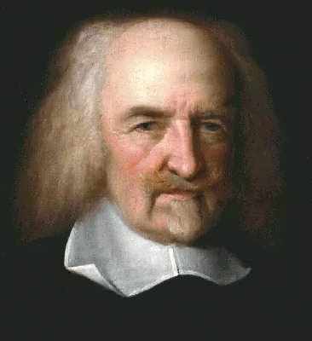 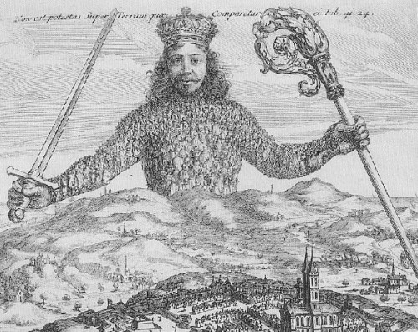
  - Biographical Information
    - English political philosopher who lived from 1588-1679
    - He traveled to Paris, where he studied alongside Descartes, and Italy where he exchanged ideas with Galileo.
    - His first publication was a translation of the Thucydides’ classic History of the Peloponesian War from which he developed a dark view of human nature.
  - Hobbes’s Works
    - Leviathan (1651)
      - Written shortly after the English Civil War, he attempts to philosophically justify the necessity for a strong central authority.
      - Hobbes traced all psychological processes to bare sensation and regarded all human motivations as egotistical, intended to increase pleasure and minimize pain.
      - The Social Contract
        - Hobbes contends that only a sovereign commonwealth established by a contract between the ruler and the ruled could enable human beings to meet their needs by limiting the free exercise of the natural human pursuit of self-interest with all its potential conflict.
        - Hobbes rejects the idea that human beings are naturally sociable but rather self-centered creatures.
        - In the state of nature, Hobbes believed, humans live in constant conflict and fear of destruction and death.
        - Essentially, he believes human beings are naturally willing to give up the absolute individual freedom of the state of nature for the comfort and protection provided by a strong central ruler.

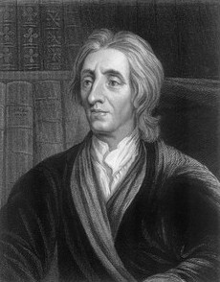
John Locke: Defender of Moderate Liberty and Toleration
  - Biographical information
    - Locke (1632-1704) was the most influential philosophical and political thinker of the seventeenth century.
    - He criticized absolutism.
    - His family had Puritan sympathies and his father fought with Parliament against the monarchy in the English Civil War.
    - Locke was a close associate of Ashley Cooper, the earl of Shaftesbury, who was considered a radical; both he and Locke were forced to flee to Holland after Shaftesbury organized an unsuccessful rebellion to overthrow Charles II in 1682.
  - Locke’s works
    - Second Treatise of Civil Government
      - He advocated for a government that must be responsible for and responsive to the concerns of the governed.
      - Contrary to Hobbes, Locke regarded humans in the state of nature as creatures of reason and basic goodwill.
      - Humans enter into the social contract in order to form political society to secure and preserve the rights, liberty, and property that they already possess prior to the existence of political authority.
      - The relationship between the governed and the government is one of trust, and if the government breaks that trust, it is the responsibility of the governed to replace them.
    - Letters Concerning Toleration
      - Locke advocated for extensive religious toleration among Christians to prevent the chaos caused by over a century of religious struggles.
      - He believed that religious salvation was an individual endeavor not to be mandated by the state.
      - He did not, however, believe toleration should be extended to Roman Catholics whom he believed to have pledged allegiance to a foreign prince [the papacy].
    - Essay Concerning Human Understanding (1690)
      - The major work of European psychology during the eighteenth century.
      - He believed the mind to be a “blank tablet” at birth whose content would be determined by sense experience; therefore, the human condition could be improved by changing the environment.

