Name __________________________ Study Guide #2
Unit  2 | 500-1500 | Middle Ages: Chapters 13-14: Medieval Europe, Plague Mongols
 | 1300-1600 | Agents of change: Chapter 17: Renaissance and Reformation
 | 1300-1800 | Agents of change (2)Chapters 18-20: Muslim World, Exploration and the Atlantic World
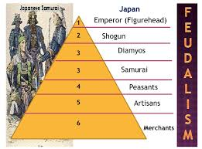
Feudal Japan:
Code of Bushido, Samurai, Shogun, daimyo, Tokugawa Era, Shinto
- Compare to European feudalism and Japanese feudalism.
- What is Bushido?

Medieval Europe:
Feudalism, rigid social class structure, serf, vassal, lord, nobles, self-sufficiency, manor, three field system, chivalry, fief, clergy, Gothic architecture crusade, guild, urbanization, Inquisition
People: Pope Urban II, Saladin, Isabella and Ferdinand, Joan of Arc, King John
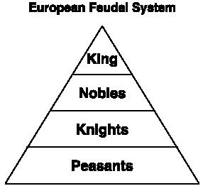
Events: Fall of Rome, Reconquista, Crusades, Plague Outbreak, Hundred Years’ War, , Inquisition
- How did Feudalism work as a political system?
- What were the causes and long-term effects of the Crusades?
- What were the causes and long-term effects of the Black Death?
- What is Chivalry?
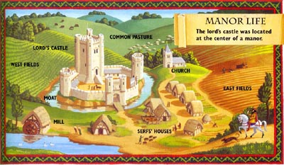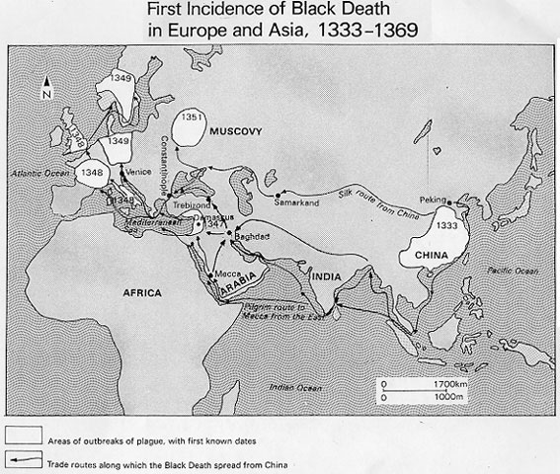
Mongol Empire:
Concepts/Terms: Golden Horde, Yuan Dynasty, Pax Mongolia, Silk Road, Bubonic Plague, stirrup,
People: Genghis Khan, Kublai Khan, Marco Polo
- What were the extent, rule, and contributions of the Mongol Empire?
- How did the Mongol empire impact trade & culture is spread from China Europe?
- How did the Mongol Influence Russia?
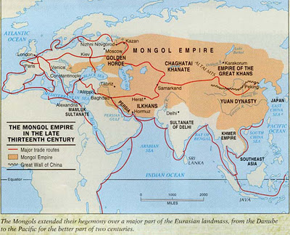
European Renaissance:
Renaissance, humanism,
People: de Medici, Michelangelo, da Vinci, Machiavelli( the Prince) , Gutenberg, Shakespeare, Elizabeth I
Events: Spread of the Renaissance from Italy to Northern Europe, introduction of the printing press
- What were the conditions that gave rise to the Renaissance in Italy (economic, social, political)
- How was the Renaissance a turning point in European/ World History?

Reformation: Concepts/Terms
Reformation, protestant, indulgence, 95 Theses, excommunication, Church of England/Anglican,
People: Martin Luther, Henry VIII, Elizabeth I, John Calvin
Events: Reformation, Counter-Reformation/Catholic Reformation, Council of Trent,
- Know that - Spread of Luther’s ideas came via printing press

Age of Exploration / Colonization- Concepts/Terms
Mercantilism, mother country, navigational instruments (astrolabe/compass), Inca, Treaty of Tordesillas, Aztec, Maya, Mesoamerica, Conquistadors, social class structure in colonial Latin America including, Peninsulares, criollos, mestizos, mulattos, African slaves and Native-Americans, Encomienda System, Metal Weapons
People:
Prince Henry the Navigator, Vasco da Gama, Montezuma II, Francisco Pizzaro, Hernando Cortes, Christopher Columbus, Ferdinand and Isabella, ,Bartholomeu Dias
Events: Commercial Revolution, Columbian Exchange, Triangle Trade, Colonization
- Know the American civilization before 1492, were complex civilizations.
- What were the political, economic and social motives for European exploration/colonization?
- What technological advancements that made exploration / conquering possible?
- Effects : Columbian Exchange- Colonization
Ming Dynasty-Concepts/Terms
Middle Kingdom, Isolation, Ethnocentric,
Events: exploration- People: Zheng He
- What were the effect of China isolation from foreign trade?

