Study Guide Unit # 1
Neolithic Revolution and early civilizations
Terms |  | Events | People
Nomad  permanent settlements  domestication  civilization  Writing systems- Cuneiform- hieroglyphics – Sanskrit  Fertile Crescent  cultural diffusion | Hammurabi’s Code  specialization  social class structure  terracing farming  traditional economy  Agricultural  Technology  Oracle Bones | Neolithic Revolution | Mary Leakey(Lucy)  River Valley Civilizations  Mesopotamia  Egypt  Indus  Huang He
- What were the political, economic, geographic and social changes brought about as a result of the Neolithic Revolution. (Or how did the Neolithic Revolution create major changes to human’s way of life?)
- Characteristics of civilization- Specialized Workers, Complex Institutions , Record Keeping, Advanced Cities and Technology
- List 2-4 characteristics of the following early civilizations. Mesopotamia, Egypt, Indus and Huang He.
- How did geographic factors of rivers, deserts, mountains, and seas influence the development of early civilizations?
Belief Systems
Terms
Monotheistic  Polytheistic  Hinduism  Caste System  Untouchables  Reincarnation  Karma | Buddhism  Eightfold Path  Nirvana  Four Nobel Truth  Siddhartha Gautama  Judaism | Confucius  Confucianism  Filial Piety  Five Relationships Torah  Christianity  Ten Commandments  Bible  Jesus Christ | Islam  Mohammad  Five Pillars  Koran (Qur’an)  Daoism  Animism  Shintoism
- Know Religions and Belief Systems moral codes and how they impacted culture.
Greece & Rome: Greece (1750BCE-133BCE) & Rome (509 BCE- 476 CE)
Concepts/Terms | Events | People
Political systems: (democracy, direct democracy, aristocracy, monarchy, oligarchy, republic)  City-states- Athens, Sparta  Twelve Tables  Mediterranean Sea | Pax Romana  Hellenistic Age  golden age  Road systems  Division of Rome | Pericles  Socrates, Aristotle & Plato  Alexander the Great  Augustus
- Know how geography impacted both empires.

Han Dynasty: (206 BC- 220 CE)
Concepts/Terms Events
Paper money Dynastic Cycle Silk Road Civil service
Centralized Government Chinese Legalism Silk Road

Maurya and Gupta Empire: (250 BCE- 600 CE)
Concepts/Terms | People
Decimal point (System)  Concept of zero- “0”  Golden Age | Asoka (Ashoka) the Great
1. Web: Achievements and contributions.
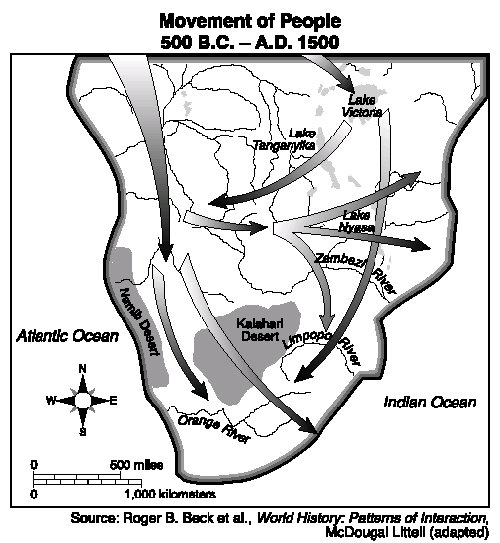
Bantu Migrations
Events
Migration- Cultural diffusion

- Know a few achievements and contributions of each of the previous empire.
- Know how geography impacted two of these empires.
Golden Age Empires
- What were the contributions of the following Golden Ages civilization
Byzantine: 330-1453
Terms | People | Events
Justinian’s Code  Cyrillic alphabet  Hagia Sophia “Holy Wisdom” | Constantinople  Justinian | Great Schism  Orthodox Christianity
- Know: Impact of Byzantine Empire and how did they impact Russia and Muslims.
Tang and Song Dynasty: 618-1215
gunpowder movable wooden type abacus compass Porcelain Paper Money
- Know the Impact of the technology of the Tang and Song.
Islamic Empires 650- 900s
Terms | People and Events
Caliph  Sunni  Shi’a  Calligraphy | preserved Greek and Roman culture  Islamic Golden Age  Ibn Battuta( similar to Marco…. Polo…Marco…. fish out of water)
- Here the regents will test your depth of knowledge: You must know that the Muslims had a golden age (Math and Science advancements) They preserved Greek and Roman culture but wait the is much much more like this guy Battuta (below) traveled and wrote about Muslims.
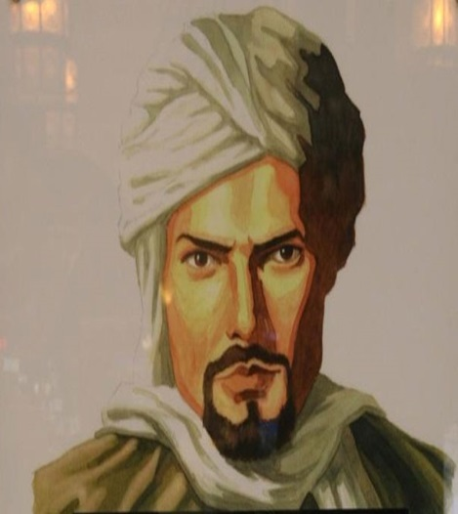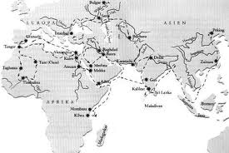
African Trading Kingdoms: Ghana, Mali, & Songhai
Timbuktu- prosperous- gold and salt Mansa Musa trans-Saharan trade routes
Spread of Islam
- There will likely be one or two questions on your regents on the terms above just know them.

