Question/ answer | Terms to study | Question/ answer | Terms to study

Use the following excerpt to answer 1-3.
“When the first water-frames for spinning cotton were erected at Cromford…mankind were little aware of the mighty revolution which the new system of labor was destined by Providence to achieve, not only in the structure of British society, but in the fortunes of the world at large.

Arkwright alone had the sagacity to discern, and the boldness to predict in glowing language, how vastly productive human industry would become…when made to consist of the task of guiding the work of mechanical fingers and arms, and regularly impelled with great velocity by some indefatigable physical power…”

—Andrew Ure, The Philosophy of Manufactures, 1835

1. Which of the following contributed to the rise of the new labor system in England that Andrew Ure referenced?
A. competition from continental powers like Prussia and Austria
B. available supply of natural materials like coal and iron ore
C. French investment in English infrastructure
D. the loss of colonial financial opportunity

2. Who was most likely to provide the capital needed for this system of labor and production?
A. factory owner C. the monarchy
B. Parliament D. foreign investors

3. How were artisans negatively affected by the factory system process Ure described?
A. They were forced to immigrate in order to find work.
B. They were required to transition into positions of compulsory military service.
C. They lost control of their means of production.
D. They were denied access to a minimum working wage because they refused to join unions.

Use the following image to answer 4-5.
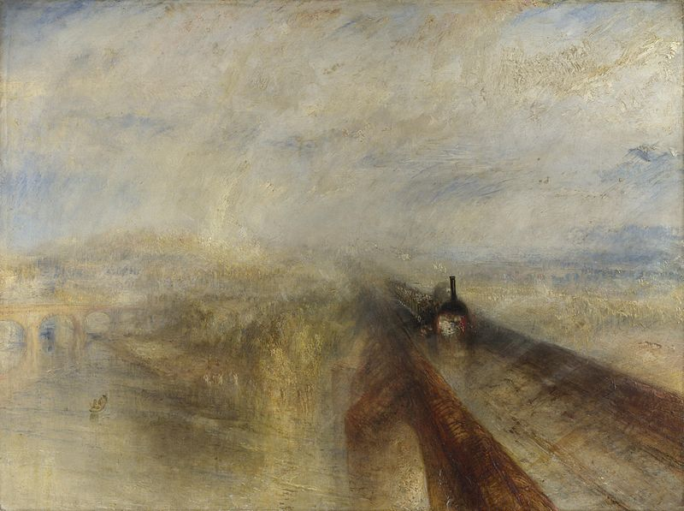
Joseph William Turner – Rain, Steam, and Speed – The Great Western Railway, 1844

4. This painting best illustrates which of the following nineteenth century artistic movements?
A. Romanticism C. Realism
B. the Pre-Rapahelite School D. the Art-Nouveau movement

5. What nineteenth century tension does Turner highlight in this image?
A. the triumph of the Romantic Movement over Realism
B. the value of painted artistic expression over written expression
C. the privilege of the upper social classes and the exploitation of the working class
D. the new technology of the Industrial Revolution and its interaction with natural world

Use the following excerpt to answer 6-8.
“When, in the course of development, class distinctions have disappeared, and all production has been concentrated in the hands of a vast association of the whole nation, the public power will lose its political character. Political power, properly so called, is merely the organised power of one class for oppressing another. If the proletariat during its contest with the bourgeoisie is compelled, by the force of circumstances, to organise itself as a class, if, by means of a revolution, it makes itself the ruling class, and, as such, sweeps away by force the old conditions of production, then it will, along with these conditions, have swept away the conditions for the existence of class antagonisms and of classes generally, and will thereby have abolished its own supremacy as a class.

In place of the old bourgeois society, with its classes and class antagonisms, we shall have an association, in which the free development of each is the condition for the free development of all.”

—Karl Marx and Friedrich Engels, Communist Manifesto 1848

6. What specific economic and social conditions were Marx and Engels referring to in this selection?
A. the social order that developed following the French Revolution
B. the impacts of the revolutionary upheaval of 1848
C. the social and economic order that emerged with the Industrial Revolution
D. the societal concerns created due to Irish immigration after the potato famine

7. What did Marx and Engels view as the fundamental cause of the conflict discussed in this selection?
A. historical tension concerning the control of the means of production
B. the failure to give the working classes the right to vote
C. governmental failure to improve urban living and working conditions
D. gender tension among the members of the working classes

8. This passage from Marx and Engels demonstrates a significant difference between their ideology and other thinkers because Marx and Engels
A. failed to support gender equality, while other thinkers like Robert Owen actually implemented policies of gender equality.
B. refused to acknowledge any meaningful correlation between social issues and political ideas, but other reformers said the two were closely linked.
C. were adamantly opposed to violence as a tool to accomplish their goals, whereas groups like the Anarchists saw violence as the only useful technique.
D. demanded the complete elimination of private property, whereas other thinkers advocated a significant rearrangement of society while still allowing for private property.

Use the following excerpt to answer 9-11.
“Required as we are, universally, to support and obey the laws, nature and reason entitle us to demand, that in the making of the laws, the universal voice shall be implicitly listened to. We perform the duties of freemen; we must have the privileges of freemen. WE DEMAND UNIVERSAL SUFFRAGE. The suffrage to be exempt from the corruption of the wealthy, and the violence of the powerful, must be secret…

WE DEMAND THE BALLOT

The connection between the representatives and the people, to be benefitted must be intimate… To public safety as well as public confidence, frequent elections are essential.

WE DEMAND ANNUAL PARLIAMENTS

With power to choose, and freedom in choosing, the range of our choice must be unrestricted.”

—The People’s Petition of 1838

9. Which group of people in England was responsible for the issuance of The People’s Petition?
A. Robert Owen’s New Lanark followers C. women suffragettes
B. the industrial middle class D. the Chartists

10. What is the significance in English political history of The People’s Petition?
A. Although it did not achieve all six of its demands, it did manage to enfranchise the English working class.
B. It successfully promoted the vote for women.
C. It represents the only time in the nineteenth century when Parliament accepted and voted on a petition introduced by the people.
D. It reflected the ideas of the first large-scale working-class political movement in Europe.

11. The specific disagreement within the movement that limited the effectiveness of The People’s Petition was whether
A. the movement should use violent or non-violent tactics.
B. the vote should be for all people in Britain or only men.
C. the petition should be submitted to Parliament or only to local governments.
D. they should work with the middle class to accomplish their objectives.

Use the following image to answer 12-14.
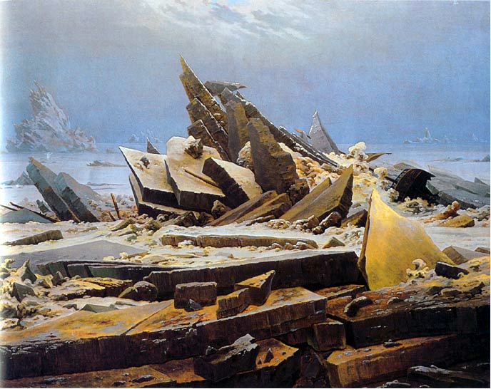
Caspar David Friedrich, The Polar Sea

“There was a time when meadow, grove, and stream,
The earth, and every common sight,
To me did seem
Appareled in celestial light,
The glory and the freshness of a dream.
It is not now as it hath been of yore –
Turn whereso’er I may,
By night or day,
The things which I have seen I now can
see no more.”

—William Wordsworth, “Ode to Intimations of Immortality”, 1803

12. “Ode to Intimations of Immortality” reflects Romanticism’s tendency to believe that
A. the individual’s experience is of utmost importance.
B. reason was more valuable to the artist than emotion.
C. deism was the preferred religious idea of the age.
D. symbols and images of the medieval era should be embraced in art.

13. What idea associated with the Romantic movement of the nineteenth century did Caspar Friedrich demonstrate in The Polar Sea?
A. People should no longer be depicted in the visual arts.
B. The events of the late eighteenth century had demonstrated that man was on the verge of self-destruction.
C. The power of nature is much greater than the influence of mankind.
D. Mankind was not heroic and should not be painted heroically any longer.

14. What common element of Romanticism do these two artistic pieces reflect?
A. a general opposition to the Industrial Revolution
B. the introduction of Gothic influences into nineteenth century art
C. an emphasis on emotion rather than reason
D. the power and attraction of nature

Use the following excerpt to answer 15-17.
“The confederated governments mutually pledge themselves to eliminate from the university or any other public educational institutions all instructors who shall have obviously proved their unfitness for the important work entrusted to them by opening deviating from their duties, or by going beyond the boundaries of their functions, or by abusing their legitimate influence over young minds, or by presenting harmful ideas hostile to public order or subverting existing governmental instructions.

The laws that have for some time been directed against secret and unauthorized societies in the universities shall be strictly enforced…The governments mutually agree that all individuals who shall be shown to have maintained their membership in secret or unauthorized associations, or shall have taken membership in such associations, shall not be eligible for public office.

As long as this edict remains in force, no publication which appears daily, or as a serial not exceeding twenty sheets of printed matter, shall be printed in any state of the Confederation without the prior knowledge and approval of the state officials…”
—Carlsbad Decrees, 1819
15. Which nineteenth century ideology triumphed with the issuance of the Carlsbad Decrees in 1819?
A. conservatism C. liberalism
B. Romanticism D. nationalism

16. The Carlsbad Decrees limited the activities of all of the following groups EXCEPT
A. university professors
B. university students
C. Catholic priests and Protestant ministers
D. publishers

17. Why did the Carlsbad Decrees implement these particular restrictions and limitations?
A. They were concerned about rising anti-Semitism in the German states and wanted to suppress it.
B. The government was convinced the education system was teaching students anti-German ideas.
C. Secret societies were caught plotting the assassination of the King of Prussia.
D. University groups were viewed as promoters of liberalism and nationalism.

Use the following image to answer 18-20.
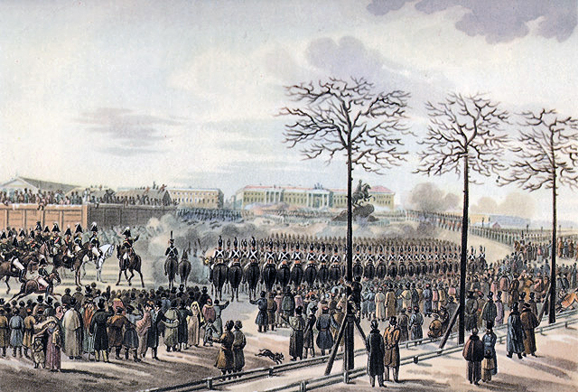
Karl Konrad, The Insurrection of the Decembrists at Senate Square,
St Petersburg on 14th December, 1825

18. What specific group in Russian society led the uprising depicted in Karl Konrad’s painting?
A. disgruntled serfs who were angry over rising labor requirements
B. military officers who wanted to see the ideas of the Enlightenment implemented in Russia
C. the emerging middle class who wanted the franchise extended to them
D. Russian boyars who were upset about their declining position in society

19. What was the immediate cause of this uprising in Russia in 1825?
A. the rejection of Nicholas’ leadership and calls for a constitution
B. a bloody coup that removed the popular leader Constantine from power
C. the failure of the Russians to defeat the Ottomans for control in the Crimea
D. an economic depression that created a cycle of famine for over five years

20. What political ideology triumphed at the conclusion of the Decembrist uprising?
A. liberalism C. conservatism
B. nationalism D. Romantic republicanism

Use the following image to answer 21.
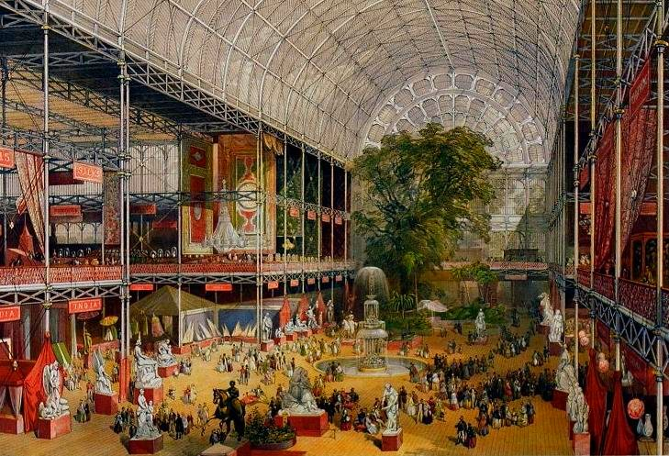
Crystal Palace during the International Exhibition, 1851

21. The Crystal Palace depicted in this painting was built for which of the following purposes?
A. to commemorate the defeat of Napoleon at Waterloo
B. in honor of Queen Victoria’s ascension to the British throne
C. to celebrate England’s advancements in commercial interests and industry
D. to serve as a new art museum for nineteenth century artists and designers

Use the following excerpt to answer 22-24.
“Any agricultural economy that depends on a single product is in a precarious position. If the people that that economy supports also depend on a single source of food, they also stand on the edge of catastrophe – they have nothing to fall back on if their only source of food fails. That kind of catastrophe occurred in Ireland, which was under British rule in the 1840’s when the potato crop failed.

During the eighteenth century, almost half of the Irish population came to depend in the potato, which had been brought to Europe from South America in the seventeenth century, as virtually their only food. On less than one acre, an Irish peasant could raise enough potatoes to feed the other people for a year and pay his rent (few Irish peasants owned their own land).

[A] series of Irish potato crop failures was the worst agricultural disaster to strike nineteenth-century Europe. Without potatoes, Irish tenants could not pay their rent. Landlords drove starving tenants off their farms. Disease spread, and tens of thousands died.”

—R.N. Salama, The History and Social Influence of the Potato & Cecil Woodham-Smith, The Great Hunger: Ireland 1845–1849

22. Which of the following best represents the British government’s reaction to the crisis discussed by R.N. Salama and Cecil Woodham-Smith in this document?
A. The federal government repealed the Corn Laws.
B. Queen Victoria refused to take any action at the national level.
C. Parliament passed a series of poor relief laws aimed at alleviating the suffering of the Irish.
D. The government supplied wheat to needy farmers who lost their potato crops.

23. What earlier historical process created the conditions for the mid-nineteenth century crisis discussed in this document?
A. the Industrial Revolution C. the Columbian Exchange
B. Romantic nationalism D. mercantilism

24. Which of the following is a specific result of the crisis identified by R.N. Salama and Cecil Woodham-Smith?
A. Irish nationalism grew, resulting in independence for the majority of Ireland.
B. Many of the Irish poor emigrated to Britain and the United States.
C. Settlers from England moved to Ireland to take advantage of land vacated by Irish farmers.
D. The Irish population grew rapidly as new crops were introduced to replace the lost potato crop.

Use the following image to answer 25-27.
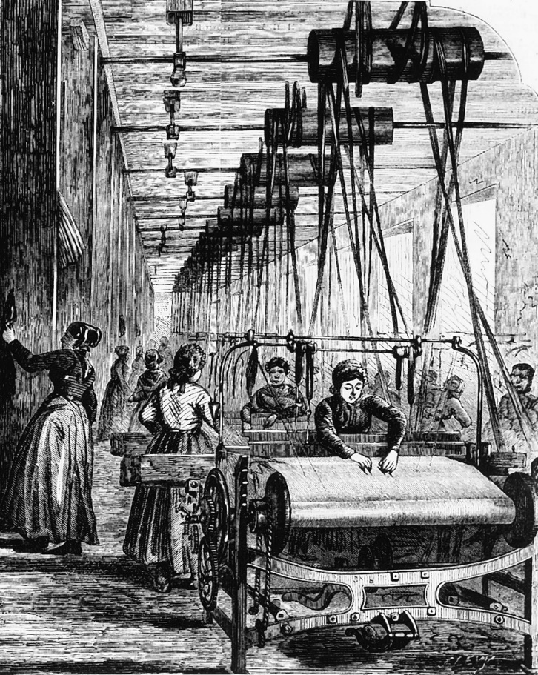

25. Which group of women typically composed the work force depicted in the image above?
A. middle class married women C. young, single women and widows
B. rural peasants D. girls under the age of fifteen

26. What type of factory work did the women in the image above do?
A. munitions production C. manufactured steam engine parts
B. train engine construction D. textile production

27. How did skill requirements for women in this image differ from those in earlier home production?
A. Women had to wait to take this job until they achieved a certain education level.
B. Fewer skills were necessary for these jobs than were required for earlier jobs.
C. This job required women to secure special skills that men in similar jobs did not have to gain.
D. Both jobs required the same skills since they continued to do the same work.

Use the following map to answer 28-31.
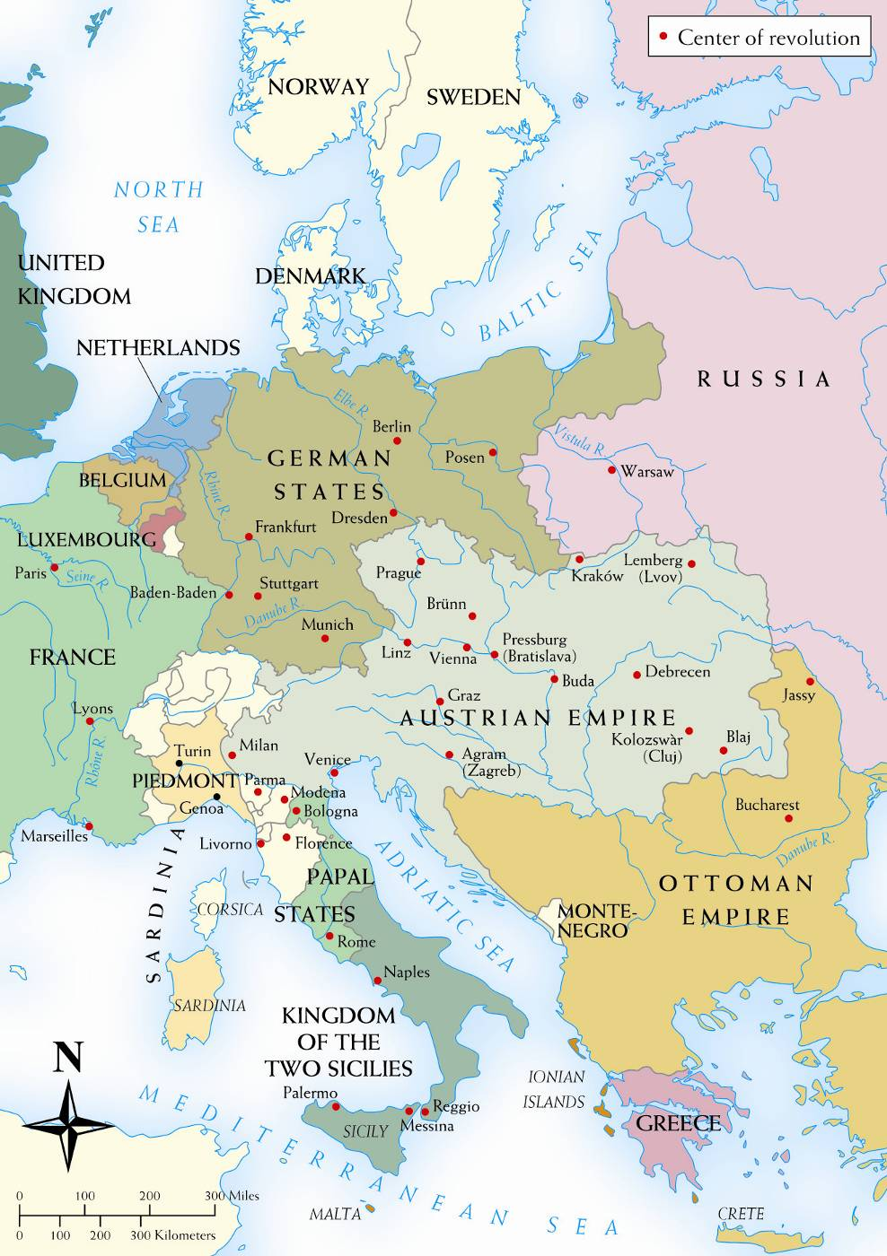

28. All of the following were causes in 1848 of the European event shown on this map except
A. food shortages, a series of poor harvests, and famine.
B. widespread unemployment and a depressed European economy.
C. political liberalism that emphasized concepts like representative government.
D. Napoleon’s aggressive foreign policy that led to the conquest of most of the continent.

29. Which European nation’s overthrow of the July Monarchy was the impetus for the revolutions depicted in this map?
A. Russia C. The Kingdom of the Two Sicilies
B. Austria Empire D. France

30. According to this map, what specific challenge did Austria face in 1848–1849?
A. ethnic nationalities that might threaten Austrian unity
B. an unprotected border with Russia that led to war
C. a vulnerable trade city on the coast of the Black Sea
D. an empire that was divided by a Prussian state in the center of their territory

31. Which of the following groups shown on this map did not resist Austrian control during the events of 1848–1849?
A. Austrian Netherlands C. Czech Nationalists
B. Hungary D. Milan

Use the following map to answer 32-35.
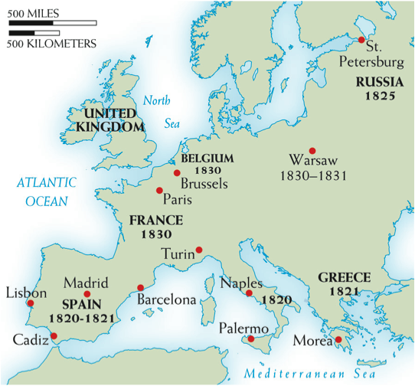

32. Which of the uprisings on the map above was suppressed by its own domestic conservative government?
A. Belgium C. Greece
B. Spain D. Russia

33. Which two uprisings were fueled by nationalism and resulted in independence from another European power?
A. Greece and Belgium C. Spain and Naples
B. France and Naples D. Greece and Spain

34. Why is there no revolution in the United Kingdom on the map above?
A. Britain had suffered a devastating economic crisis that prevented a revolt
B. Britain elected to implement reforms rather than risk revolution by the people
C. The death of the last Hanoverian king brought the divided country together
D. The government actions at the Peterloo Massacre eliminated the desire to revolt

35. What was the political result of the 1830 Revolution and the installment of the July Monarchy in France?
A. a return to the conservative principles of the Bourbon restoration
B. the creation of the Second Republic in France
C. the installation of Napoleon III as emperor of France
D. a constitutional government based on the principles of classical liberalism

Use the following excerpt to answer 36-37.
“I. AIM OF THE SOCIETY

1. The aim of this society is the triumph of the principle of revolution in the world, and consequently the radical overthrow of all presently existing religious, political, economic and social organizations and institutions and the reconstitution first of European and subsequently of world society on the basis of liberty, reason, justice and work.

II. REVOLUTIONARY CATECHISM

3. Liberty is the absolute right of all adult men and women to seek no sanction for their actions except their own conscience and their own reason, to determine them only of their own free will, and consequently to be responsible for them to themselves first of all, and then to the society of which they are a part, but only in so far as they freely consent to be a part of it…
6. There is only one dogma, one law, one moral basis for men, and that is liberty. To respect your neighbor’s liberty is duty; to love, help and serve him, is virtue…
9. It is impossible to determine a concrete, universal and compulsory norm for the internal development and political organization of nations [and] any undertaking of this nature, being utterly devoid of practical utility, would militate against the richness and spontaneity of life, which delights in infinite diversity, and would in addition be contrary to the very principle of liberty. Nevertheless, there do exist essential, absolute conditions without which the practical realization and organization of liberty will always be impossible. These conditions are:
9(a). The radical abolition of all official religion and every privileged or state-protected, -financed or -maintained church…
9(c). Abolition of monarchy, republic.
9(d). Abolition of class, rank, privilege and distinction in all its forms. Complete equality of political rights for all men and all women; universal suffrage.”

—Mikhail Bakunin, “Principles and Organization of the International Brotherhood,” 1866

36. What ideology did Mikhail Bakunin strongly disagree with, leading him to develop the anarchist plan in the above document?
A. nationalism C. socialism
B. conservatism D. Romanticism

37. What was Bakunin’s belief about the role of government in society?
A. He believed that structured governments were oppressive and not necessary in a modern society.
B. He felt that formal governments’ only responsibility was to protect the natural rights of its people.
C. He argued that governments needed to take a more active role in society in order to protect equality.
D. He that that governments should work closely with social and religious institutions to advance the country.

Use the following image to answer 38-39.
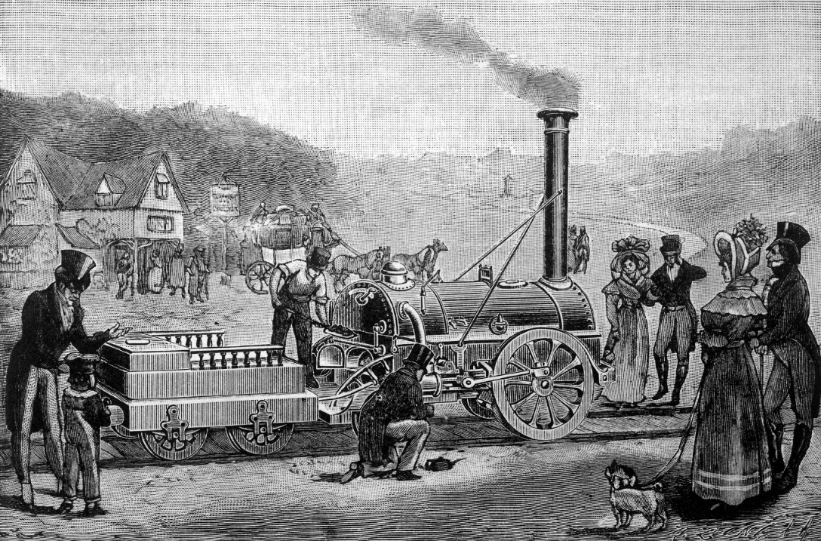

38. What economic benefit did this industrial innovation have?
A. It allowed for the cheaper and more efficient transportation of raw materials and finished goods.
B. It facilitated the movement of people from crowded cities to rural areas in order to meet agrarian labor needs.
C. It created economic competition between England and France to produce less expensive locomotives to sell in European markets.
D. It allowed for the efficient transportation of much-needed grain surpluses to meet Irish food needs after the famine appeared in Ireland.
39. How did this innovation further contribute to the Industrial Revolution in the second half of the nineteenth century?
A. It gave Britain an opportunity to catch up to continental industrial development.
B. It increased the output of consumer goods, giving workers access to additional goods.
C. It changed the power source used by factories from steam engines to internal combustion engines.
D. It created additional demand for industrial goods like iron, steel, and glass.

Use the following excerpt to answer 40-42.
“It will no doubt, be gratifying to some Readers, to be made acquainted with the origin of Luddism. From the enquiries I made in Nottinghamshire, where Luddism originated, I learnt the following particulars, namely, that a good many years ago, there lived a poor man…whose name was Edward Ludd: This man was not one of the brightest cast; in regard to his intellects; and, as is commonly the case with such characters, was of an irritable temper. This Edward Ludd, called by his neighbours Ned Ludd, was by trade a Frame Work Knitter: or in plainer language, and which is all the same, a Stocking Weaver. This man, being irritated, either by his Employer, or his work, or both took the desperate resolution of avenging himself, by breaking his Stocking Frame…

About the latter end of the year 1811, the Stocking and Lace Weavers of Nottingham, having been for a long time harassed by abridged wages, and want of employment, in whole or in part, and consequently with want of bread, entered into a combination, (as report says, upon oath) to break certain proscribed Frames…These Frame-Breakers assumed the name of their proto-type Ned Ludd. Hence when they entered a house in order to break Frames, they would say Ned Ludd or General Ludd, commands us to break these Frames…These men, collectively, were therefore called Luddites, and their system was, and is, called Luddism.”

—Kenneth Carpenter, ed. The Luddites: 3 Pamphlets, 1812–1839, 1972

40. What was the general complaint of those who participated in the movement originally sparked by Edward Ludd?
A. The British government had failed to extend voting rights to the workers.
B. Economic policies like the Corn Laws had impoverished many in the lower classes in Britain.
C. The new technologies of the Industrial Revolution threatened traditional textile workers.
D. Urban conditions had grown so bad that governmental interference was needed to address the problems.

41. What types of action did the Luddites use in order to bring attention to their concerns?
A. They brought petitions to Parliament containing over a million signatures in an effort to bring change.
B. They resorted to breaking machines, which they saw as threats to their traditional way of life.
C. They utilized labor tactics like strikes and protests to force factory owners to hear their concerns.
D. They refused to take jobs in textile factories, turning to coal mining instead.

42. Which of the following is another complaint that workers had about factories beyond those discussed in the Luddite pamphlet excerpt above?
A. Factory overseers resorted to harsh disciplinary tactics, including physical punishment.
B. Women were denied work in textile factories, depriving families of needed revenue.
C. Workers were limited to working an eight-hour day, which did not generate enough income to live on.
D. Government safety requirements meant that work often took twice as long to complete.

Use the following image to answer 43-44.
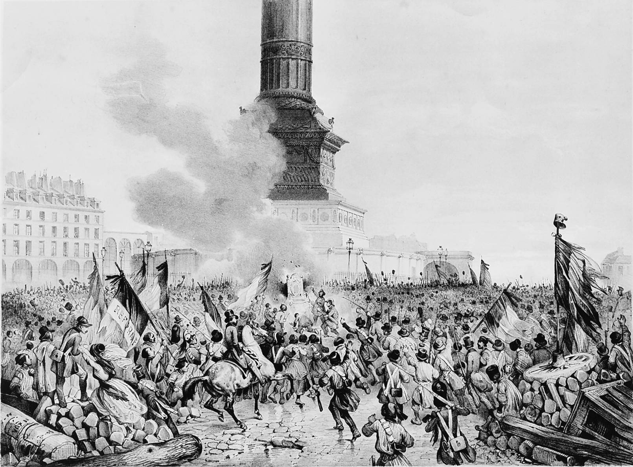
February Days, France, 1848

43. What leader of France abdicated the throne as a result of this uprising in France?
A. Louis XVIII C. Louis Philippe
B. Napoleon III D. Charles X
44. In addition to seeking greater political opportunities for the middle class, what else was a cause of the uprising depicted in the image above?
A. higher food prices that followed several years of poor harvests
B. noble demands to have their traditional privileges restored
C. working class concerns over worsening urban conditions
D. Marxist revolutionaries who sought to overthrow the monarchy

Use the following excerpt to answer 45-46.
“The object of this Essay is to assert one very simple principle, as entitled to govern absolutely the dealings of society with the individual in the way of compulsion and control, whether the means used be physical force in the form of legal penalties, or the moral coercion of public opinion. The principle is, that the sole end for which mankind are warranted, individually or collectively, in interfering with liberty of action of any of their number, is self-protection…

No society in which these liberties are not, on the whole, respected, is free, whatever may be its form of government; and none is completely free in which they do not exist absolute and unqualified. The only freedom which deserves the name, is that of pursuing our own good in our own way, so long as we do not attempt to deprive others of theirs, or impede their efforts to obtain it.”

—J.S. Mill, On Liberty, 1859

45. What nineteenth ideology is reflected in this selection by John Stuart Mill?
A. Romantic nationalism C. conservatism
B. utopian socialism D. liberalism

46. Which of the following is an example of a European government’s application of Mill’s ideas about governance?
A. Poland’s Organic Statute C. Britain’s Great Reform Act of 1832
B. German states’ Carlsbad Decrees D. Russia’s “Official Nationality” program

Use the following image to answer 47-48.
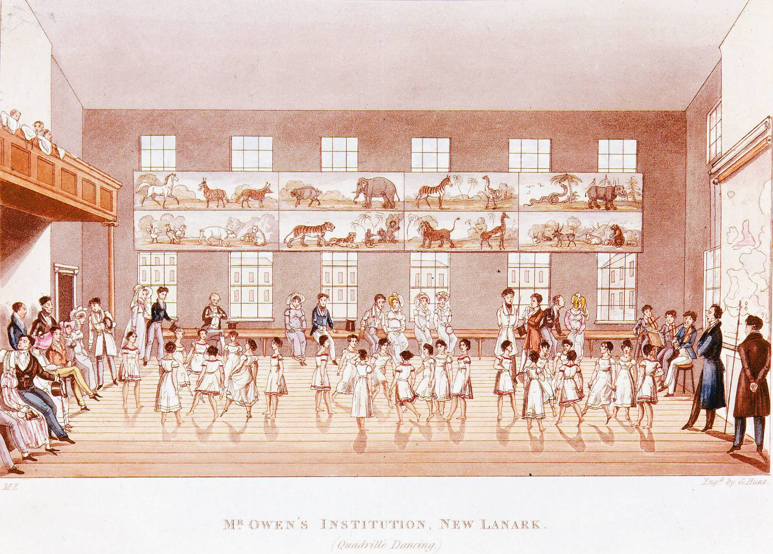

47. Which of the following best describes Robert Owen’s organization of this community?
A. a cultural social club that gave members a chance to participate in art and music activities
B. an early educational experiment that focused on educating girls
C. an industrial town that organized workers around a principle of “enlightened management”
D. a religious organization that provided housing and brought food to London’s working poor

48. All of the following are characteristics of the community referenced in this image except
A. educational opportunities for workers’ children.
B. good living quarters and recreational opportunities for industrial workers.
C. issuing rewards to workers for exemplary factory work.
D. the organization of all community members into phalanxes based in skills.

Use the following image to answer 49-50.
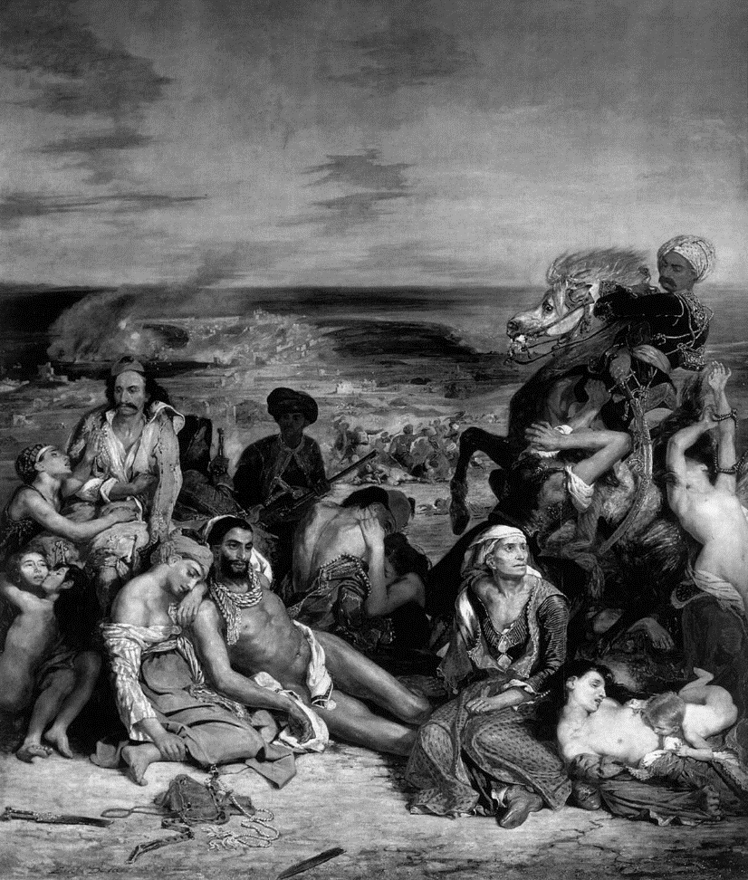
Eugene Delacroix, Massacre at Chios (1824)

49. Who were the Greeks attempting to gain independence from in this image?
A. the Austrians C. the Prussians
B. the Ottomans D. the Russians

50. All of the following were reasons western European nations offered support to the Greeks in their independence movement except
A. Europeans believed the revolt in Greece was the reappearance of ancient Greek democracy in the region.
B. Governments in Western Europe felt that supporting the revolution was an attack against Ottoman despotism.
C. Western Europeans argued that an independent Greece would give them more stable trade relations in the region.
D. European Christians were deeply concerned about the treatment of Greek Christians in the empire.

