Unit 2 AP Euro Test:
Absolutism, Scientific Revolution, Enlightenment, Developments of the 18th Century

One must attempt, above all, to know the special genius of the people which one wants to govern in order to know if one must treat them leniently or severely, if they are inclined to revolt….
[The Prussian nobility] has sacrificed its life and goods for the service of the state; its loyalty and merit have earned it the protection of all its rulers…. In such a state no factions or rebellions need be feared…it is one goal of the policy of this state to preserve the nobility.
A well conducted government must have an underlying concept so well integrated that it could be likened to a system of philosophy. All actions taken must be well reasoned.
It is of no concern in politics whether the ruler has a religion or whether he has none. All religions, if one examines them, are founded on superstitious systems, more or less absurd. It is impossible for a man of good sense, who dissects their contents, not to see their error

- King Frederick II of Prussia, Political Testament, 1752

- The idea expressed in this excerpt best reflects which of the following historical trends?
  - Monarchs “westernized” the state and society by transforming political, religious, and cultural institutions
  - Many rulers undertook enduring domestic reforms while curtailing some rights and manipulating popular impulses behind a façade of representative institutions.
  - In the eighteenth century, a number of states in eastern and central Europe experimented with “enlightened absolutism.”
  - Louis XIV’s nearly continuous wars, pursuing both dynastic and state interests, provoked a coalition of European powers opposing him.

- Based on this document, which of the following can be inferred as a significant effect of the renewed emphasis on science and reason in European culture?
  - Debates about female roles in the family, society, and the church intensified
  - Religion was increasingly viewed as a matter of private rather than public concern.
  - By 1800 most governments had extended tolerance to Christian minorities, and, in some states, civil equality to Jews.
  - The French Revolution resulted from a combination of long-term social and political causes, as well as Enlightenment ideas.

- The ideas expressed in the excerpt are evidence of which of the following eighteenth-century trends?
  - Absolute monarchies limited the nobility’s participation in governance but preserved the aristocracy’s social and legal privileges.
  - Monarchies seeking to consolidate power faced challenges from nobles who wished to retain traditional forms of shared governance and regional autonomy.
  - Expanding empires created nationalist responses throughout Europe.
  - Conservatives developed new ideologies in support of traditional political authorities.

- The state policy expressed by Frederick in this document was most unlike which of the following policies of his contemporary monarchs?
  - In France, Louis XIV and his finance minister Jean-Baptiste Colbert extended the administrative, financial, military, and religious control of the central state over the French population.
  - In Poland, the monarchy’s inability to consolidate its authority over the nobility led to the country’s partition by the late eighteenth century.
  - In England, the outcome of the English Civil War and Glorious Revolution protected the rights of gentry and aristocracy from absolutism by codifying the rights of Parliament.
  - In the Netherlands, the Dutch Republic developed an oligarchy of urban gentry and rural landholders that promoted trade and protected traditional rights.

It appears from all this that the person of the king is sacred, and that to attack him in any way is sacrilege. God has the kings anointed by his prophets with the holy unction in like manner as he has bishops and altars anointed. But even without the external application in thus being anointed, they are by their very office the representatives of the divine majesty deputed by Providence for the execution of his purposes. Accordingly God calls Cyrus his anointed. "Thus saith the Lord to his anointed, to Cyrus, whose right hand I have holden, to subdue nations before him." Kings should be guarded as holy things, and whosoever neglects to protect them is worthy of death . . .There is something religious in the respect accorded to a prince. The service of God and the respect for kings are bound together. St. Peter unites these two duties when he says, "Fear God. Honour the king."

- Jacques–Benigne Bossuet, 1678

- What philosophy of government is advocated in the passage?
  - Divine Right Monarchy
  - Constitutional Monarchy
  - Enlightened Despotism
  - Aristocratic Oligarchy

- What did Peter the Great achieve through absolutism in Russia?
  - Insurrection from the nobility and peasant uprisings
  - Assassination attempts from other members of the royal family
  - Westernization and naval military reform
  - Resistance from the Russian Orthodox Church

- What development in the eighteenth century did the most to undermine this form of government?
- The Enlightenment
- The Industrial Revolution
- The Agricultural Revolution
- The Scientific Revolution

- All of the following were considered absolute monarchs of the 17th century EXCEPT
- Louis XIV
- James I
- William of Orange
- Charles I

Some years ago, as your Serene Highness well knows, I discovered in the heavens many things that had not been seen before our own age. The novelty of these things, as well as some consequences which followed from them in contradiction to the physical notions commonly held among academic philosophers, stirred up against me no small number of professors-as if I had placed these things in the sky with my own hands in order to upset nature and overturn the sciences. They seemed to forget that the increase in known truths stimulates the investigation, establishment, and growth of the arts; not their diminution or destruction. Showing a greater fondness for their own opinions than for truth, they sought to deny and disprove the new things, if they had cared to look for themselves, their own senses would have demonstrated to them. To this end they hurled various charges and published numerous writings filled with vain arguments, and they made the grave mistake of sprinkling these with passages taken from places in the Bible which they had failed to understand properly, and which were ill suited to their purposes.

- Galileo Galilei, Letter to Madame Christina of Lorraine,
Grand Duchess of Tuscany, 1615

- Based on the passage, Galileo and astronomers in the Scientific Revolution primarily focused on
- Deducing from prior knowledge comprehensive theories of the universe
- Careful observation of traditionally accepted astronomical phenomena
- Sustaining accepted cosmologies to bolster the authority of and reverence for learned men
- Systematically building on empirical discoveries to further knowledge of the universe, regardless of past learning

- Which of the following is the best justification for the assertion that Galileo understood his precarious social position?
- Galileo referred complimentarily on the practice of using Biblical passages in scientific works to gain support from religious authorities.
- Galileo, in writing to the Duchess, sought noble patronage so he could defend himself if needed.
- Galileo correctly viewed his opponents as of similar station to himself and felt free to criticize their methods as academic.
- Galileo felt some apprehension about the number of professors against his new truths, but still felt relatively secure due to his relationship with the new pope.

Questions 7-9 are based on the following passage.

Let us then suppose the mind to be, as we say, white paper, void of all characters, without any ideas. How comes it to be furnished?...Whence has it all the materials of reason and knowledge? To this I answer, in one word, from experience…Our observation, employed either by external sensible objects or about the internal operations of our minds perceived and reflected on by ourselves, is that which supplies our understanding with all the materials of thinking

- John Locke, Essay Concerning Human Understanding, 1690

Man being born, as has been proved, with a title to perfect freedom, and an uncontrolled enjoyment of all the rights and privileges of the laws of nature, equally with any other man, or number of men in the world, hath by nature a power, not only to preserve his property, that is, his life, liberty and estate, against the injuries and estates of other men; but to judge of, and punish the breaches of that law in others…But because no political society can be, nor subsist, without having in itself the power to preserve the property, and in order thereunto, punish the offices of all those of that society; there, and there only is political society, where every one of the members hath quitted his natural power, resigned it up into the hands of the community in all cases that exclude him not from appealing to protection from the law established by it. And thus all private judgment of every particular member being excluded. The community comes to be umpire, by settled standing rules, indifferent, and the same to all parties

- John Locke, Second Treatise on Government, Section 87, 1690

- According to the first excerpt, the source of human knowledge is depicted as
- Official political dogma
- Experience and observation
- Faith and spiritual inspiration
- Local tradition and custom

- The ideas in the first excerpt were a direct challenge to which of the following thinkers of the 17th century?
- Rene Descartes
- David Hume
- Friedrich Engels
- George Berkeley

- Which of the following groups would be most supportive of the sentiments expressed in the second passage?
- Indentured servants and slaves
- Tenant farmers
- Urban workers
- Merchants and businessmen

- Which of the following was an implementation of the ideas described in these excerpts?
- The U.S. Declaration of Independence
- Leviathan by Thomas Hobbes
- Catherine the Great’s “Instructions for the Guidance of the Assembly”
- Karl Marx’s Das Kapital

And here he is still arguing against those who say that man is a single element, just as I have said that I proposed from the beginning. Firstly, he criticized those that say that man is blood. He said that, if the nature of the body were blood alone, it must be the case, that healthy men would have blood alone in their bodies, without biles and phlegm, and, even if it were granted that at some time bile and phlegm might be present, then still a certain time of life or season of the year would be found in which blood alone would be in the body without the other humors. And in the same way he criticizes those who say that man is bile or phlegm, as if the particular element existed naturally alone; and he also criticizes those who assume in this way that the first origin arises from this particular humor.

- Galen, On Hippocrates’ On the Nature of Man (2nd Century CE)

- Based on the passage, Galen’s beliefs on the nature of man can best be summarized as
- The belief that the interaction of blood, bile, and phlegm cause illness
- The belief in the human body as a complex, multi-system organism
- The belief in the importance of the humors as regulatory elements of the body
- The belief in both medical and spiritual influences on health

- William Harvey challenged the traditional beliefs of Galen
- By presenting the human body as an integrated system not at the mercy of humors
- By refashioning the humors as viral and bacterial agents
- Through deductive reasoning instead of empirical observation of human dissections
- Through reclassifying the humors as bodily fluids each with separate distinct roles

- Based on the passage, which of the following treatments of disease were a direct result of Galen’s traditional beliefs on the humors and disease?
- Bleeding, leeching and sweating out sickness
- Sanitizing instruments and hospitals to prevent the spread of disease
- Protecting physicians and barber surgeons from contact with bodily fluids
- Focusing on securing clean water and sewage treatment

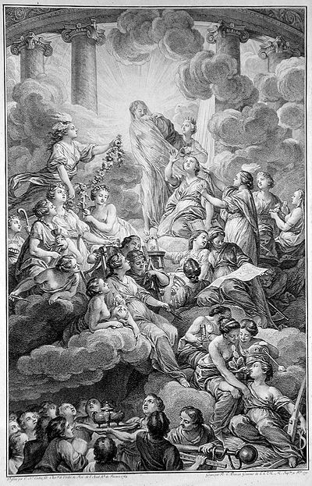

Frontispiece of the Encyclopédie, Diderot 1751

- After examining the above image, what symbolism does this illustration portray about the Encyclopédie?
  - It was a piece of literature that symbolized God and the angels in heaven
  - Readers could experience truth through the knowledge captured in the book
  - It represented the classical texts from Greece and Rome
  - There was a great deal of controversy involved with the information in the book

- From the illustration, which of the following is represented?
  - The exaltation of religious practice above personal discovery
  - Examination of different governmental roles as well as religious institutions
  - Principles of the Scientific Revolution as well as human institutions
  - Debate of the role of women in a society dominated by men

Political liberty is to be found only in moderate governments; and even in these it is not always found. It is there only when there is no abuse of power: but constant experience shows us that every man who is given power is likely to abuse it… To prevent this abuse, it is necessary, from the very nature of things, that power should be a check to power… To discover political liberty in a constitution, no great labor is required… In every government there are three sorts of power; the legislative; the executive… and the civil law [i.e. judicial].

The political liberty of a subject is a tranquility of mind arising from an opinion each person has of his own safety. In order to have this liberty, it is necessary that the government be so constituted that one man need not be afraid of another…there is no power if the judicial liberty is not separated from the legislative and the executive. If it is joined to the legislative, the life and liberty of the subject would be exposed to arbitrary control; for the judge would be the legislator as well. Were it joined to the executive power, the judge might behave with violence and oppression. There would be an end of everything if the same man or the same body were…to exercise those three powers; that of enacting laws, of carrying them out, and of trying individual cases.

- The Baron de Montesquieu, The Spirit of the Laws, 1748

- The author’s statement that…there is no liberty if the judicial power is not separated from the legislative and executive describes which of the following ideas?
- The executive branch of the government should be more powerful than the legislative and judicial branches.
- The right to life, liberty and property are basic rights of all citizens.
- The powers of government should be divided between its main branches.
- The best form of government is a constitutional monarchy.

- The author of the excerpt is describing his understanding of the government of which of the following countries?
- Holland
- The United States
- France
- Great Britain

Man is born free, and everywhere he is in chains. Many a one believes himself the master of others, and yet he is a greater slave than they.
To find a form of association which may defend and protect with the whole force of the community the person the property of all its members by means of which each, coalescing with all, may nevertheless obey only himself, and remain as free as before. Such is the fundamental problem of which the social contract furnished the solution. In short, each giving himself to all, gives himself to nobody… We see from this formula that the act of association contains a reciprocal (mutual) engagement between the public and individuals, and that every individual… is engaged in a double relation… the social pact… includes this engagement... that whoever refuses to obey the general will shall be constrained to do so by the whole body; which means nothing else than that he shall be forced to be free

- Jean Jacques Rousseau, The Social Contract, 1762

- Which of the following represents the author’s major view of society?
- All citizens, regardless of their gender or socio-economic status, should have the right to vote.
- Government isn’t the cause of, but rather the solution to, society’s ills.
- Society’s moral standards must be based on Christian principles.
- Man is born in a pure state of nature, but is corrupted by society.

- Which of the following statements least supports the author’s view?
- Individual desires should be subordinated to the perceived wishes of the group.
- The source of legitimate political authority is the social contract agreed to by all citizens for their mutual protection.
- Those who do not accept the general will must be forced to do what they ought to do, not what they want to do.
- The most important function of laws is to protect the private property of individuals.

- The author’s concept of the “general will” could be manipulated and used as a justification for which of the following?
- Laissez-faire economic policies
- A colonial empire
- Mercantilism
- Dictatorship

- Rousseau’s ideas in this excerpt are most like what other early modern thinker’s philosophy?
  - Adam Smith’s challenges to mercantilism through his espousal of free trade and a free market
  - Peter the Great’s, and later Catherine the Great’s, “westernization” of the political, religious, and cultural institutions of the Russian state
  - Voltaire’s development of new philosophies of deism, skepticism, and atheism
  - Locke’s argument that the state’s authority originated in the consent of the governed

Although, with Her Imperial Majesty’s permission, Jews may be elected as officials …, Jews are allotted fewer votes than other people and hence no Jew can ever attain office. Consequently, Jews have no one to defend them in courts and find themselves in a desperate situation—given their fear and ignorance of Russian—in case of misfortune, even if innocent. To consummate all the good already bestowed, Jews dare to petition that an equal number of electors be required from Jews as from others (or, at least, that in matters involving Jews and non-Jews, be present to accompany Jews in court, and attend the interrogation of Jews). But cases involving only Jews…should be handled solely in Jewish courts, because Jews assume obligations among themselves, make agreements and conclude all kinds of deals in the Jewish language and in accordance with Jewish rites and laws (which are not known to others).

- A petition from Belorussian Jews to Catherine the Great,
concerning her rule over Belorussia, 1780s

- The request that “cases involving only Jews…should be handled solely in Jewish courts” illustrates the fact that most European Jews during the Old Regime lived in separate communities known as
- concentration camps.
- communes.
- ghettos.
- confines.

- The excerpt above speaks to which of the following issues faced by many “Enlightened” monarchs such as Catherine the Great?
- They often faced resistance from their subjects, particularly minorities such as Jews
- enjoyed a good standard of living as a group.
- Despite espousing toleration, many of them did not practice it in their own kingdoms
- were active in most trades.

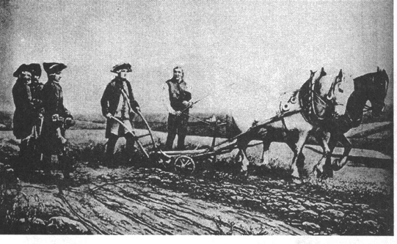

- The painting above depicts the Austrian Emperor Joseph II (1780-1790) as which of the following?
- a democratic representative of the common people.
- a ruler surveying conquered territories.
- an Enlightened monarch interested in methods of improving productivity.
- the "first servant of the state" who encouraged Enlightenment philosophes.

- Monarchs such as Joseph II and Catherine II made "enlightened" reforms as part of their drive to
- increase revenues and gain political support.
- give commoners more political power.
- begin the process of moving toward constitutional monarchy.
- do away with the nobility in their realms.

- Many Enlightenment thinkers had different perspectives of government power. Which of the following was the most likely to support Enlightened Despotism?
  - Rousseau
  - Locke
  - Voltaire
  - Beccaria

The poor laws of England tend to depress the general condition of the poor in these two ways. Their first obvious tendency is to increase population without increasing the food for its support. A poor man may marry with little or no prospect of being able to support a family in independence. They may be said therefore in some measure to create the poor which they maintain…. Secondly, the quantity of provisions consumed in workhouses upon a part of the society that cannot in general be considered as the most valuable part diminishes the shares that would otherwise belong to more industrious and more worthy members, and thus in the same manner forces more to become dependent…. Fortunately for England, a spirit of independence still remains among the peasantry. The poor laws are strongly calculated to eradicate this spirit.
- Thomas Malthus, Essay on the Principle of Population, 1798

- Which of the following would be most likely to support the ideas about the poor presented in the passage?
- Jean-Jacques Rousseau
- Robert Owen
- John Locke
- Adam Smith

- The above document reflects which of the following patterns that emerged in the 18th century?
- The constant threat of war in order to ensure “balance of power.”
- Competition over relief aid and welfare programs for the poor
- Rising population with not enough jobs or resources to survive
- Praising the peasantry for their good work and dedication

Let us now pay a visit to a house inhabited by prosperous peasants in about 1625… Propped against the wall, or hanging from it, there are various agricultural tools…. There are shelves bearing dishes, jugs, and the Bible. A spinning wheel dominates one corner of the room...[where] textiles are spun.

Urban growth was due predominantly to immigration, as the mortality rate in the city was higher than it was in the country. Such density of population encouraged the spread of illness.

Pots, pans, and cutlery were on the increase…. Many items cost less than they had in the past.
To confront a famine situation, people began growing plants which previously had been little cultivated in Europe, such as rice [and] maize was imported into Europe by Columbus in 1493. War encouraged the spread of the potato. In the sixteenth century [sugar] became a luxury seasoning. Tea became popular in England. In the second half of the seventeenth century the first coffee shops appeared.

- Rafaella Sarti, historian, “Material Conditions of Family Life,” 2001

- Which of the following was an important cause in the decline of famine in Europe in the 17th century?
  - The importation and transplantation of agricultural products from the Americas, which contributed to an increase in Europe’s food supply
  - The exchange of goods shifted Europe’s economic center of power from the Mediterranean to the Atlantic states, bringing the latter a wider variety of foods
  - The persistence of subsistence agriculture with three-crop field rotation in the north and two-crop rotation in the Mediterranean
  - The increase in the price of agricultural commodities as the population recovered to pre-Great Plague levels

- This excerpt best illustrates what economic transformation in European villages during the eighteenth century?
  - The putting-out system, or cottage industry, expanded as increasing numbers of laborers in homes produced for markets.
  - Labor and trade in commodities were increasingly freed from traditional restrictions imposed by corporate entities.
  - The development of the market economy led to new financial practices and institutions.
  - European states followed mercantilist policies by exploiting colonies in the New World and elsewhere.

- The consumption of goods such as tea, sugar, and coffee suggests that
  - the consumer revolution of the eighteenth century was shaped by the purchase of new goods for homes.
  - improved transportation increased the food supply.
  - new efficient methods of transportation during the Second Industrial Revolution increased consumerism.
  - overseas products and influences contributed to the development of a consumer culture in Europe.

- Which of the following was a significant cause of the urban population growth discussed in the excerpt?
  - City governments strained to provide protection and a healthy environment.
  - The Agricultural Revolution produced more food using fewer workers.
  - The rate of illegitimate births increased in the eighteenth century.
  - In the eighteenth century, plague disappeared as a major epidemic disease.

[Parliament] being now assembled in a full and free representation of this nation…asserting their ancient rights and liberties declare
That the pretended power of suspending the laws or the execution of laws by regal authority without consent of Parliament is illegal;
That the pretended power of dispensing with laws or execution of laws by regal authority without consent of Parliament is illegal….
That levying money for or to the use of the Crown by pretense of prerogative, without grant of Parliament is illegal
That the freedom of speech and debates or proceedings in Parliament ought not to be impeached or questioned in any court or place outside of Parliament….
That the raising or keeping a standing army within the kingdom in time of peace, unless it be with the consent of Parliament, is against the law.

- English Parliament, the Bill of Rights, 1689

- The time period reflected in the piece above places this document directly after which of the following events?
  - The Glorious Revolution
  - The French Revolution
  - The Agricultural Revolution
  - The English Civil War

- The excerpt above is most indicative of which of the following?
  - The idea that separation of powers was the most effective form of government.
  - Parliament’s willingness to extend political participation to the majority of English citizens.
  - A power-sharing compromise between Parliament and the English monarchy after the Glorious Revolution.
  - The triumph of Parliamentary supremacy in England in limiting royal power.

- Which two Enlightenment philosophes would have espoused similar beliefs expressed in the English Bill of Rights?
  - Rousseau and Voltaire
  - Hobbes and Locke
  - Locke and Montesquieu
  - Rousseau and Wollstonecraft

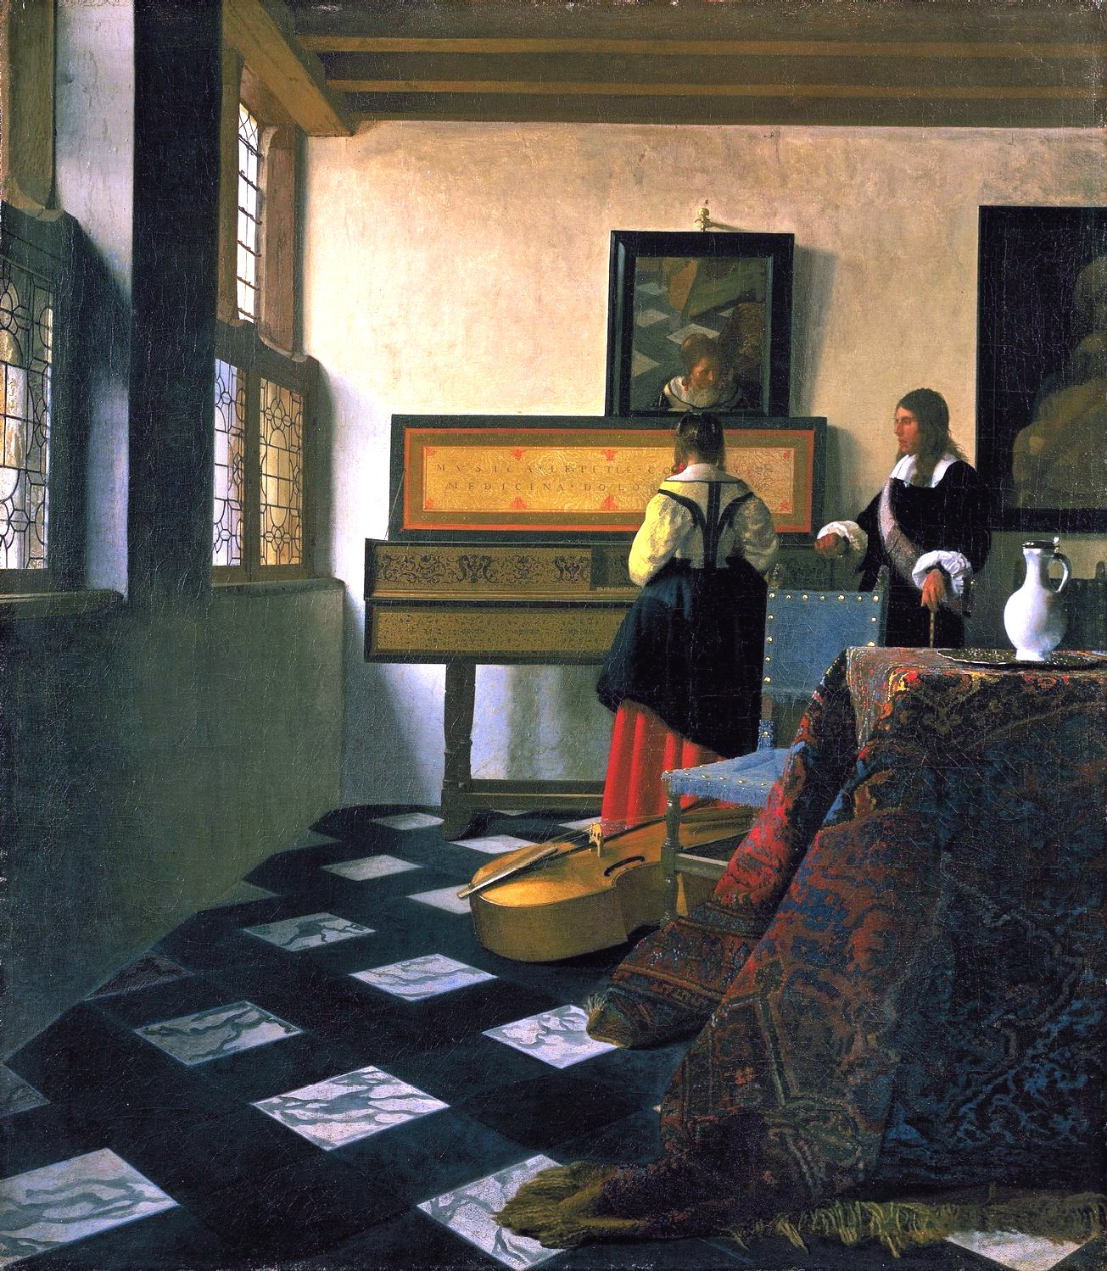

Johannes Vermeer, The Music Lesson, 1665

- The above painting most accurately can be attributed to which of the following artistic movements?
  - Dutch Golden Age
  - Mannerism
  - Rococo
  - Neoclassicism

- What quality of this painting sets it apart from the Baroque art of the same time period?
  - The geometric perspective
  - Peasant subject matter
  - It is secular in nature
  - Use of light

- Considering the use of perspective in this painting, the artists could have taken some inspiration from what other artistic movement?
  - Rococo
  - Renaissance
  - Mannerism
  - Romanticism

During the past two generations, the historical reputation of enlightened absolutism has undergone remarkable vicissitudes, above all in Anglo-American historical writing about later eighteenth-century Europe. It first rose to prominence during the 1930s, and for a generation thereafter was widely accepted among historians. By the 1960s, however, the tide was beginning to turn and the skeptics, who saw only the conventional aims of the state-building in these policies and regarded the enlightened professions which accompanied them as mere window-dressing, were gaining the ascendant. The critics of enlightened absolutism argued that few monarchs, and certainly none of the major rulers, could afford to adhere blindly to an enlightened blueprint and ignore, or even neglect, the demands of self-defense. The competitive states-system within which the great powers operated required large and powerful armies and administrative and fiscal systems to support them. These priorities pre-empted much of the scope for enlightened reform. Above all, critics of the notion of enlightened absolutism argued that the success of these initiatives was often incomplete and could, at times, be very limited indeed.

- H.M. Scott, “The Problem of Enlightened Absolutism,” 1990

- The historian above argues which of the following?
  - Several rulers in the 18th century adhered to Enlightenment thought, but in fact, did not know much about it
  - The idea of enlightened absolutism was a new idea starting in the 1930s and was previously completely unknown
  - Enlightened absolutism was a failure due to the realities of ruling the state in the 18th century.
  - Critics argued that enlightened absolutism was unsuccessful, but in reality, many rulers accomplished many goals aligned with Enlightenment thought.

- Which of the following factors would have prevented enlightened reform in the 18th century?
  - Peasantry
  - Bourgeoisie
  - Nobility
  - Royalty

- All of the following experimented with enlightened absolutism, except
  - Catherine the Great
  - Frederick II
  - Joseph II
  - Peter the Great

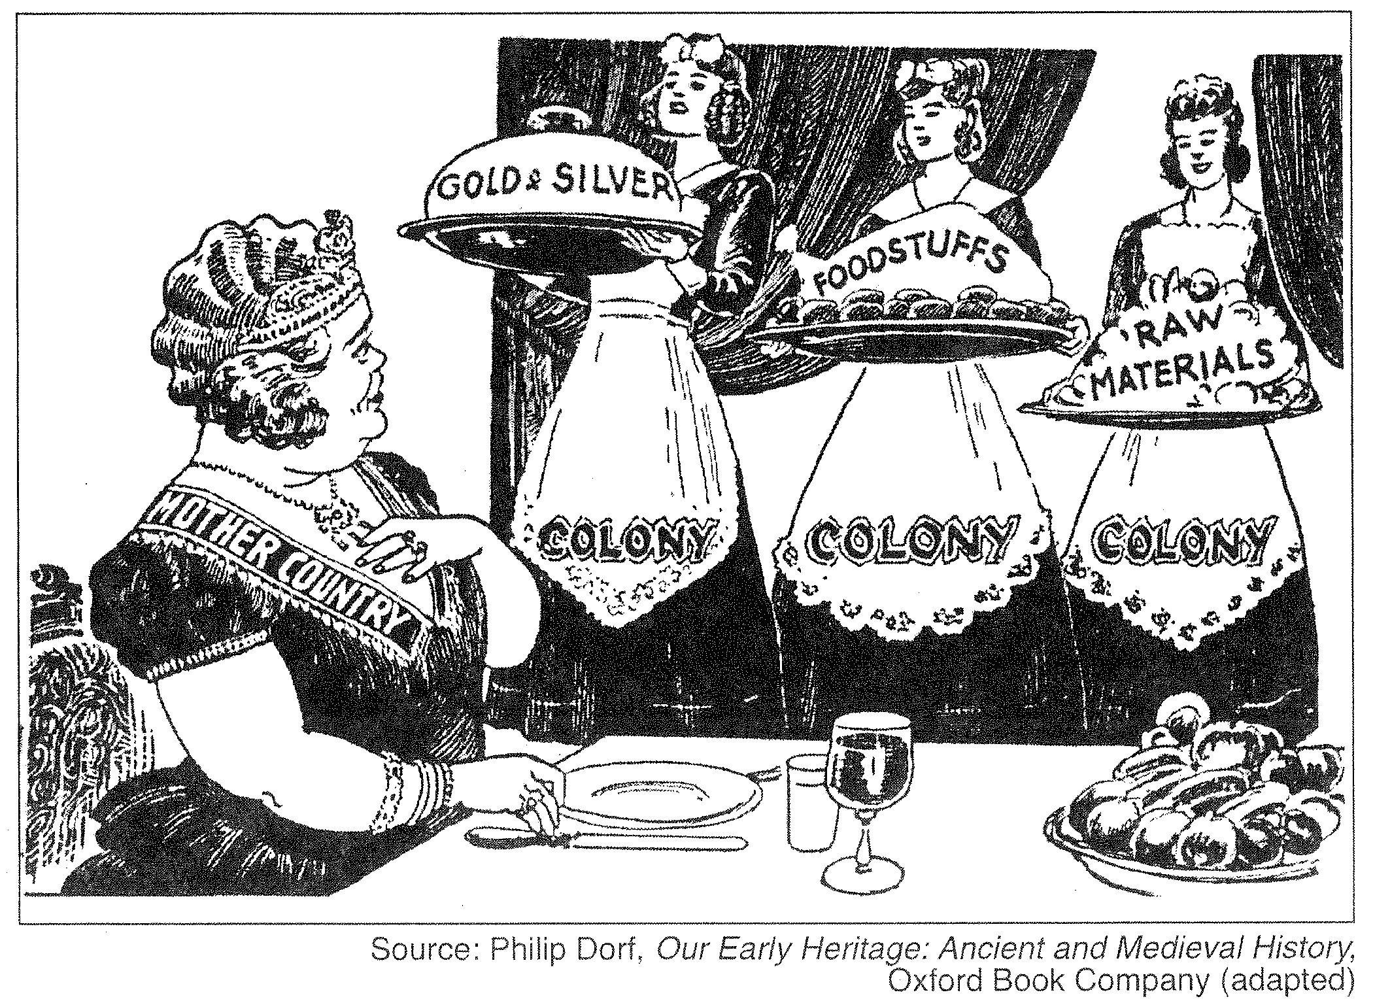

- The economic system depicted in the cartoon would most likely be supported the most by which of the following countries?
- Prussia
- Spain
- Russia
- Austria

- Followers of the economic system depicted in the cartoon believed that:
- rapid growth every fiscal year was possible and necessary.
- a stable economy was one that maintained its wealth, not allowing it to grow or decline.
- gold and silver had little real value.
- only modest levels of economic growth were possible.

- Under this economic system, colonies existed to provide markets and natural resources for the industries of the home country and in turn, the home country was to:
- do little or nothing.
- protect and govern the colonies.
- produce agricultural goods to supply the colonies.
- educate and Christianize the colonies.

- In the 18th century, this philosophy began to give way to which other economic practice?
  - Utopian socialism
  - Marxism
  - Free-market capitalism
  - Democratic socialism

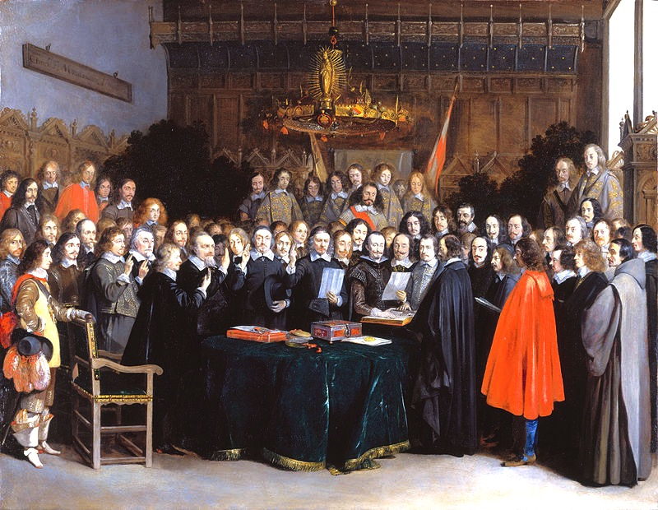
The Ratification of the Treaty of Münster, 15 May 1648 by Gerard ter Borch

- Which of the following figures is missing from the picture above, symbolizing a significant change in politics
  - Women
  - The pope
  - Weaponry
  - Cardinal Richelieu

- The signing of the above Treaty by the King of France and the Holy Roman Emperor ended a war that was most directly caused by which of the following?
- The attempt to control religious privileges in Bohemia
- The refusal to accept Maria Theresa as Holy Roman Empress
- The Peace of Augsburg in 1555 that denied religious freedom to Calvinists
- The Peasant Revolt in Germany advocating for better wages

- The Thirty Years War was considered a turning point for which of the following reasons
  - Technology, tactics, and strategies tipped the balance of power toward states able to marshal sufficient resources for the new military environment
  - Monarchies seeking enhanced power faced challenges from nobles who wished to retain traditional forms of shared governance and regional autonomy.
  - marked the effective end of the medieval ideal of universal Christendom, accelerated the decline of the Holy Roman Empire by grating local leaders control over religion
  - New Monarchies laid the foundation for the centralized modern state by establishing a monopoly on tax collection

- Which of the following was an effect of the Thirty Years War?
  - The Dutch Republic developed an oligarchy of urban gentry and rural landholders to promote trade and protect traditional rights
  - There were frequent conflicts over power, and Prussia rose to power, which in turn lead to the Habsburgs, centered in Austria, shifting their empire eastward
  - The inability of the Polish monarchy to consolidate its authority over the nobility led to Poland’s partition
  - Catherin the Great rose to power and successfully implemented reforms

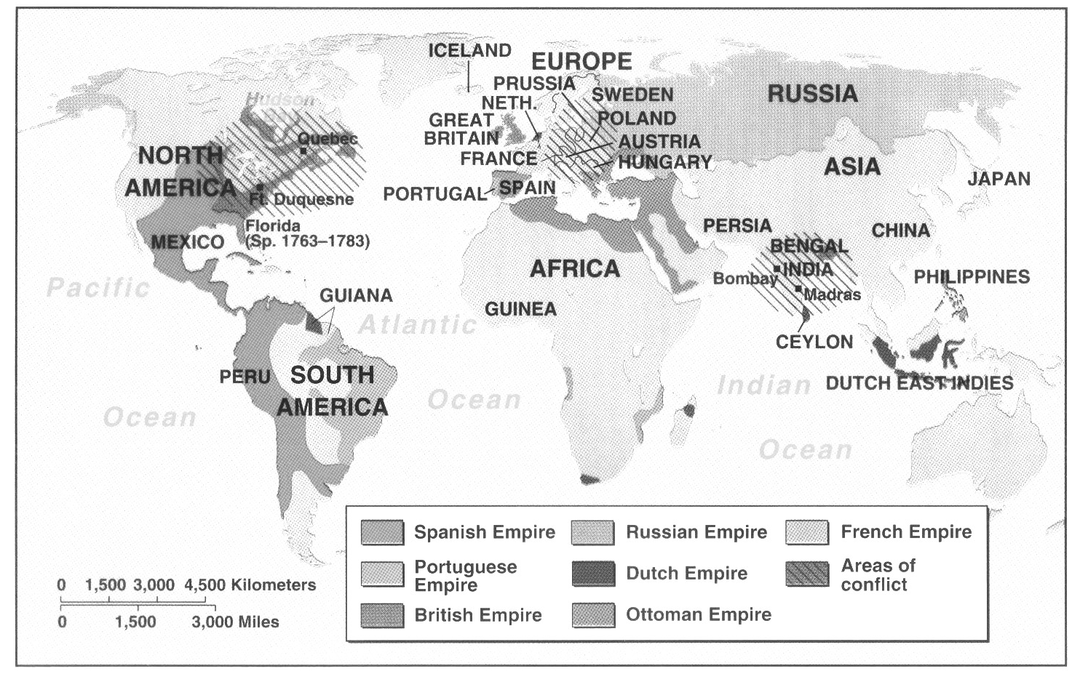

- The above map depicts a war that was considered to be a continuation of which of the following previous conflicts?
  - War of Spanish Succession
  - War of Austrian Succession
  - The Thirty Years War
  - The English Civil War

- After examining the map, the conclusion can be made that
  - Colonial trade opened up for most European empires in the 18th century
  - Warfare in India resulted in the reduction of the British empire overall
  - Rivalry between Britain and France resulted in world wars fought both in Europe and in the colonies
  - France emerged as a powerful trading force due to their victory in the French and Indian War

