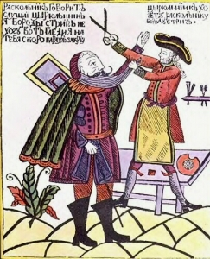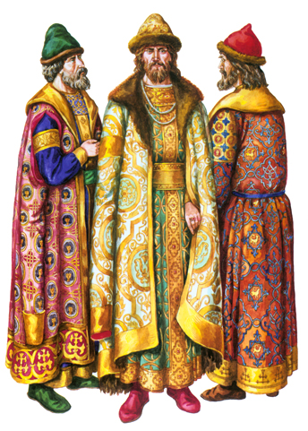
- Make a list of 5-7 words that summarize the reign of Peter the Great the best.
“Old Believers”
Peter the Great
Strelski
Great Northern War
“Window on the West”
Table of Ranks
St. Petersburg
Winter Palace
Russian Navy

- Describe Russia prior to Peter.
- Any questions about Peter- ????
- Make a list of Peter’s effect on Russia and his policies and analyze and evaluate each reform
Reform ( describe) | Analyze (why did he do this?) | Evaluate ( How good or bad?)
War against Sweden/
Build St. Petersburg

Compare and contrast the goals and major policies of Louis XIV of France (1654-1715) with those of Peter the Great of Russia (ruled 1682-1725).

