EXPLORATION
Europeans explored and settled overseas territories, encountering and interacting with indigenous populations
European nations were driven by commercial and religious motives to explore overseas territories and establish colonies. (God, Glory and Gold)
A. European states sought direct access to gold and spices and luxury goods as a means to enhance personal wealth and state power.
B. The rise of mercantilism gave the state a new role in promoting commercial development and the acquisition of colonies overseas.
C. Christianity served as a stimulus for exploration as governments and religious authorities sought to spread the faith and counter Islam, and as a justification for the physical and cultural subjugation of indigenous civilizations.
D. Exploration was a major era of history that brought change to all aspects of European life (PERSIA)
- Explain how the following technologies were important to the period of Exploration.
- Analyze the changes in European society that were needed to create the following technologies.
- Compass
- Stern-post rudder
- Mapping (creation of Latitude and Longitude)
- Quadrant and astrolabe
- Lateen rig
- Horses
- Guns and gunpowder

Section Five—Voyages of Discovery and the New Empires in the West and East  Section Overview  - Discovery of the Americas expanded European horizons both intellectually and geographically  - Mineral and human wealth set in motion the engines of capitalism and trade shifted from the Mediterranean and Baltic areas to the Atlantic seaboard  The Portuguese Chart the Course  - Prince Henry the Navigator, conquered Ceuta(N. Africa)  - He was in search of gold, slaves, and also launched missionary efforts here to save the Muslims  - Portuguese ships delivered over 150,000 slaves to Europe in the second half of the fifteenth century  - Henry searched for a safe route around the tip of Africa to Asia’s spice market  - Cloves and pepper were the most sought after spices  - Causes: limited supply of spices  - Bartholomew Dias was the first Portuguese explorer to sail around the Cape of Good Hope in 1487  - Vasco da Gama sailed all the way to India and returned with a vessel filled with spices worth 60X the cost of the voyage  - The Portuguese established colonies in India (Calcutta and Goa)  The Spanish Voyages of Columbus  - Portuguese explored- east on India,  - Spanish sought a faster route to the east, and access to the spice trade, by sailing west across the Atlantic  - Columbus’ first (33 days) he landed in San Salvador in the eastern Bahamas, he thought he had landed on an outer island of Japan  - Not until his third voyage to the Caribbean in 1498 did he realize Cuba was not Japan and South America was not China  - Believing he landed in the East Indies, Columbus called the Taino Indians—Indians  - Amerigo Vespucci and Ferdinand Magellan explored the coastline of South America  - Magellan first to circumnavigate the globe (killed in the Philippines)  - Intended and unintended consequences (C & E)  - The Spanish launched a series of wars of conquests, along with missionary efforts, against the native people of the Americas  - Gold and silver extracted from Spain’s colonies in America helped ignite a period of economic expansion in Europe  - This finance Spain’s wars of religion in the sixteenth and seventeenth centuries  - American Indian population were devastated by the epidemics of measles and smallpox that the Europeans returned to Europe with a deadly strand of syphilis  - Spanish left an imprint of Roman Catholicism, economic dependency, and hierarchical social structure, all still visible today  Colombian Exchange  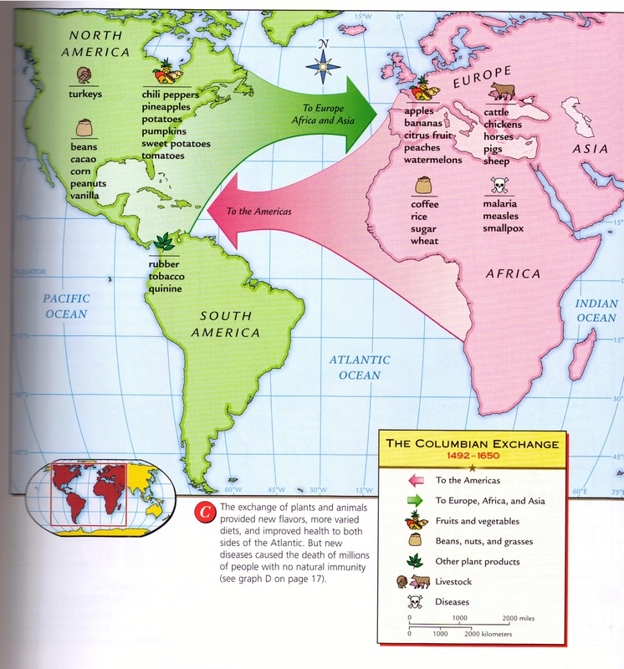  The Spanish Empire in the New World  - Spanish Conquests of the Aztecs in Mexico  - The Aztecs ruled all of Central America until Hernan Cortes (Conquistador)arrived in 1519  - Cortes arrived with five hundred men and a few horses, was initially believed to be the god  - Cortes, sacked Aztec capital, Spanish Conquests of the Incas in Peru  - Incas controlled an enormous empire in the highlands of Peru  - Francisco Pizarro landed on the western coast of South America with a group of 200 men  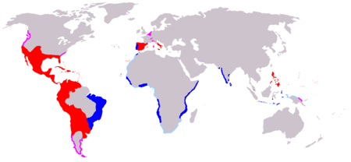  The Church in Spanish America  Missionaries accompanied the earliest explorers and conquerors and attempted to convert Europeans to Christianity, and brought with them European style of education and civilization  - Dominican missionary, Bartolome de Las Casas was outspoken about the poor treatment of natives; he also believed that conquests was not necessary for conversion  - The colonial Church prospered in the New World  - The Church became a great landowner in the new world as it was given large tracts of land by the crown  The Economy of Exploitation  - Mining  - Conquistadores set up gold and silver mines—Potosi in Peru  - Forced natives to labor in the mines  - Agriculture  - The Feudal system was set up in the New World.  - Labor Servitude  - Encomienda—a formal grant of the rights to the labor of a specific number of Indians for a designated period of time  - Debt peonage—free Indian laborers were required to purchase goods from the landowner of mine owner, to whom they became forever indebted; this practice lasted well into the twentieth century  - Effect: The native population of Mexico was reduced from 25 million to 2 million in 100 years  The Impact of Europe  - Columbus’s discovery demonstrated the new knowledge existed, plus proved some old teachings dead wrong (Paradigm Shift)  - Enlightenment philosophers compared Columbus’s discovery of the New World to the invention of the printing press in terms of their statuses as world historic events  - New wealth enabled governments and private entrepreneurs to sponsor research and expansion in printing, shipping, mining, textile, and weapons industry  - Whenever possible, entrepreneurs established monopolies ( Commercial Revolution- started)  - New industries disrupted the traditional social divisions and this made the way for the Reformation by making people critical of all traditional institutions (Social, Political, Economic upheaval) | 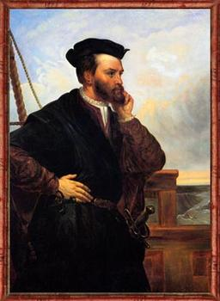  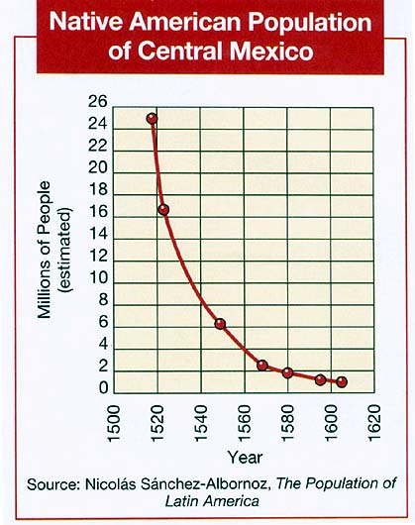  Colombian Exchange  Explain the effects on the Columbian Exchange on European nation-states and on the population of Europe.  A. The exchange of goods shifted the center of economic power in Europe from the  Mediterranean to the Atlantic states and brought the latter into an expanding  world economy.  B. The exchange of new plants, animals, and diseases — the Columbian Exchange  — created economic opportunities for Europeans and facilitated European  subjugation and destruction of indigenous peoples, particularly in the Americas.  Impact???

