AP EUROPEAN HISTORY TEST 1
(Renaissance and Exploration)
Time – 26 minutes
Source materials have been edited for the purpose of this exercise.

Questions 1 – 3 refer to the passage below.

“I would have him more than passably learned in letters, at least in those studies which we call the humanities. Let him be conversant not only with the Latin language, but with Greek as well, because of the abundance and variety of things that are so divinely written therein. Let him be versed in the poets, as well as in the orators and the historians, and let him be practiced also in writing verse and prose, especially in our own vernacular; for, beside the personal satisfaction he will take in this, in this way he will never want for pleasant entertainment with the ladies, who are usually fond of such things.”

“… And to repeat briefly a part of what has already been said. I wish this Lady to have knowledge of letters, of music, or painting, and know how to dance and how to be festive, adding a discreet modesty and the giving of good impression of herself to those other things that have been required of the Courtier. And so, in her talk, her laughter, her play, her jesting, in short in everything, she will be most graceful and will converse appropriately with every person in whose company she may happen to be, using witticisms and pleasantries that are becoming to her.”
- Balsassare Castiglione, The Book of the Courtier, 1508-1516

1. The ideas about education expressed by Castiglione in the above passages are most consistent with which of the following?
- The Italian Renaissance humanists’ focus on the study of divinity
- The Italian Renaissance humanists’ focus on the study of classical literature
- The increase in equal educational opportunities for women during the Italian Renaissance
- Humanist admiration for Greek and Roman political institutions

2. The sentiments expressed in the passages would have been most influenced by:
- European exploration and settlements of overseas territories in the fifteenth and sixteenth centuries
- the growth of mercantilist policies during the fifteenth and sixteenth centuries
- writings of Christian humanists such as Erasmus
- the invention of the printing press in the 1450s

3. The ideas expressed by Castiglione in the passages most directly support which of the following ideals regarding women during the Italian Renaissance?
- Most Renaissance humanists believed that it was not proper for educated women to serve in the same roles as educated men
- Most Renaissance humanists believed that men and women should have similar roles in society
- Most Renaissance humanists believed that men and women should have equal access to a classical education
- Most Renaissance humanists believed that women should have an increased role in the arts

Questions 4 – 6 refer to the passage below.

“Ferdinand and Isabella resumed the Reconquista, dormant for more than 200 years, and in 1492 they captured Granada, earning for themselves the title of Catholic Kings. Once Islamic Spain had ceased to exist, attention turned to the internal threat posed by hundreds of thousands of Muslims living in the recently incorporated Granada. ‘Spanish society drove itself,’ historian J. H. Elliot writes, ‘on a ruthless, ultimately self-defeating quest for an unattainable purity.’

Everywhere in sixteenth-century Europe, it was assumed that religious unity was necessary for political unity, but only in Spain was there such a sense of urgency in enforcing religious conformity. Spain’s population was more heterogeneous than that of any other European nation, and it contained significant non-Christian communities. Several of these communities, including in particular some in Granada, harbored a significant element of doubtful loyalty. Moriscos (Granada Muslims) were given the choice of voluntary exile or conversion to Christianity. Many Jews converted to Christianity, and some of these Conversos filled important government and ecclesiastical posts in Castile and in Aragon for more than 100 years.”
- Eric Solsten and Sandra W. Meditz, editors, Spain: A Country Study, 1988

4. According to the excerpt above, Ferdinand and Isabella felt that in order to create a centralized modern state, they must:
- enforce tax collection on all subjects
- build a strong military
- create religious uniformity
- dispense justice to their subjects

5. According to Solsten and Meditz, how was Spain different from most other European nations?
- Spain had a weak system of taxation
- Religious conflicts had become a basis for challenging monarchial control in Spain
- There was more religious plurality in Spain than elsewhere on the continent
- Issues of religious reform had increased conflicts between the monarchy and the nobles in Spain

6. Which of the following would also be considered a major achievement of the Spanish monarchy in the late fifteenth and early sixteenth century?
- The Spanish established colonies across the Americas, the Caribbean, and the Pacific
- The Spanish competed for trade with the other European powers
- The Spanish established a commercial network along the African coast
- The Spanish Habsburgs rulers were able to restore Catholic unity across Europe

Questions 7 – 8 refer to the chart below.

New Exchanges in the Columbian Exchange
From the Americas:
beans, squash, tomatoes, sweet potatoes, peanuts, chilies, chocolate, corn, potatoes, avocadoes, pineapples, manioc, syphilis

From the Eastern Hemisphere:
wheat, rice, olives grapes, bananas, rice, citrus fruits, melons, figs, sugar, coconuts, okra, horses, cattle pigs, sheep, goats, chickens, rabbits, rats, smallpox

7. An important demographic change that occurred as a direct result of the exchange illustrated above was that:
- death rates among Amerindians rapidly increased, killing much of the population
- the Americas were overcrowded by the end of the sixteenth century
- much more intermarriage between Amerindians and Europeans occurred in North America than in Latin America
- labor systems in the Americas were highly dependent on slavery

8. Which of the following was a positive consequence of the Columbian Exchange, apparent by the late seventeenth century?
- Many diseases became much less commonplace than they had been before
- Many domesticated animals native to North America were brought to Europe, Africa, and Asia
- The variety of available food increased, giving people wider access to an assortment of nutrients
- Antagonisms among European countries decreased, since all had access to new wealth

Questions 9 – 11 refer to the following map.

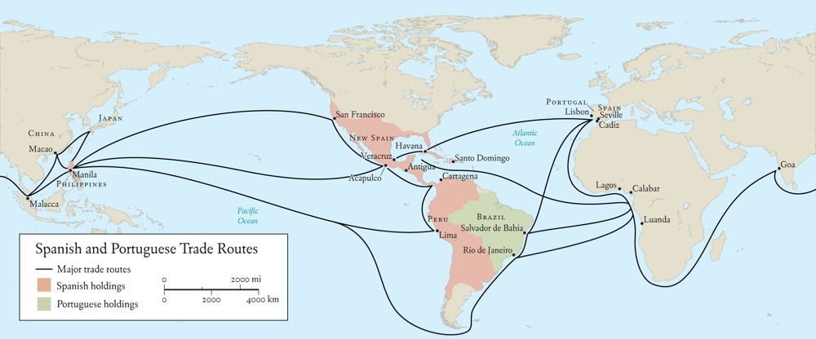

9. Portuguese exploration in the fifteenth and sixteenth centuries was aided by all of the following except:
- Prince Henry the Navigator’s sponsorship of explorers who traveled the coast of Africa
- the search for gold and wealth
- the desire to spread Christianity and establish a friendly ally against the Muslims
- the desire to catch up with Spanish explorers who had gained an early advantage by being the first to launch voyages of exploration

10. All of the following are important results of Spanish control of Potosi except:
- the Portuguese began to extend their South American empire, quickly claiming large amounts of land in the center of the continent
- the influx of precious metals stimulated high inflation, contributing to the price revolution of the sixteenth century
- native labor was drafted to work in the silver mines
- the Potosi mines provided large amounts of silver to the Spanish economy

11. Which of the following was an important reason that the Spanish controlled more land in the Americas than the Portuguese?
- The Spanish bribed the natives with foodstuffs from Europe and made treaties with many native tribes that granted the Spanish control of their lands
- The Portuguese and Spanish respected the line of demarcation created by the Treaty of Tordisillas and concentrated their efforts in different regions to avoid a conflict
- The Portuguese had inferior firearms and were unable to subdue most of the natives in the Americas
- The Spanish defeated the Portuguese in Brazil to take control of most of South America

Questions 12 – 14 refer to the following passage.

“At last the best of artisans [God] ordained that the creature to whom He had been able to give nothing proper to himself should have joint possession of whatever had been able to give nothing proper to himself should have joint possession of whatever had been peculiar to each of the different kinds of being. He therefore took man as a creature of indeterminate nature, and assigning him a place in the middle of the world, addressed him thus: ‘Neither a fixed abode nor a form that is yours alone nor any function peculiar to yourself have we given you, Adam, to the end that according to your longing and according to your judgment you may have and possess what abode, what form, and what functions you yourself desire. The nature of all other beings is limited and constrained within the bounds of law prescribed by Us. You, constrained by no limits, in accordance with your own free will, in whose hand We have placed you, shall ordain for yourself the limits of your nature. We have set you at the world’s center that you may from there more easily observe whatever is in the world. We have made you neither of heaven nor of earth, neither mortal nor immortal, so that with freedom of choice and with honor, as though the maker and molder of yourself, you may fashion yourself whatever shape you shall prefer. You shall have the power to degenerate into the lower forms of life, which are brutish. You shall have the power, out of your soul’s judgment, to be reborn into the higher forms, which are divine.’”
- Pico della Mirandola, Oration on the Dignity of Man, 1486

12. In the Oration on the Dignity of Man, Pico della Mirandola made which of the following claims?
- Man was created by God and owes complete allegiance to the Church
- Man is an amazing creature with unlimited power
- Man is a limited creature who can never fully understand the world
- Man’s thinking is wholly controlled by the Church

13. Who among the following would most likely have supported the argument of Pico della Mirandola?
- a humanist
- a clergyman
- a nobleman
- a peasant

14. Pico della Mirandola would most likely have disapproved of which of the following?
- humanist education
- individualism
- clerical educational curriculum
- civic humanism

Questions 15 – 17 refer to the following passage.

“First and foremost, then, the document stated the city of Kinsay to be so great that it hath a hundred miles of compass. And there are in it twelve thousand bridges of stone, for the most part so lofty that a great fleet could pass beneath them…
The document aforesaid also state that the number and wealth of the merchants, and the amount of goods that passed through their hands, was so enormous that no man could form a just estimate thereof…
All the streets are paved with stone or brick…
In this part [of the city] are ten principal markets, though besides these there are a vast number of others … there is always an ample supply of every kind of meat and game, as of roebuck, reddeer, fallow-deer, hares, rabbits, partridges, pheasants, francolins, quails, fowls, capons, and of ducks and geese an infinite quantity…
Those markets make a daily display of every kind of vegetables and fruits; and among the latter there are in particular certain pears of enormous size, weighing as much as then pounds apiece…
Now Messer Marco heard it stated by one of the Great Khan’s officers of customs that the quantity of pepper introduced daily for consumption into the city of Kinsay amounted to 43 loads, each load being equal to 223 lbs.
The houses of the citizens are well built and elaborately finished; and the delight they take in decoration, in painting and in architecture, leads them to spend in this way sums of money that would astonish you.”
- The Travels of Marco Polo, c.1300

15. Which of the following was an important impact of the distribution of The Travels of Marco Polo?
- Europeans began to fear the dangers of traveling to foreign lands
- Europeans began to wish they could travel to foreign lands
- Europeans desired the wealth of foreign lands such as China
- Europeans began to believe that exploration was too dangerous and did not support it

16. All of the following were motives for European exploration of the New World except:
- descriptions of Asia by medieval European travelers appealed to merchants
- the hope of economic gain appealed to Europeans
- the desire to Christianize the natives led missionaries to take an interest in the New World
- the desire to take over more land for agricultural purposes appealed to European farmers

17. Which of the following was an important result of the popularity of travel literature, such as The Travels of Marco Polo?
- Europeans began to establish colonial empires in China
- Europeans began to expand the Silk Road
- Europeans increased trade with China
- rich Europeans began to travel to China in large numbers

Questions 18 – 20 refer to the passage below.

“Here the question arises; whether it is better to be loved than feared or feared than loved. The answer is that it would be desirable to be both but, since that is difficult, it is much safer to be feared than to be loved, if one must choose. For on men in general this observation may be made: they are ungrateful, fickle, and deceitful, eager to avoid dangers, and avid for gain, and while you are useful to them they are all with you, offering you their blood, their property, their lives, and their sons so long as danger is remote… but when it approaches they turn on you. Any prince, trusting only in their words and having no other preparations made, will fall to his ruin… Men have less hesitation in offending a man who is loved than one who is feared, for love is held by a bond of obligation which, as men are wicked, is broken whenever personal advantage suggests it, but fear is accompanied by the dread of punishment which never relaxes.”
- Machiavelli, The Prince (1513)

18. The author of the passage, Niccolo Machiavelli, is one of the most famous sixteenth century writers most directly influenced by:
- scholasticism
- skepticism
- Renaissance humanism
- dualism

19. In the passage above, the main subject that the author is addressing is:
- relationships within the family
- political leadership
- sea-based power vs. land-based power
- political vs. religious power

20. Which of the following is the most important assumption that Machiavelli based his observations on?
- The building of states and political authority are goals in themselves, separate from religion.
- Religion and family shape the nature of political institutions.
- Only state with both powerful navies and armies can be successful.
- Political leaders must always be subject to religious leaders, and moral principles should shape political decisions.

Questions 21 – 23 refer to the following map.

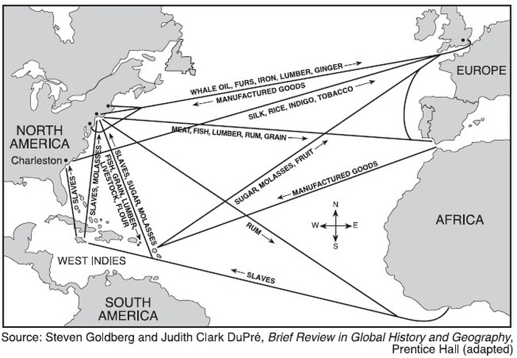
21. The map above shows a system of trade known as the:
- Columbian Exchange
- price revolution
- triangular trade
- encomienda system

22. The turning point that prompted the importation of large numbers of slave from West Africa to Brazil and the Caribbean was:
- the foundation of permanent colonies in North America by the British and the French
- the growth of cane sugar plantations in the New World
- the growth of tobacco plantations in the New World
- the foundation of the encomienda system

23. The slave trade caused all of the following except:
- great unity among Africans, as all wanted to avoid being captured by European slave traders
- increased warfare and violence among some African tribes
- the influx of European manufactured goods, which undermined the native system of production in many African communities
- the depopulation of some coastal regions of Africa

Questions 24 – 26 refer to the passage below.

This selection is taken from the letters of a Florentine matron, Alessandra of the illustrious Strozzi family, to her son Filippo in Naples. The family’s considerations for marriage were complicated by the fact that the son was in exile.

[April 20, 1464] . . . Concerning the matter of a wife [for you], it appears to me that if Francesco di Messer Tanagli wishes to give his daughter, that it would be a fine marriage. . . . Now I will speak with Marco [Parenti, Alessandra’s son-in-law], to see if there are other prospects that would be better, and if there are none, then we will learn if he wishes to give her [in marriage]. . . You may ask: ‘‘Why should he give her to someone in exile?’’ ...First, there aren’t many young men of good family who have both virtue and property. Second, she has only a small dowry, 1,000 florins, which is the dowry of an artisan . . . Third, I believe that he will give her away, because he has a large family and he will need help to settle them. . .

[August 31, 1465] . . . I have recently received some very favorable information [about the Tanagli girl] from two individuals. . . . They are in agreement that whoever gets her will be content. . . . Concerning her beauty, they told me what I had already seen, that she is attractive and well-proportioned. Her face is long, but I couldn’t look directly into her face, since she appeared to be aware that I was examining her . . . and so she turned away from me like the wind. . . . She reads quite well...and she can dance and sing....

24. The passage above, most clearly shows the influence of which of the following trends in fifteenth-century Italy?
- The growth of the concept of the “Renaissance Man”
- Renaissance attitudes regarding an “ideal women”
- The growing concept of marriage based on love
- The growing input of daughters in decisions regarding their marriage
25. Based on the above passage, it can be assumed that Francesco di Messer is a member of which Renaissance Social class?
  - Nobleman
  - Patrician
  - Petty-Burgher
  - Property-less worker

26. An historian could best use this letter as evidence for which of the following features of Renaissance social expectations?
- Young men were expected to marry up, above the level of their own social class
- A young woman in Renaissance Italy without a large dowry had fewer marriage options
- A young woman in Renaissance Italy always married above the level of her own social class
- Emotional compatibility was the most important factor in determining marriage partners in Renaissance Italy

 | b | 14 | c
 | d | 15 | b
 | a | 16 | d
 | C | 17 | c
 | c | 18 | c
 | a | 19 | b
 | A | 20 | a
 | c | 21 | c
 | d | 22 | b
 | a | 23 | a
 | b | 24 | b
 | b | 25 | c
 | a | 26 | b

SECTION I, Part B
Time – 50 minutes
4 Questions

Direction: Answer all parts of every question. Use complete sentences; an outline or bulleted list alone is not acceptable. Sources have been edited for the purpose of this exercise.

- Answer all parts of the question that follows.

The 19th-century Swiss historian Jacob Burckhardt portrayed the Italian Renaissance as the “birthplace of the modern world” where “man became a spiritual individual, and recognized himself as such.”

A. Provide TWO specific pieces of evidence that supports this characterization of the period and explain how they support it.

B. Provide ONE specific piece of evidence that undermines this characterization of the period and explain how it undermines it.

Use the fresco below, Delivery of the Keys (circa 1481-1482) by Italian painter Pietro Perugino, to answer all parts of the question that follows.

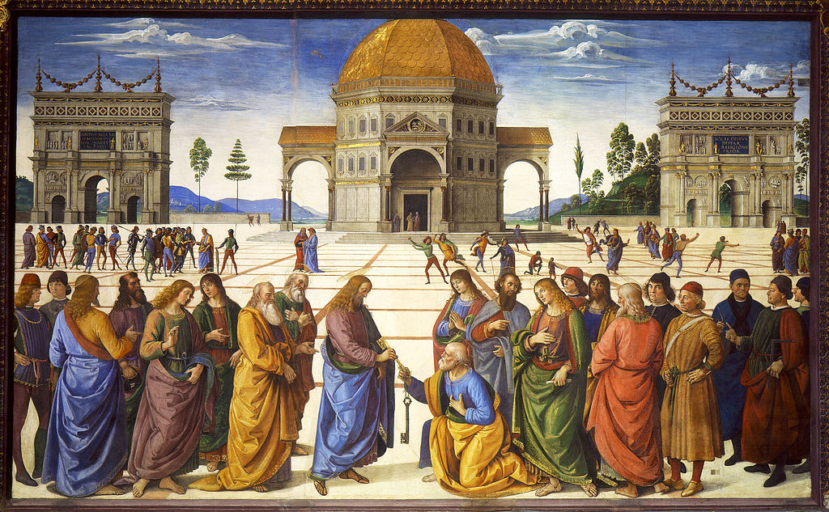

- A. Briefly analyze how the subject of this fresco reflects artistic trends in fifteenth-century Europe.

B. Based on the painting and your knowledge of European history, briefly analyze TWO features of Renaissance values in the fifteenth century reflected in this painting.

- Using your knowledge of European history, answer parts A, B, and C.

A. Briefly explain ONE important difference between medieval and Renaissance political organizations.

B. Briefly explain ONE important difference between medieval and Renaissance social organizations.

C. Briefly analyze ONE factor that accounts for the difference you identified in Part B.

- Using your knowledge of European history, answer parts A, B, and C.

A. Briefly explain TWO effects on the European economy during the sixteenth and seventeenth centuries brought about by the Age of Exploration.

B. Briefly explain ONE effect on European society during the sixteenth and seventeenth centuries brought about by the Age of Exploration

