Name ___________________________ agenda, WWI and New governments systems (chapters 25-27)
2/27 | 28 | 3/1 | 3/2 | 3/3
Chapter 25 Test  Who’s to blame?  Seminar | Bell- Cause/ effect  The Allies won, Why? | WWI DBQ Skills | Disillusionment, and Society  Effect of WWI | Treaty of Versailles Evaluation
Homework
Question # 1 below  WWI Causes (Causation Skills)  Paragraph | WWI DBQ Skills and outline  Effects of WWI | SAQ Practice | Treaty of Versailles Evaluation  One paragraph:  Compare to COV | Feminism-  777-780, 821-824  Role of Women and the Home front
3/6 | 3/7 | 3/8 | 3/9 | 3/10
Impact on WWI  Women, Feminism in the 19th and 20th Century | DBQ –assessment  Maybe Russian Rev Video | Quiz: Kagan 854-858  Russian Revolutions: Causes- Timeline | SAQ- Quiz  Lenin Case Study  Russian Revolution Seminar | SAQ TEST- WWI- Russian Revolution
If absent check the weebly- WWI page  DBQ Planning/ write  Self assessment | Kagan 854-858  SAQ Practice | Hw 876-886  Seminar Questions  Russian Revolution- review
# 1 Analyze major causes of World War I. (this should take up half a page in your notebook.) - Short the vocabulary list above into the boxes below, be prepared to provide evidence to support each of the topics below were causes of WWI.
Militarism | Alliances | Industrialization | Nationalism | Imperialism | Assassination of AD FF
#2 Graphic Organizer Compare with the French Revolution with the Russian Revolution- See the Back
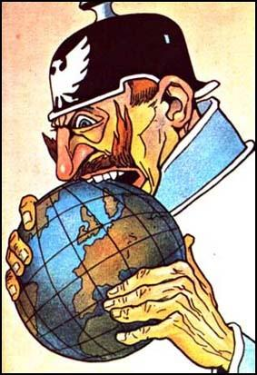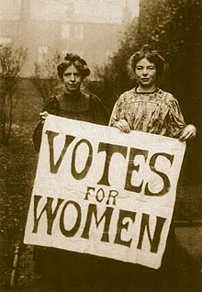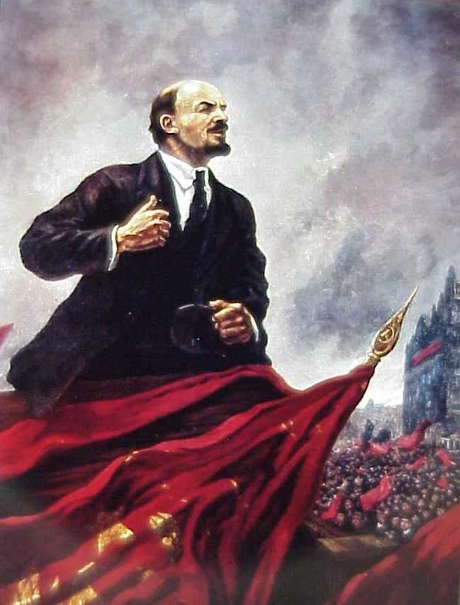
Russian Revolution
Alexander II& III  Emancipation Act, 1861  “Autocracy, Orthodoxy, Russification”  pogroms  Count S. Y. Witte  Nicholas II  Russo-Japanese War  “Bloody Sunday”  Revolution of 1905  Duma  Vladimir Lenin  Bolsheviks | Leon Trotsky  Provisional Government  Petrograd Soviet  Army Order No. 1  April Theses  October Revolution  Red Army  Treaty of Brest-Litovsk, 1918  Russian Civil War  “war communism”  Union of Soviet Socialist Republics (USSR | - Analyze major causes of the Russian Revolution.  - How did the Bolshevik revolution pose a challenge to the rest of Europe?  - How did Lenin and the Bolsheviks rule the new Soviet Union?  - What was War Communism?  - What was Lenin’s New Economic Policy (NEP)? Why did Lenin institute the New Economic Policy? Was it successful?  - Could the Russian Revolution have succeeded without Lenin?  - What were the ideological differences between Trotsky and Stalin?  - Why did Stalin, and not Trotsky, emerge as Lenin’s successor?  - How did Stalin gain his power?  - What were his strengths and weaknesses?  - How did the Bolshevik revolution result in the split of the socialist parties in Western Europe?

Crane Briton- Model of Political Revolution
French Revolution and Napoleon | Model of Political Revolution | Russian Revolution- Bolshevik Rev.
 | Writers
 | Riots
 | Reformers
 | Former Rulers
 | Radicals
 | Return to Normalcy
 | Rise of Imperialism

