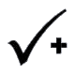 |  | 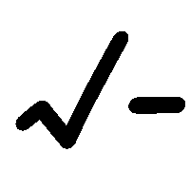
Name __________________________ Two Point Activity
- Crossword puzzle- used at least 10 of our vocabulary terms (Handout Graph paper)

Across | Down

Puzzle

