Name ___________________________ December 14- 23 Imperialism Part 1
Email: Panderson@albany.K12.ny.us  Homework- (Parent Signature) In an attempt to have greater connection between school and home, I’m asking for students and parents to sit down discuss expectations and homework. This agenda is available at http://ahsanderson.weebly.com/ _______5 pts |  | 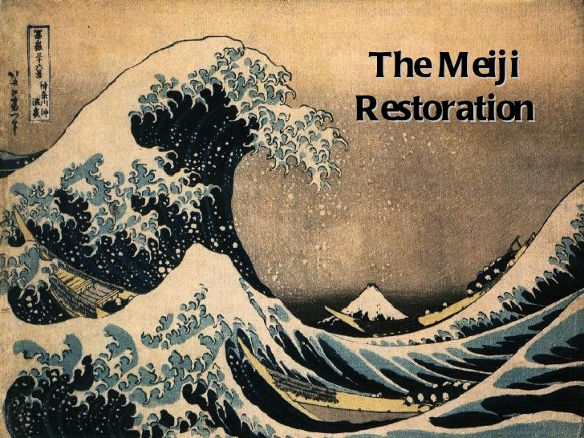
Parent Signature_________________________
Class activities | Objectives: I will be able to explain.
Monday: 12/14  Review of Industrial Revolution-  - CFA # 9- Vocabulary  - Essay Outline (Thematic- Thinkers)  Start Imperialism  Homework:  Unit vocabulary Chapter 28 (pages 714- 723) | 1. define the terms of the Industrial Revolution  2. Outline a thematic essay with an analytical thesis.
Tuesday:  - Essay Review and assessment  Homework:  - Make essay corrections due Friday  - Read and outline 28.1 China responds to Pressure from the West ( 715-719) | 1. Accurately access my DBQ essay using a New York State Rubric.
Wednesday  - OPEN NOTE QUIZ- 28.1 China responds to Pressure from the West ( 715-719)  - timeline activity  Homework: To be determined | 1. Examine the social, economic, and political motivations for European Imperialism throughout the world.  2. Explain how China was able to resist Europeans  3. Evaluate the impact of Imperialism on China using SPICE
Thursday  - Opium DBQ  Homework:  - Complete writing with the use of OSI and analysis | 1. Analyze the impact of the opium trade on China society.  2. What were the social, political and economic characteristics of the new imperialism?
Friday
- Opium War Video ( Maybe)
- Vocabulary/ objectives check
- Read and outline Japan Modernizes (720-723)
Homework:
- Complete Japan Modernizes (720-723)
Monday  - OPEN NOTE QUIZ- Japan Modernizes (720-723)  - Modernization and imperialism of Japan | Analyze the impact of the opium trade on China society.  - What were the social, political and economic characteristics of the new imperialism?  - Examine the social, economic, and political motivations for European Imperialism throughout the world.
Tuesday
- VOCABULARY QUIZ : China and Japan
- Review of Meiji era (Poem)
- Last Samurai: case study
Wednesday
- Last Samurai: case study

Name _________________________________ DATE _______________ period _____

CHINA AND JAPAN IMPERIALISM Vocabulary
Please define the following terms using chapter 28 and the glossary in the textbook.
Define the term | Draw a picture / make an analogy or use in a sentence
self-sufficient

Opium War

extraterritorial rights

Taiping Rebellion

sphere of influence

Open Door Policy

Boxer Rebellion

Treaty of Kanagawa

Meiji Era

Russo-Japanese War

