Unit 4: Byzantine, Tang and Song Dynasty Islamic Empire and African Trading kingdoms
Byzantine: 330-1453
Terms | People | Events
Justinian’s Code  Cyrillic alphabet  Hagia Sophia “Holy Wisdom” | Constantinople  Justinian | Great Schism  Orthodox Christianity
- Know: Impact of Byzantine Empire and how did they impact Russia and Muslims.
Tang and Song Dynasty: 618-1215
gunpowder movable wooden type abacus compass Porcelain Paper Money
- Know the Impact of the technology of the Tang and Song.
Terms | People and Events
Caliph  Sunni  Shi’a  Calligraphy | preserved Greek and Roman culture  Islamic Golden Age  Ibn Battuta( similar to Marco…. Polo)
- Here the regents will test your depth of knowledge: You must know that the Muslims had a golden age (Math and Science advancements) They preserved Greek and Roman culture but wait the is much much more like this guy Battuta (below) traveled and wrote about Muslims.
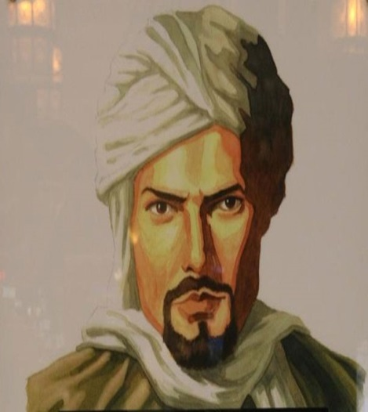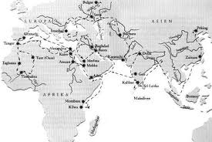
African Trading Kingdoms: Ghana, Mali, & Songhai
Timbuktu- prosperous- gold and salt Mansa Musa trans-Saharan trade routes
Spread of Islam
- There will likely be one or two questions on your regents on the terms above just know them.

