AP European History
Exam—Unit 6

"Self-interest drives people to action and the Invisible Hand of competition acts as an automatic regulator so that the market will generate wealth for the nation."

1. The author of this passage would have agreed with which of the following statements?
a. Government regulation of the market helps to promote a healthy economy.
b. People will produce according to their abilities and be compensated according to their needs.
c. Individual self-interest, however enlightened, will destroy the market.
d. Government must not interfere with the market mechanism if it is to perform properly.
e. Wealth will be divided equally by the market mechanism.

2. The ideas expressed in the passage above are fundamental to the economic theories of:
a. socialism
b. capitalism
c. mercantilism
d. communism
e. fascism

3. "Sincerely influenced by the ideas of the Enlightenment, this monarch abolished capital punishment, established equality before the law, freed the serfs, created a system of primary education, established religious toleration, and tightened the control of the state over the established church." The enlightened despot described above was:
a. Catherine the Great of Russia
b. Joseph II of Austria
c. Maria Theresa of Austria
d. Frederick the Great of Prussia
e. Charles III of Spain

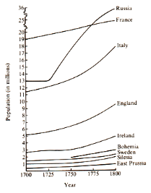
4. All of the following statements about Europe's population in the eighteenth century can be inferred from the graph above EXCEPT:
a. For most of the century, France had the largest population of any European power.
b. The population of Eastern Europe outstripped that of Western Europe in size.
c. Russia experienced the largest increase in rate of population growth.
d. The population of the British Isles grew throughout the century.
e. Rates of population growth increased after 1750.
5. Eighteenth-century popularizers of the seventeenth-century scientific revolution would have most likely agreed with which of the following statements?
a. God intervenes actively in the universe's operation.
b. Understanding the natural order is beyond human comprehension.
c. Humans are imperfect and wicked by nature.
d. Underlying natural laws govern society.
e. Respect for tradition ensures human progress.

6. Enlightened monarchs of the eighteenth century supported all of the following EXCEPT:
a. religious toleration
b. increased economic productivity
c. pacifist foreign policy
d. administrative reform
e. secular and technical education

7. Which of the following statements is NOT true regarding religious life in the eighteenth century?
a. John Wesley's Methodist movement demonstrates a religious revival among the lower classes.
b. The Enlightened monarchs extended toleration to religious minorities, including Jews.
c. In both Catholic and Protestant nations, states gained more power over churches.
d. Popular religious devotion in Catholic nations declined dramatically.
e. The philsophes demonstrated an indifferent if not hostile attitude toward organized religion.

8. Which of the following was a cause of the other three?
a. development of children's games and literature
b. rise in the prevalence of breast-feeding
c. the educational views of Locke and Rousseau
d. a decline in the use of corporal punishment

9. In his On Crimes and Punishments, Cesare Beccaria:
a. criticized physical punishments and advocated legal reform
b. championed the cause of barristers in the courts
c. argued for a unified Italian legal code
d. noted the importance of the common people in the making of laws
e. suggested the building of maximum security prisons

10. In the eighteenth century, elite and popular cultures:
a. began to diverge
b. both focused on reading for entertainment
c. enjoyed taverns for relaxation
d. were undermined by the Scientific Revolution
e. were patronized by the philosophes

11. Which is NOT a reason that European population rose significantly in the eighteenth century?
a. improved diet and nutrition
b. new medical breakthroughs
c. the Agricultural Revolution
d. a decline in the death rate
e. end of the bubonic plague

12. Literacy rates in eighteenth-century Europe:
a. were about equal for men and women
b. were distributed evenly across class lines
c. were closely related to primary education
d. actually declined from the seventeenth century
e. were higher in Catholic nations
13. Which of the following was invented in the eighteenth century?
a. jigsaw puzzle
b. telescope
c. astrolabe
d. barometer
e. microscope

14. Which of the following is true of women during the Enlightenment?
a. the vast majority of philosophes accepted the equality of women
b. Mary Wollstonecraft's attack on women's domestic role led to a decline in the marriage rate
c. though several prominent women participated in salons, most women were unaffected
d. enlightened monarchs established universities specifically designed for women's education
e. women contributed significant intellectual breakthroughs in the area of philosophy

15. "The law is the expression of the general will. All citizens have a right to concur either personally or by their representatives in its formation. The law should be the same for all, whether it protects of whether it punishes." The quotation above is a formulation of the ideas of:
a. Frederick the Great
b. Jean-Jacques Rousseau
c. Adam Smith
d. Condorcet
e. Voltaire

16. "The pasturing stock is allowed in peace to eat up the food on pastures to its utmost limits, thus the stock returns more ample profit to the farmer. In managing arable lands, the farmer derives other solid advantages, such as security against trespass and adoption of correct crop rotation." The eighteenth-century British quotation above is a justification for which of the following?
a. enclosure of common lands
b. strip farming
c. sharecropping
d. three-field crop rotation
e. serfdom

17. Which of the following ideas is NOT associated with the ideas of Rousseau?
a. inequality results from property
b. the "noble savage"
c. the Cult of Sentiment
d. women are men's intellectual equals
e. education should be based on experiences not rote

18. The Rococo artistic style of the eighteenth century was:
a. highly formal and geometric
b. known for its light-hearted subject matter in painting
c. heavily influenced by the French Academy of Art
d. banned by the French kings
e. a conspiracy to undermine good taste

19. The Agricultural Revolution of the seventeenth and the eighteenth centuries in England and the Netherlands involved all of the following EXCEPT:
a. draining wetlands
b. enclosure of common fields
c. introduction of new crops
d. selective breeding of livestock
e. use of heavy machinery

20. All of the following were common characteristics of the Old Regime in eighteenth-century Europe EXCEPT:
a. aristocratic elites
b. state religions
c. guilds
d. feudal dues
e. large factories

21. Laws should be relative to the climate of each country, to the quality of its soil, to the principal occupation of its natives. Laws should have a relation to the degree of liberty which the constitution will bear, to the religion of the inhabitants, to their manner and customs. Who is the author?
a. Louis XIV
b. Montesquieu
c. Bossuet
d. Rousseau
e. Thomas Paine

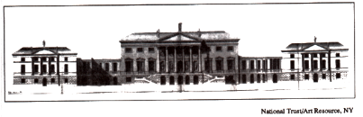
22. This design of an English nobleman’s house from 1760 embodies what qualities that the English aristocracy admired?
a. American rusticity, grace, and freshness
b. Prussian discipline, frugality, and militarism
c. Islamic geometry and abstraction
d. Roman strength, order, and balance
e. Egyptian elaboration and polychromatism

23. All of the following were developments admired by the philosophes EXCEPT:
a. increased religious toleration
b. the use of reason
c. the idea of progress
d. secularization of society
e. mercantilism

24. Deism was supposed to be all of the following EXCEPT:
a. based on reason
b. lead to moral behavior
c. did not restrict freedom of thought
d. deduced form empirical evidence
e. based on the supernatural

25. A social historian would be most likely to research which of the following topics?
a. French diplomacy, 1742-63
b. Frederick William I and the General Directory of War, Finance, and Domains
c. The philosophical assumptions of Montesquieu's Persian Letters
d. Family life in a French village
e. Napoleon's Freudian relationship with Madame de Stael

26. A significant social and cultural trend during the eighteenth century in western Europe was:
a. the increase in number of published books and periodicals
b. the rise in the mortality rate among the lower classes
c. a return to spiritual explanations for natural phenomenon
d. the near absence of peasant and urban revolts
e. simple and provincial styles of interior decor

27. In eighteenth-century Europe, the most important imperial rivalries existed among which three of the following?
a. Russia, France, and Great Britain
b. The German states, the Italian states, and Great Britain
c. The German states, the Italian states, and France
d. France, Russia, and Spain
e. Spain, France, and Great Britain

28. The Agricultural Revolution of the seventeenth and the eighteenth centuries in England and the Netherlands involved all of the following EXCEPT:
a.. draining wetlands
b. enclosure of common fields
c. introduction of new crops
d. selective breeding of livestock
e. use of heavy machinery

29. Economic and social life among the mass of people under the ancien regime of the eighteenth century still primarily focused around:
a. the harvest
b. the stock market
c. colonial trade
d. parliamentary elections
e. military service

30. The most common cause of urban riots in the eighteenth century was:
a. bread shortages
b. foreign policy issues
c. partisan politics
d. class warfare
e. guild rivalries

31. All of the following were common characteristics of the ancien regime in eighteenth-century Europe EXCEPT:
a. aristocratic elites
b. state religions
c. guilds
d. feudal dues
e. large factories

32. All of the following factors contributed to the expansion of population in eighteenth-century Europe EXCEPT:
a. fewer epidemics
b. new drugs
c. improved sanitation
d. changes in food supply
e. climatic changes

33. “Laws should be relative to the climate of each country, to the quality of its soil, to the principal occupation of its natives. Laws should have a relation to the degree of liberty which the constitution will bear, to the religion of the inhabitants, to their manner and customs.” Who is the author?
a. Louis XIV
b. Montesquieu
c. Bossuet
d. Rousseau
e. Thomas Paine

34. The Social Contract, published in 1762, was written by:
a. Turgot
b. Necker
c. Diderot
d. Beccaria
e. Rousseau

35. Emperor Joseph II of Austria failed in his attempts to reform his country because he
a. lacked ruthlessness
b. failed win the support of the peasantry
c. was unwilling to dissolve monasteries
d. failed to abolish the robot
e. agreed with his mothers opinions

36. Deism was supposed to be all of the following EXCEPT:
a. based on reason
b. lead to moral behavior
c. did not restrict freedom of thought
d. deduced form empirical evidence
e. based on the supernatural

37. All of the following were developments admired by the philosophes EXCEPT:
a. increased religious toleration
b. the use of reason
c. the idea of progress
d. secularization of society
e. mercantilism

38. “Generally speaking, there is no one who knows what is for your interest so well as yourself--no one who is disposed with so much ardor and constancy to pursue it.” The author of the above passage would support which of the following?
a. laissez faire
b. selection taxation to promote industry
c. navigation acts
d. government price supports
e. high tariffs

39. Which of the following had the largest population in 1763?
a. France
b. Sweden
c. England
d. Austria
e. Spain

40. Adam Smith maintained that:
a. workers’ real wages decrease in the long run
b. population always tends to outstrip food supplies
c. monopolies benefit the state
d. competition is socially beneficial
e. social revolution is inevitable

41. The eighteenth-century philosophes believed that society could best achieve progress through:
a. prayer and contemplation
b. intuition
c. hard work and self-denial
d. scientific empiricism
e. analysis of Greek and Latin texts

42. “The salon was a weekly gathering held in the home of one of the dominant ladies of the society, at which dinner was usually served, cards usually played, but conversation led by the hostess predominated. A few salons were known as having the ideal mixture of leading intellectuals, open-minded nobles, and clever, elegant women.” The passage above describes and important aspect of social life in which of the following?
a. Geneva during the Reformation
b. Florence during the Renaissance
c. London during the Glorious Revolution
d. Paris during the Enlightenment
e. Moscow in the time of Peter the Great

43. Which of the following best expresses Voltaire’s views concerning religion?
a. Catholics should obediently follow the dictates of the pope.
b. Protestants should be excluded from French government service.
c. Religious unity is fundamental to enlightened monarchies.
d. Organized religion perpetuates superstition and ignorance.
e. Criticism of religious doctrines and authorities should be condemned.

44. “I will allow that bodily strength seems to give man a natural superiority over woman; and this is the only solid basis on which the superiority of men over women can be built.” The passage above reflects the argument of:
a. John Locke
b. Thomas Hobbes
c. Mary Wollstonecraft
d. Jane Austen
e. Emily Bronte

45. Just as the reign of Louis XIV of France is cited as an example of absolutism, the reign of Joseph II of Austria is often cited as an example of:
a. liberalism
b. theocracy
c. mercantilism
d. enlightened absolutism
e. divine right of kings

46. Family relations in western Europe in the period 1500-1700 were generally similar to modern ones in that:
a. the core of the family was nuclear
b. the legal power of the father over the family steadily declined
c. divorce on the basis of irreconcilable differences increase dramatically
d. family chapels, directed by fathers, dominated community services
e. children left home and established separate households soon after puberty

47. Hobbes and Rousseau would have agreed that:
a. a monarch has absolute power
b. the state is based on a social contract
c. the state of nature is peaceful and harmonious
d. political authority should be shared by the monarch and representatives of the people
e. citizens have the right to revolt

48. By the late seventeenth century, witchcraft trials and executions had declined in western Europe in part because of:
a. popular uprisings and peasant resistance to persecution
b. growing feminist protest against persecution
c. official church rejection of the concept of witches
d. increased disbelief among elites in the concept of witches
e. a declining number of women practicing midwifery

49. Adam Smith’s Inquiry into the Nature and Causes of the Wealth of Nations advocated a system of:
a. imperialism
b. free trade
c. protective tariffs
d. socialism
e. mercantilism

50. The major drawback of the open-field (three-field. agricultural system was that:
a. it relied on individual farming methods
b. it prohibited the communal use of oxen and other farm animals
c. every year a substantial portion of the land was not planted
d. insects regularly devastated the crops and infected the herds
e. thieves were able to steal crops easily

51. Historians attribute the “population explosion” of the eighteenth century primarily to:
a. the elimination of childhood diseases
b. a more abundant food supply
c. the widespread introduction of piped water and sewers
d. the eradication of childbirth fever
e. new sanitary procedures in hospitals

52. The group most severely criticized in the works of Voltaire, the French philosophe, was the:
a. English people
b. French middle class
c. German peasantry
d. Roman Catholic clergy
e. Italian ruling class

53. Which of the following pairs of European rulers is generally identified as “enlightened” monarchs?
a. Anne of England and Louis XV
b. Joseph II and Catherine the Great
c. Frederick William I and George III
d. Elizabeth I and Mary Stuart
e. Peter the Great and Catherine de Medicis

54. The eighteenth-century Enlightenment philosophes were primarily concerned with:
a. the advancement of theological and metaphysical knowledge
b. the setting of limits on the human ability to change
c. pure skepticism and the negation of reason
d. mystical sciences such as numerology and astrology
e. critical and inquiring approaches to knowledge

55. Improvements associated with the Agricultural Revolution of the seventeenth and eighteenth centuries began in:
a. France and Spain
b. the Low Countries and Britain
c. Prussia and Saxony
d. Poland
e. Russia

56. The Agricultural Revolution of the eighteenth century can best described as:
a. the widespread adoption of machinery for planting and harvesting of crops
b. incremental improvements in use of fertilizers, fodder crops, and other techniques
c. the abolition of serfdom and feudalism in favor of commercial agriculture
d. the enclosure of virtually all lands west of the Elbe river
e. the end of the "little ice age"

57. Which of the following best describes a major cultural development of the eighteenth century?
a. a significant expansion in the number of published books and in the literacy rate
b. major theoretical breakthroughs in the understanding and treatment of infectious diseases
c. the rapid abandonment among the masses of blood sports such as bear-baiting and cock-fighting
d. a revival of supernatural explanations in the writing of history
e. the increasing influence of organized religion in the affairs of the state

58. Which of the following statements is true regarding family life in the period 1750-1850 in Western Europe?
a. there was a significant decline in out-of-wedlock births due to Enlightenment reforms
b. the birthrate increased significantly due to government social welfare programs
c. life expectancy declined due to problems associated with industrialization
d. there was an increased importance placed on child-rearing among the upper classes
e. most nations repealed laws that enforced the legal and economic inferiority of women

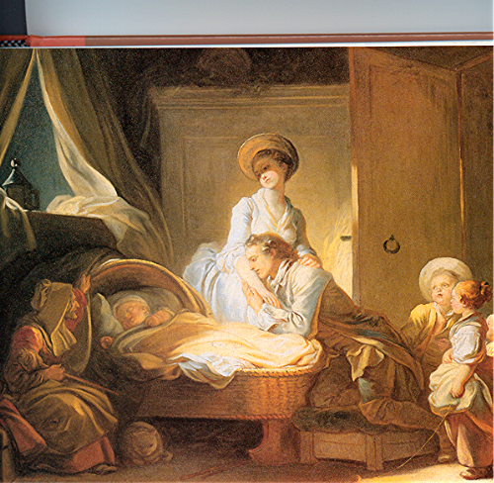

59. The painting above from the late eighteenth century demonstrates the emergence of what concept?
a. the importance of wealth as a measure of social status
b. that women were morally inferior to men and unfit to be educated
c. that production must remain in the home as opposed to the new factories
d. opposition to the use of wet nurses
e. the value of children and the home as a refuge from the outside world

60. Which of the following pairs of thinkers proposed new theories of child-rearing and education?
a. John Stuart Mill and Thomas Hobbes
b. Niccolo Machiavelli and Voltaire
c. John Locke and Rousseau
d. Isaac Newton and Michel de Montaigne
e. Denis Diderot and Edmund Burke

61. A significant social and cultural trend during the eighteenth century in western Europe was:
a. the increase in number of published books and periodicals
b. the rise in the mortality rate among the lower classes
c. a return to spiritual explanations for natural phenomenon
d. the near absence of peasant and urban revolts
e. simple and provincial styles of interior décor

62. The Agricultural Revolution of the eighteenth century is best described as:
a. the widespread adoption of machinery for planting and harvesting of crops
b. incremental improvements in use of fertilizers, fodder crops, and other techniques
c. the abolition of serfdom and feudalism in favor of commercial agriculture
d. the enclosure of virtually all lands west of the Elbe river
e. the end of the "little ice age"

63. The enclosure movement in eighteenth-century England did which of the following?
a. Provided cheap housing for the rural poor.
b. Secured the nation’s coastal defenses.
c. Initiated a program of church-building throughout the country.
d. Encouraged the development of market-oriented agricultural production.
e. Barred the Roman Catholic heirs from the throne.

64. Which of the following is most characteristic of Voltaire’s ideas?
a. Empiricism and religious toleration are to be celebrated.
b. The branches of government should be balanced.
c. Future progress is inevitable and limitless.
d. The General Will is the ideal basis for good government.
e. Sensory experience can never be verified.

65. Jean-Jacques Rousseau differed significantly from other Enlightenment philosophés in his:
a. emphasis on emotions and his admiration for the “noble savage”
b. emphasis on the importance of science to social progress
c. belief in traditional religious customs
d. belief in determinism
e. belief in the divine right of kings

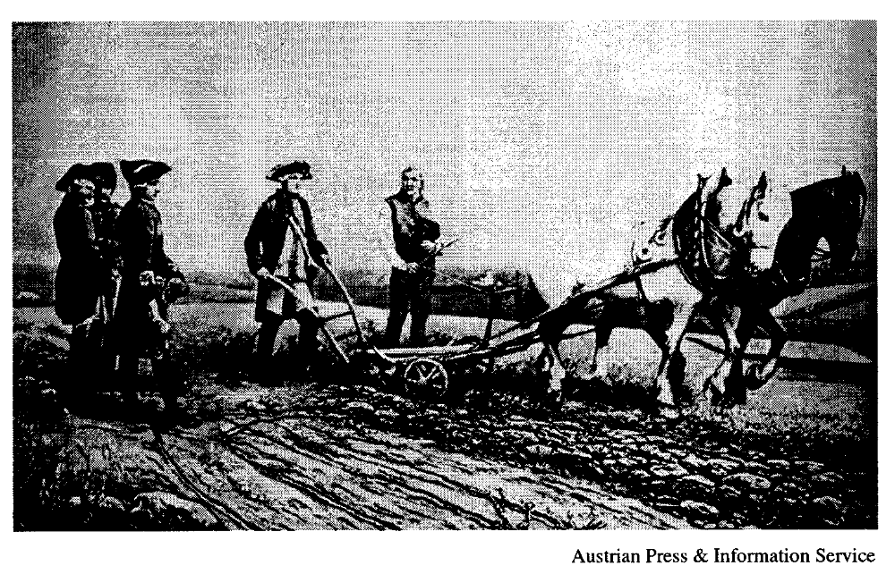

66. The painting above depicts the Austrian Emperor Joseph II (1780-90) as:
a. a democratic representative of the common people
b. a ruler surveying conquered territories
c. an Enlightened monarch interested in methods of improving productivity
d. the “first servant of the state” who encouraged Enlightenment philosophés
e. an advocate of the reeducation of the aristocracy through forced agricultural labor

67. Which of the following activities did Adam Smith believe was the most appropriate for a national government?
a. Granting monopolies
b. Providing tax exemptions to infant industries
c. Acquiring colonies
d. Defending the state against foreign invasion
e. Fixing wages and prices

68. Peasant men in seventeenth- and eighteenth-century Europe generally married in their twenties primarily
because
a. they had to spend a period of time in the military
b. they were required to finish their apprenticeships
c. there were more women than men
d. Church prohibited early marriage
e. they wanted to establish independent households first

69. Which of the following diseases did NOT produce a major epidemic after the eighteenth century?
a. Measles
b. Typhus
c. Influenza
d. Cholera
e. Bubonic plague

70. Which of the following is true regarding the salons of the eighteenth century?
a. They were exclusively a French phenomenon.
b. They excluded women.
c. They discussed social questions as well as literary works.
d. They were held exclusively at royal courts.
e. They were endorsed by traditional religious figures.

“I asked him to tell me in what true religion consisted.

‘Have I not told you?’ [he answered] ‘Love God and your neighbor as yourself.’”

--Voltaire, Philosophical Dictionary

71. In the excerpt above, Voltaire was supporting
a. religious toleration
b. papal authority
c. unification of all Christian churches
d. Protestantism
e. the monastic life

72. A controversial aspect of the Agricultural Revolution in eighteenth-century England was the transformation of
common land into private land through the process known as
a. enclosure
b. puddling
c. asiento
d. crop rotation
e. syndication

73. According to Adam Smith, the “invisible hand” would
a. provide checks and balances among the branches of government
b. convince devout men and women of the value of religious toleration
c. reconcile selfish individual interests with general economic benefits
d. guide absolute monarchs to embrace liberal reforms
e. cause population to exceed available food supplies

74. A distinguishing feature of the Old Regime in eighteenth-century France was the
a. dominant influence of the Roman Catholic Church on the cultural life of the elites
b. steady decline in the peasant populations
c. growth of modern machine industry in manufacturing centers such as Lyon
d. inability of the monarchy to carry out reforms necessary for its survival
e. mass emigration to the colonies in the New World

75. Which of the following was most responsible for the steady population growth in eighteenth-century Europe?
a. A rising birth rate among all classes
b. The virtual elimination of the bubonic plague through successful inoculation
c. Greater freedom of choice in selecting marriage partners
d. A steady decline in bread prices, especially after 1750
e. An overall decline in the death rate

