Type your Name: How our brains are biologically wired for fake news
http://www.nydailynews.com/life-style/brains-biologically-wired-fake-news-article-1.2991246
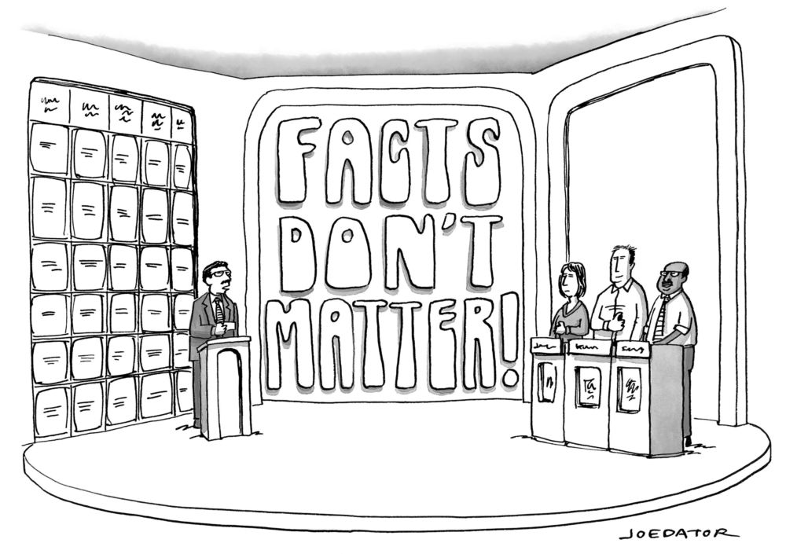  Janice you had the correct answer; however Ted answered louder, so he gets the points even though he was wrong. | Explain how this cartoon illustrates a major problem with the consumption of media today.
- What are the three reasons the author believes that we are wired to except fact news? Explain them.

Examine the Content:(Source Assessment
Is this article reporting facts or opinions or both?

Ask about the Author:
Authority: Does the author have a background/expertise in the topic being reported on? Do they have a history of reporting on this topic? (check ‘about the author’)
Who made this?
• How was this made?
• Why was this made?

Bias: Does the author or news source have a known bias? (Yes or No)
Who do/have they worked for?
Is there information that should be checked or questioned?
• When was this made?
• What is this missing?

Credibility: Is the author or site known for make false or exaggerated claims?
• Where do I go from here?

