Analyze the various ways in which the Thirty Years’ War (1618–1648) represented a turning
point in European history.
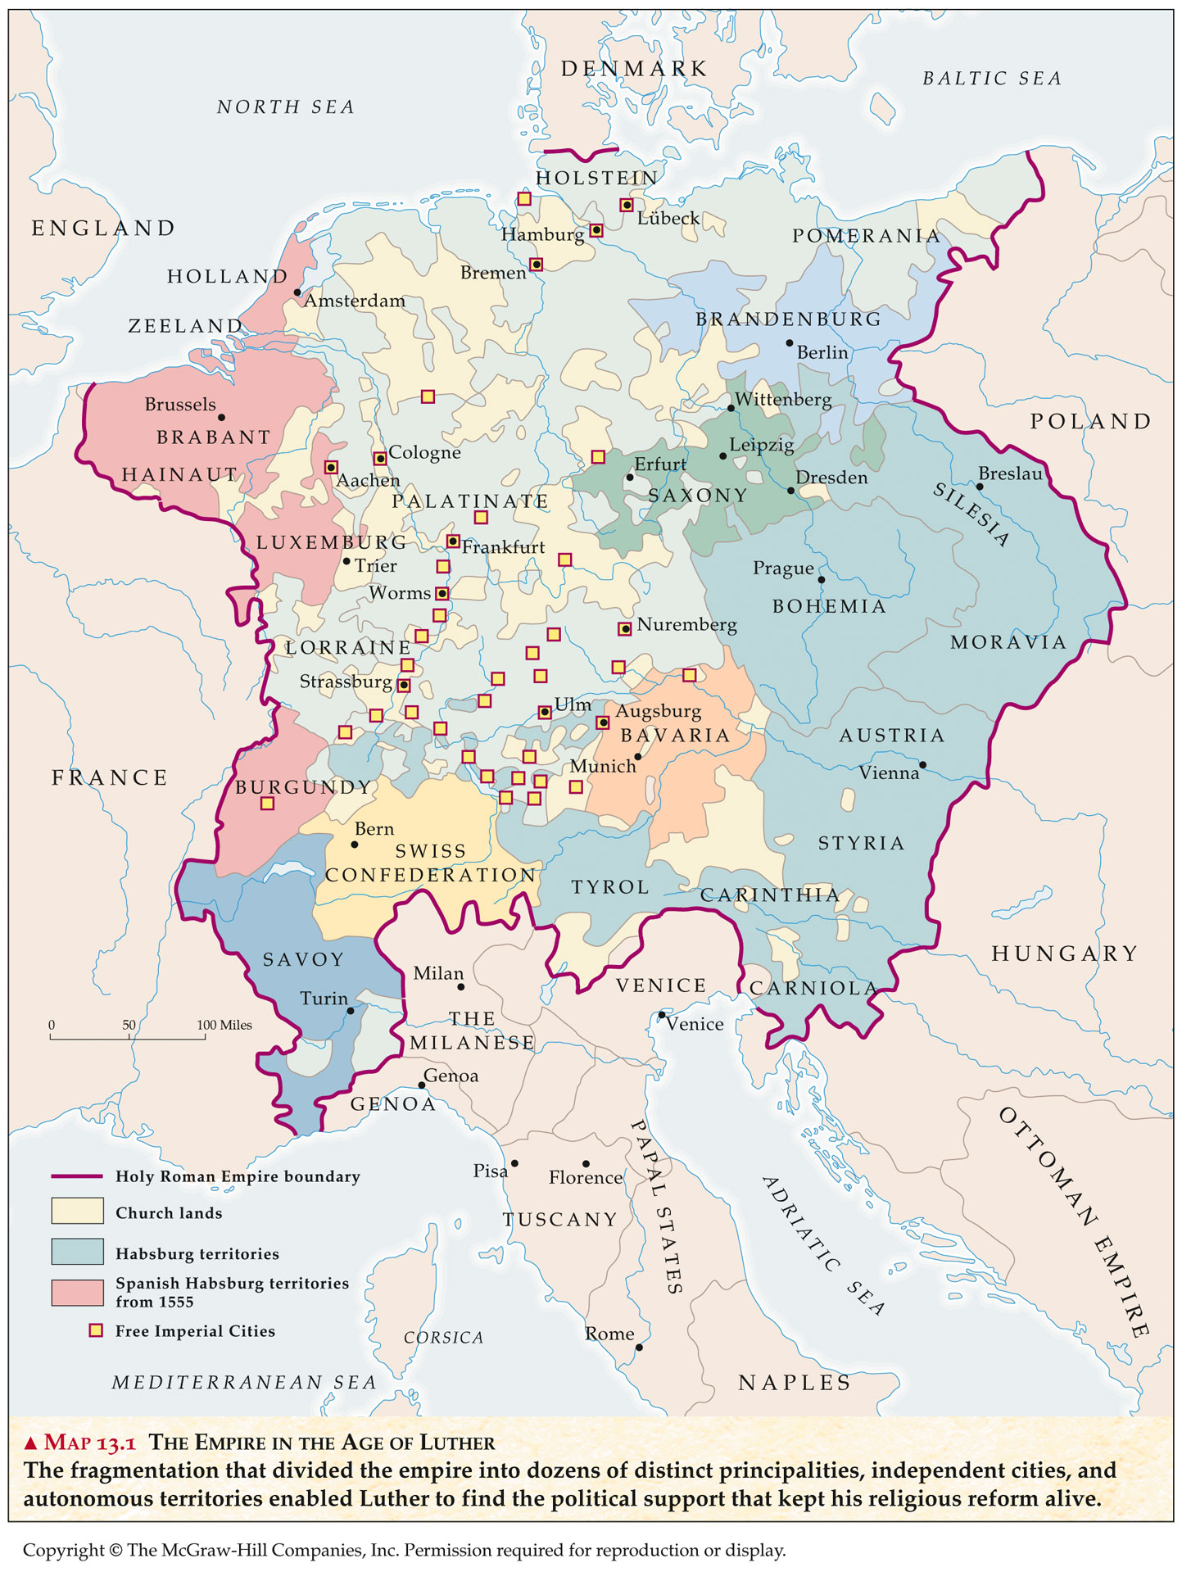

- Thirty Years’ War (1618-1648) – most important war of the 17th century
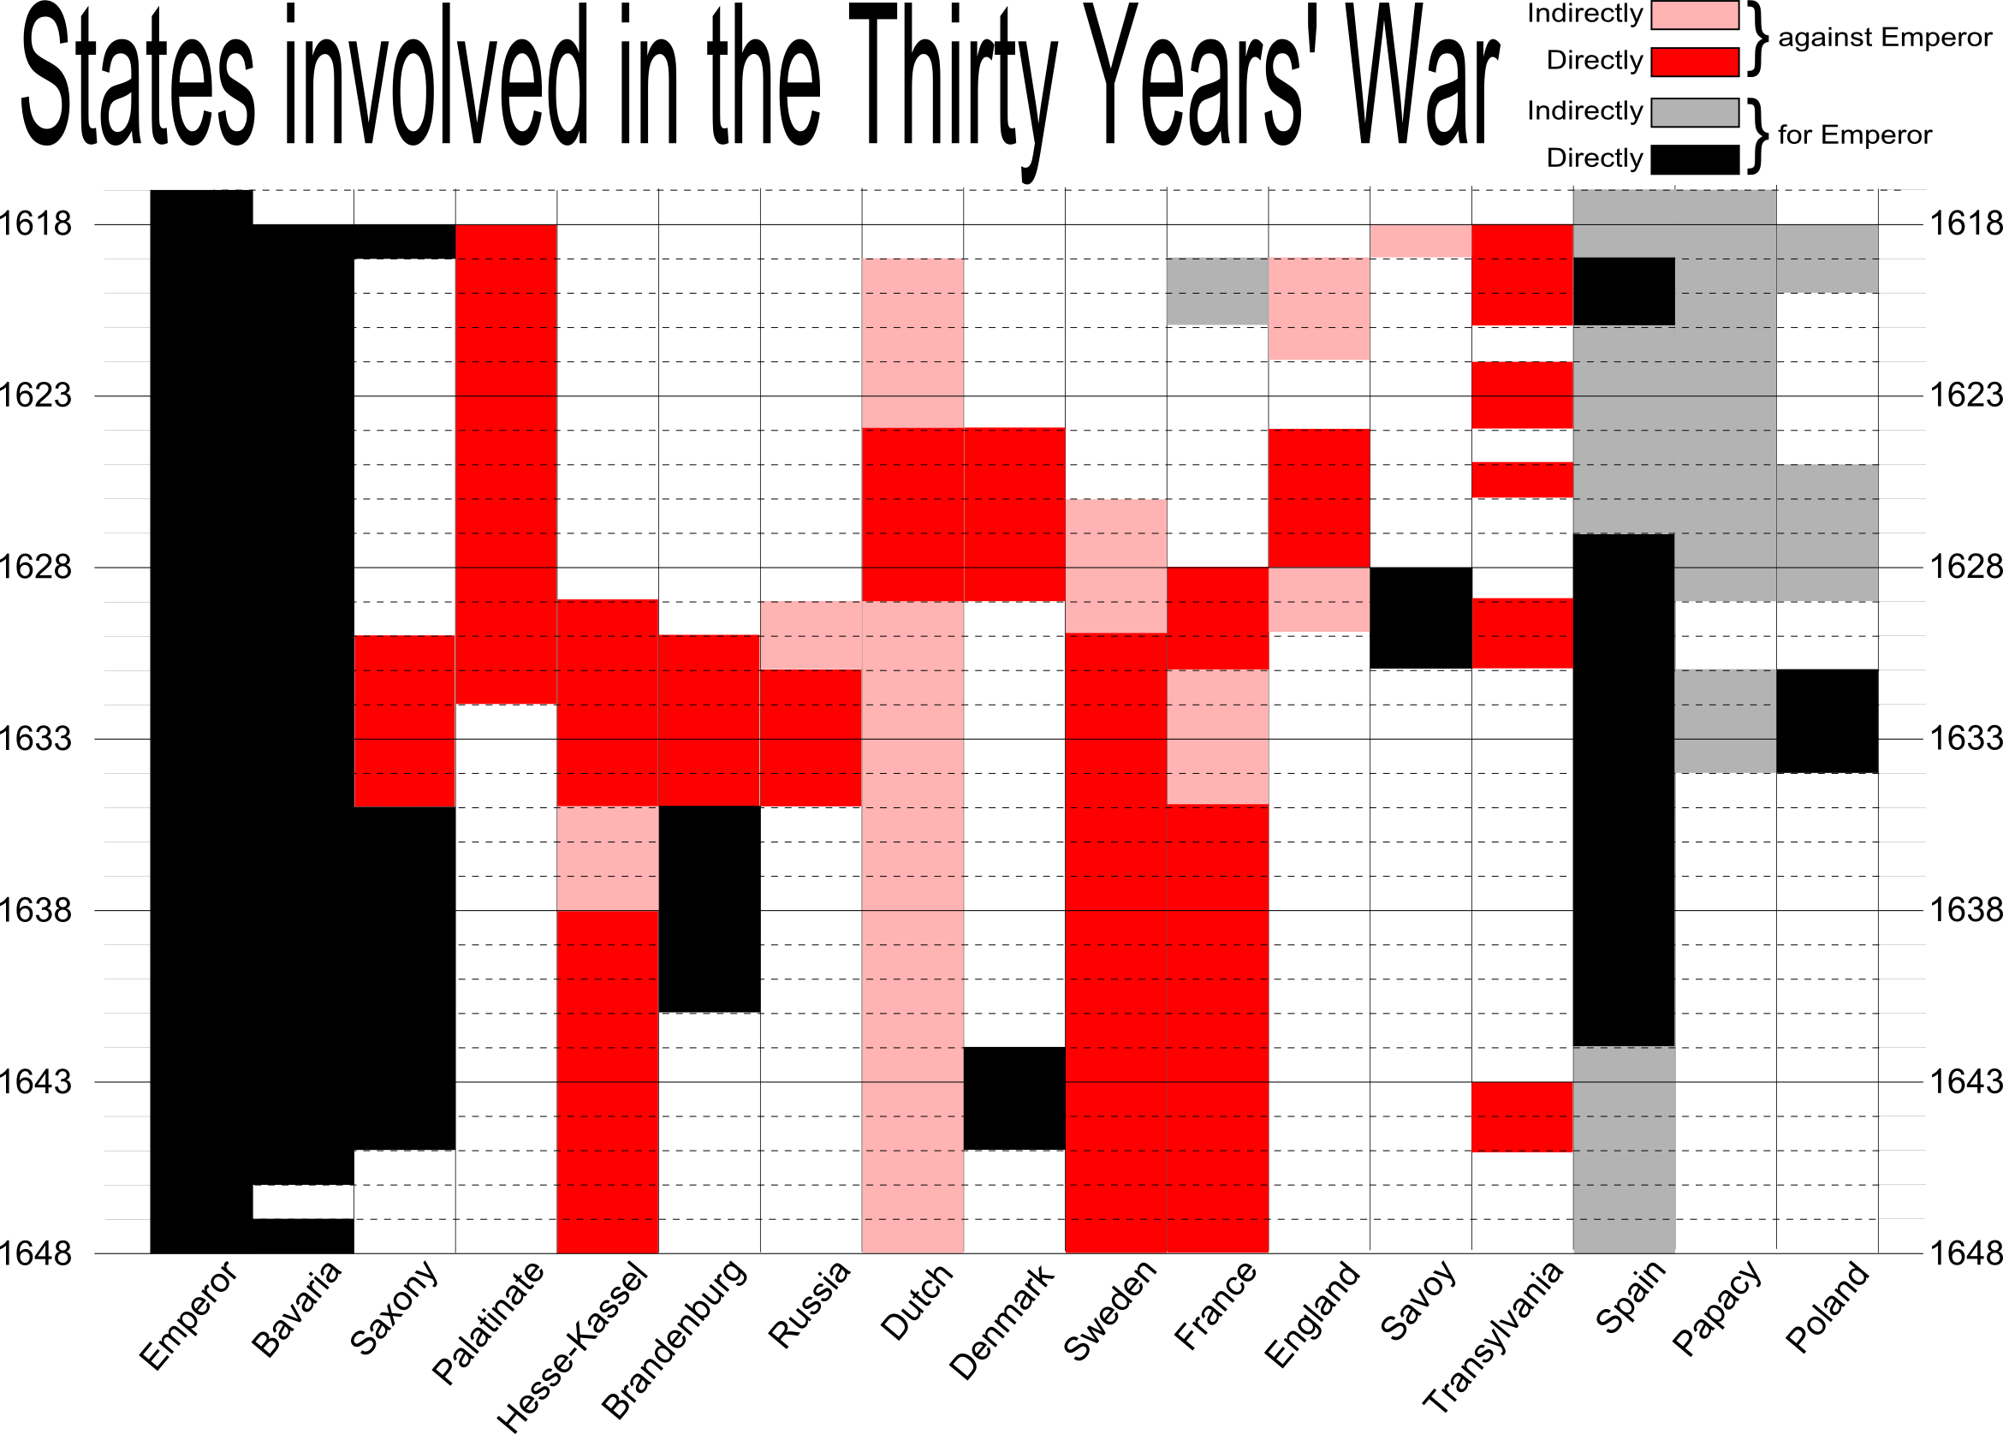
          - Failure of the Peace of Augsburg, 1555
            - The 1555 agreement had given German princes the right to choose either Catholicism or Lutheranism as the official religion of their states.
            - The truce in Germany lasted for 60 years until factionalism in the Holy Roman Empire precipitated a cataclysmic war
Cause-
  - Fragmented Germany
    - Germany consisted of about 360 autonomous political entities and each was granted independence in political ideologue by the Peace of Augsburg.
    - There had been longstanding feuds between the Catholic Habsburg emperors and the territorial princes with the empire
    - Unrecognized by the Peace of Augsburg, Calvinism found a stronghold in the Holy Roman when Frederick III, a devout convert to Calvinism, became the ruler of the Palatinate and made it the official religion.
    - Maximilian I, duke of Bavaria, organized a Catholic League to counter the Protestant system of alliances.
    - The Catholic League fielded a great army and the stage was set for the Thirty Years’ War.

          - Four phases of the war:
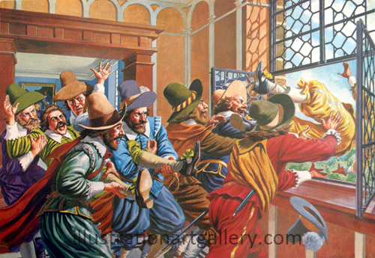
- Bohemian Phase
- Defenestration of Prague (1618): triggered war in Bohemia
- The Holy Roman Emperor (Ferdinand II) placed severe restrictions on Protestantism
- Protestant nobility in Prague responded the “defenestration of Prague”- Two HRE officials were thrown out a window and fell 70 feet below (did not die because they were saved by a large pile of manure)
- The emperor then sought to annihilate the Calvinist nobility in Bohemia
- Protestant forces were eventually defeated and Protestantism was eliminated in Bohemia
- Danish Phase: represented the height of Catholic power during the war
  - Albrecht von Wallenstein (1583-1634): Mercenary general who was paid by the emperor to fight for the HRE
- Won a number of important battles against Protestant armies
  - Edict of Restitution (1629): The Emperor declared all church territories that had been secularized since 1552 to be automatically restored to Catholic Church
- Swedish Phase: Protestants liberated territory lost in previous (Danish) phase
  - Gustavus Adolphus (King of Sweden): led an army that pushed Catholic forces back to Bohemia
- Battle of Breitenfeld, 1631: victory for Gustav’s forces that ended Hapsburg hopes of reuniting Germany under Catholicism
- Gustav was killed in another battle in 1632
  - In response, the Holy Roman Emperor reluctantly annulled the Edict of Restitution
  - The Swedish army was defeated in 1634; France now feared a resurgence of Catholicism in the HRE.
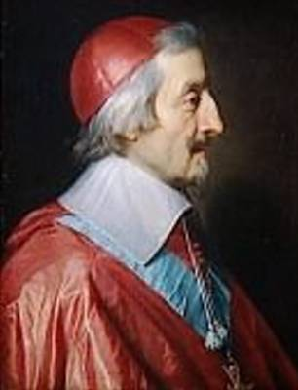
- French Phase: “International Phase”

  - Cardinal Richelieu of France allied with the Protestant
forces to defeat the HRE (as had occurred in the earlier
Hapsburg-Valois Wars).
  - Richelieu’s policies reflected Catholic France’s paramount
diplomatic concerns as political, not religious;
thus he can be seen as a politique.
- Had the Habsburgs won in Germany, France would
have been confronted with a more powerful German
state on its eastern border.
          - Treaty of Westphalia (1648):

  - Decline of the importance of religion as a motive for conflict- ended the Catholic Reformation in Germany
a. Renewal of Peace of Augsburg (but added Calvinism as a politically accepted faith)
b. In effect, it ended the Catholic Reformation in Germany
c. Guaranteed that Germany would remain divided politically and religiously for centuries
  - Dissolution of Holy Roman Empire confirmed
    - The Netherlands and Switzerland gained their independence from Spanish rule
    - 300+ German states became sovereign
    - The pope was denied the right to intervene in HRE affairs.
    - Economically weakens HRE- devided they could not compete with England and France
  - France, Sweden, and Brandenburg (future Prussia) received various territories and gained international stature. (The new powers of Europe)
  - The two Hapsburg branches were weakened:
- Spanish Hapsburgs saw their empire decline dramatically thereafter
- Austrian Hapsburgs lost much influence in Germany
  - Changes in the process of diplomacy
    - The Peace of Westphalia assumed the principle of mutual recognition of sovereignty and marked the beginning of the modern system of diplomatic relations
  - Military revolution
    - Gustavus Adolphus also implemented new tactics with more flexible lines of pikemen and muskets and more mobile artillery. Improved military training led to more professionalized fighting forces that were not disbanded at the end of the war or the campaign season.
    - Army size increased significantly. During the Thirty Years’ War, the French army had 125,000 men and grew to 250,000 by the Dutch War (1672-78). The Swedish army had 150,000 men by 1632 (growth due to conscription).
- All of this required supporting bureaucracies to expand, as well as increased taxes, placing new burdens on the populations, especially the lower orders.
          - Results of 30 Years’ War
Memory Device for Treaty of Westphalia: EF-CHIP

E nd of Wars of Religion
F rance emerges as Europe’s most powerful country
C alvinism added to the Peace of Augsburg
H oly Roman Empire effectively destroyed
I ndependence for the Netherlands and Switzerland
P russia emerges as a great power
      - Germany physically devastated (as much as 1/3 of the population in certain areas perished)
      - Germany was further divided by the decline of the Holy Roman Empire
      - Ended the wars of religion
      - Beginning of the rise of France as the dominant European power; also accelerated the continued rise of Britain & the Netherlands
- Balance of power diplomacy emerged in Europe
