Name ______________________________
3 | 1500-1789 | Absolutism and revolutions: Chapters 21-22: Divine Right Absolute Monarchs, Scientific Revolution and Enlightenment.
 | 1789-1900 | Revolutions: Chapters 23-24: French and Latin American Rev. and Nationalism
 | 1700-1914 | Modernization: Chapters 25-28: Industrial Revolution, 19th century, Imperialism
Absolutism- Scientific Revolution and Enlightenment
Global Absolutism-
Concepts/Terms | Events: | People:
Absolutism/ absolute rule, monarch divine right  Westernization  constitutional monarchy  Limited Monarchy  English Bill of Rights | English Civil War  Restoration  Glorious Revolution | Akbar the Great  Suleiman I  Phillip II  Louis XIV of France  Peter the Great  Catherine the Great
- What are the characteristics of Absolutism
- Make a web/ chart/ list of how Louis XIV of France and Peter the Great fit the model of Absolutism.
Scientific Revolution & European Enlightenment:
Concepts/Terms: | Events: | People:
Scientific method  natural rights  social contract  separation of powers  Enlightened Despot  Reason | Copernicus & Galileo  Locke  Rousseau, Montesquieu, & Voltaire  Catherine the Great | Scientific Revolution  Enlightenment
3. Know that the Scientific Revolution and Enlightenment were based on Reason.
4. Know your scientists and philosophers.
Political Revolutions
French Revolution:
Concepts/Terms: | Events: | People:
Old Regime,  the Estates General  bourgeoisie  Declaration of the Rights of Man  Napoleonic Code  Balance of Power  National Assembly  Coup d’etat | Reign of Terror  Congress of Vienna | Louis XVI  Robespierre  Napoleon  Metternich
5. What were the causes and Effects of the French Revolution
6. Briefly describe Robespierre, Napoleon, and Metternich

Latin American Independence/ Revolution and Nationalism:
Concepts/Terms: | Events: | People:
Nationalism  Independence movement  Nation-state  unification  realpolitik  Blood and Iron  encomienda system | Enlightenment  American Revolution  French Revolution | Bolivar  L’Ouverture  de San Martin  Hidalgo  Bismark  Cavour  Garibaldi
7. List all Nationalist leaders
8. List all independence leaders
9. What were the causes of the Latin American Independence movements/ Revolutions?
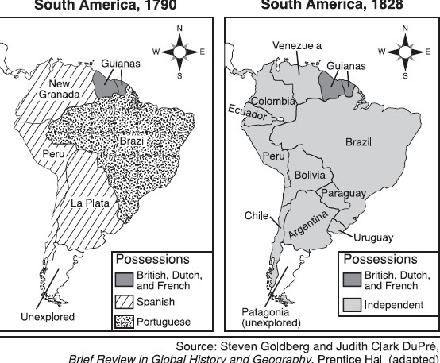
Industrialization
Concepts/Terms: |  | Events: | People:
laissez-faire capitalism  socialism  urban pollution  urbanization | railroads | Industrial Revolution  Irish Potato famine  migration of many Irish  reforms (suffrage) | Karl Marx (Communist Manifesto)  Friederich Engels  Adam Smith (Wealth of Nations)
10. How was the Industrial Rev. a turning point?
11. Who was Karl Marx?
Imperialism
Concepts/Terms: | Events: | People:
raw materials  “The Sun never  sets on the British Empire”  Social Darwinism  White Man’s Burden  cultural diffusion  isolationism  Westernization/ Modern | European imperialism  Scramble for Africa  Berlin Conference  Opium Wars  Sepoy Mutiny  Boxer Rebellion  Zulu resistance  Meiji Restoration  independence movements | British East Indian Company  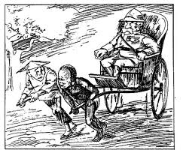  Commodore Matthew Perry’s

12. What were the Causes and effects of Imperialism
13. What was the Meiji Restoration?

