Period 2 Questions: Enlightenment through Napoleon
Questions 1. refer to the passage below.
“…freedom of men under government is, to have a standing rule to live by, common to every one of that society, and made by the legislative power erected in it; a liberty to follow my own will in all things, where the rule prescribes not; and not to be subject to the inconstant, uncertain, unknown, arbitrary will of another man: as freedom of nature is, to be under no other restraint but the law of nature.” John Locke, Second Treatise of Civil Government, Ch. IV, sec. 22, 1689
1. Locke’s view regarding government most clearly reflects which of the following ideas?  (A) Government based on divine providence  (B) Self-government by reasonable people  (C) Government through enlightened monarchs  (D) Authority based on historical traditions | 2. The political philosophy expressed in the passage most clearly reflects which of the following movements?  (A) Absolutism  (B) Socialism  (C) Republicanism  (D) Liberalism
3. Which tenet of the philosophical movement of which Locke was a part is most evident in the above passage?
(A) The power of representative authority (C) Tolerance of repressive institutions
(B) The rights of the individual (D) Submission to the state

Questions 4-5 refer to the passage below.
“Every man, as long as he does not violate the laws of justice, is left perfectly free to pursue his own interest his own way, and to bring both his industry and capital into competition with those of any other man, or order of men… According to the system of natural liberty, the sovereign [government] has only three duties to attend to: first, the duty of protecting the society from the violence and invasion of other independent societies; secondly, the duty of protecting, as far as possible, every member of the society from the injustice or oppression of every other member of it…; and, thirdly, the duty of erecting and maintaining certain public works and certain public institutions…. The proper performance of those several duties of the sovereign necessarily supposes a certain expense; and this expense again necessarily requires a certain revenue to support it.”
- Adam Smith, English economist, The Wealth of Nations, 1776

4. It can be inferred from the passage that Adam Smith advocated:
(A) the ending of England's mercantile system. (C) that government take absolutely no part in the economy.
(B) a large role for government in the economy. (D) an end to all taxes.

5. Smith’s assertion that “Every man…is left perfectly free…to bring both his industry and capital into competition with those of any other man” would eventually be the centerpiece of which economic system?
- mercantilism. C. socialism
- the closed-market D. capitalism

Questions 6-8 refer to the image below of a print by Irish painter William Hincks, 1791
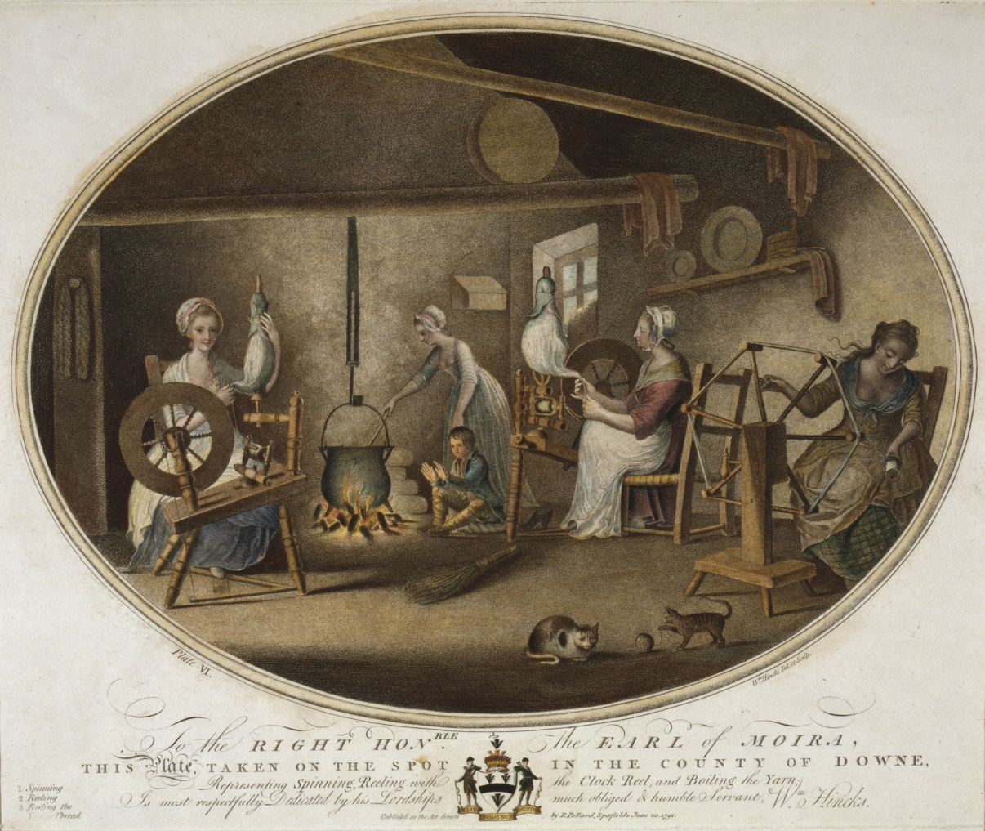
Library of Congress Prints and Photographs Division [LC-USZC4-11219]
6. The above image most clearly offers evidence of which economic development that grew in the 18th century?  (A) Cottage industry  (B) Factory system  (C) Indentured servitude  (D) Trade associations  7. Which of the following most directly resulted in the growth of the type of economic activity shown in the above image?  (A) The decline of industrialization  (B) Lack of capital for commercial enterprise  (C) Growth of commercial agriculture  (D) A stagnant money market economy | 8. Which of the following best describes the capitalists’ impetus for growing the economic system depicted in the above image?  (A) The breakdown of the nuclear family as an economic unit  (B) The opportunity to break the guild system  (C) Reinforcement of women’s traditional gender roles  (D) Raising the standard of living for the lower classes
Questions 9-11are based on the following passage.

“…Political liberty is to be found only in moderate governments; and even in these it is not always found. It is there only when there is no abuse of power: but constant experience shows us that every man who is given power is likely to abuse it… To prevent this abuse, it is necessary, from the very nature of things, that power should be a check to power… To discover political liberty in a constitution, no great labor is required… In every government there are three sorts of power; the legislative; the executive… and the..civil law [i.e. judicial].

The political liberty of a subject is a tranquility of mind arising from an opinion each person has of his own safety. In order to have this liberty, it is necessary that the government be so constituted that one man need not be afraid of another…there is no power if the judicial liberty is not separated from the legislative and the executive. If it is joined to the legislative, the life and liberty of the subject would be exposed to arbitrary control; for the judge would be the legislator as well. Were it joined to the executive power, the judge might behave with violence and oppression. There would be an end of everything if the same man or the same body were…to exercise those three powers; that of enacting laws, of carrying them out, and of trying individual cases…” The Baron de Montesquieu, The Spirit of the Laws, 1748

- The author’s statement that…there is no liberty if the judicial power is not separated from the legislative and executive describes which of the following ideas?
- The executive branch of the government should be more powerful than the legislative and judicial branches.
- The right to life, liberty and property are basic rights of all citizens.
- The powers of government should be divided between its main branches.
- The best form of government is a constitutional monarchy.
- The author of the excerpt is describing his understanding of the government of which of the following countries?  - Holland C. Great Britain  - France D. The United States | - Which of the following ideas of the Scientific Revolution does the excerpt reflect?  - There is an observable balance of forces in nature  - Scientific inquiry should be restricted to the observation of the heavens  - Political systems must be based on deist principles  - Natural laws cannot be applied to human activities and institutions

Questions 12-14 refer to the passage below.
“After the earthquake, which had destroyed three-fourths of the city of Lisbon, the sages of that country could think of no means more effectual to preserve the kingdom from utter ruin than to entertain the people with an auto-da-fé, it having been decided by the University of Coimbra, that the burning of a few people alive by a slow fire, and with great ceremony, is an infallible preventive of earthquakes.
In consequence thereof they had seized on a Biscayan for marrying his godmother, and on two Portuguese for taking out the bacon of a larded pullet they were eating; after dinner they came and secured Dr. Pangloss, and his pupil Candide, the one for speaking his mind, and the other for seeming to approve what he had said…Candide was flogged to some tune, while the anthem was being sung; the Biscayan and the two men who would not eat bacon were burned, and Pangloss was hanged, which is not a common custom at these solemnities. The same day there was another earthquake, which made most dreadful havoc.”
Voltaire, Candide, or The Optimist, 1759

12. Which group would most applaud the author’s point-of-view being conveyed in the above passage?
(A) Those who believed that most people were good but corrupted by society.
(B) Those who believe that superstition filled people with bigotry and intolerance.
(C) Those who believed that reason and science had no place in the affairs of man.
(D) Those who believed that despotism was the only rational form of political power.

13. Which 18th-century idea regarding social progress would be supported by Voltaire, based upon the above passage?
(A) Progress through social traditions
(B) Progress through study of the Ancients
(C) Progress through piety and faith
(D) Progress through the powers of the human mind

14. As supported by the above passage, Voltaire advocated for which view of religion, as opposed to traditional Christian teaching at the time?
(A) That belief in God and morality were products of reason
(B) That religion was most reasonably accomplished through institutional organization
(C) That God was knowable only through revelation
(D) That morality was determined by sages through whom God spoke

Questions 15-16 refer to the passage below.

“As early as 1664, a coffeeman on Bread Street was obtaining parliamentary news from a clerk of the House of Commons and selling access to it at his coffeehouse. A few years later, the Italian visitor Lorenzo Magalotti commented that English coffeehouses generally contain “various bodies or groups of journalists where one hears what is or is believed to be new, be it true or false.” Manuscript newsletter writers began to turn coffeehouse gossip into news stories sent out to their subscribers.”
Brian Cowan, historian, The Social Life of Coffee: The Emergence of the British Coffeehouses, 2008

15. What was significant about the social development being discussed in the above passage?

(A) Attempted government censorship of written materials (C) The creation of secret intellectual societies
(B) Falling literacy rates among the middle classes (D) The emergence of civic venues for public discussions

16. Which of the following was a notable characteristic of venues or establishments like that referenced in the above passage?
(A) The increasing cultural influence and role of women within the institutions
(B) The beginnings of opposition to liberalism within the institutions
(C) The rise of Catholic religious revivalism that began in the institutions
(D) The decline of enlightened despotism precipitated by the institutions

Questions 17-20 refer to the passage below.
“The increase sought in productivity was achieved by a more rapid abandonment of the old open-field strip system that had characterized the earlier centuries and by the gradual substitution of elaborate crop rotation by which land was not allowed to lie idle to regain its fertility. Such crops as turnips, lucerne (alfalfa), and clover, the latter especially valuable, were used to restore soil fertility. Productivity was also increased by a more general use of marl, which individual ownership made more practical, and animal manures, made more available by the additional cattle supported on the turnips, lucerne, and clover.”

Naomi Riches, historian, The Agricultural Revolution in Norfolk, 1967

17. How did wealthy landowners in the 18th century take advantage of developments such as that being described in the above passage?
(A) By enforcing villagers’ land rights under English Common Law
(B) By increasing in the number of land-holding farmers
(C) By controlling and expanding their ownership of land through Parliamentarian enclosure acts
(D) By subdividing existing land blocks among poor, small farmers

18. Which of the following developments in the 18th century was most enabled by the Agricultural Revolution?

(A) The rise of cottage industries (C) Labor shortages in rural areas
(B) Increased economic mobility among the social classes (D) A decline in urban populations

19. What was a direct impact on labor arising from developments such as those discussed in the above passage?
(A) Strengthening of the nuclear family as an economic unit (C) Stabilization of commodity prices
(B) Increased accessibility to capital for wealthy land owners (D) Growing working class dependency on wages

20. A long-term effect of the Agricultural Revolution on the general western European population was

(A) Decreasing poverty levels among the lower classes (C) Stagnation of technological discoveries
(B) Rising populations with better hygiene (D) A overall decline in standards of living

Questions 21-23 refer to the passage below.
“The role of the nobility had correspondingly declined; and the clergy, as the ideal which it proclaimed lost prestige, found its authority growing weaker. These groups preserved the highest rank in the legal structure of the country, but in reality economic power, personal abilities and confidence in the future had passed largely to the bourgeoisie. Such a discrepancy never lasts forever.”
George Lefebvre, historian, The Coming of the French Revolution, 1947

21. What evidence from the time period of the French Revolution best supports Lefebvre’s prediction in the above passage regarding the fate of the church in France?  (A) Restoration of the church’s special position within the state  (B) State protection of monasteries and the inhabitants  (C) Division among the French Catholics regarding the independence of the clergy  (D) State control of church revenue and property | 22. Lefebvre argues that the discrepancy between the legal social structure and the new economic order was destined to lead to a revolution of some kind. Which historical evidence from the early stages of the French Revolution best lends support to Lefebvre’s case?  (A) Nobles began to surrender their feudalistic rights.  (B) Peasants became burdened with manorial fees.  (C) Aristocratic tax privileges were strengthened.  (D) The systems of personal servitude among the lower classes continued.

23. Ironically, which was a discrepancy in the legal status of women and their role in the French Revolution, itself?
(A) Women were active participants, and the revolution gave them equal legal status to men.
(B) Women could not participate, but could be supportive of the revolution through political clubs only.
(C) Many women were active participants without equal legal or political rights.
(D) The women of the revolution were active only within traditional gender spheres.

Questions 24-26 refer to the passage below.

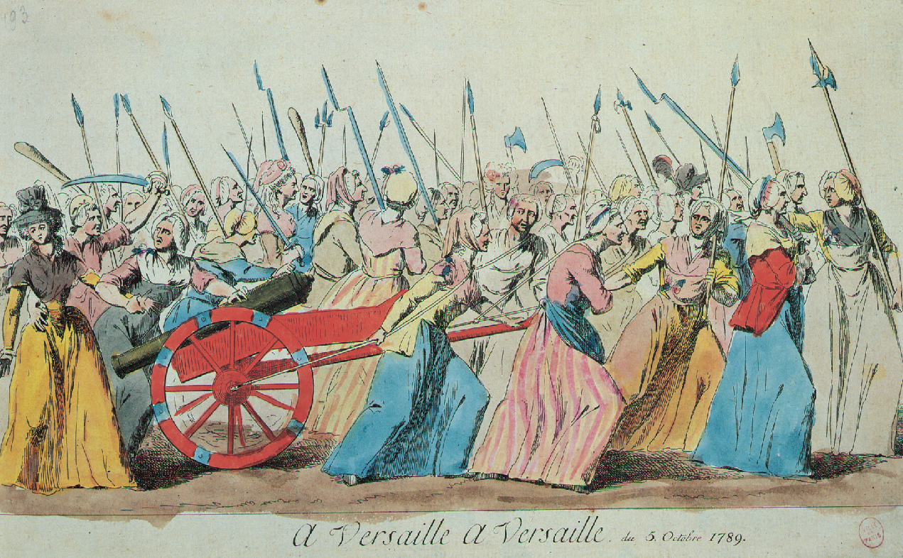

24. What was the role of women during the French Revolution?
A. Women started the Revolution and men joined later which led to an outbreak of violence
B. Women were not involved in the revolution, but were given a role in the church in order to reform
C. Women were involved in the beginning stages of the revolution, but were later surpassed by male dominated political organizations
D. Women were allowed to vote after the Declaration of the Rights of Women and Citizen was granted legal status by King Louis XVI shortly before his beheading

25. What motivated women to march to Versailles in October, 1789?
A. They were demanding equality for women under the new French constitution.
B. Bread remained scarce and prices high during the summer and fall of 1789.
C. Troops were massing at Versailles as Louis XVI prepared to use force against the revolution.
D. Louis XVI has issued an explicit order requiring confiscation of all weapons in Paris, prompting women to march in protest.

26. The Women’s March to Versailles was significant in the course of the French Revolution because it
A. resulted in the passage of a women’s suffrage bill.
B. resulted directly in the death of the King and the royal family.
C. placed the King and royal family within the reach of Parisian mobs.
D. caused the members of the National Constituent Assembly to drop the categorization of
citizens into “active” and “passive.”

Questions 27-29 refer to the 1793 image below by Isaac Cruikshank entitled The Martyrdom of Louis XVI, King of France.
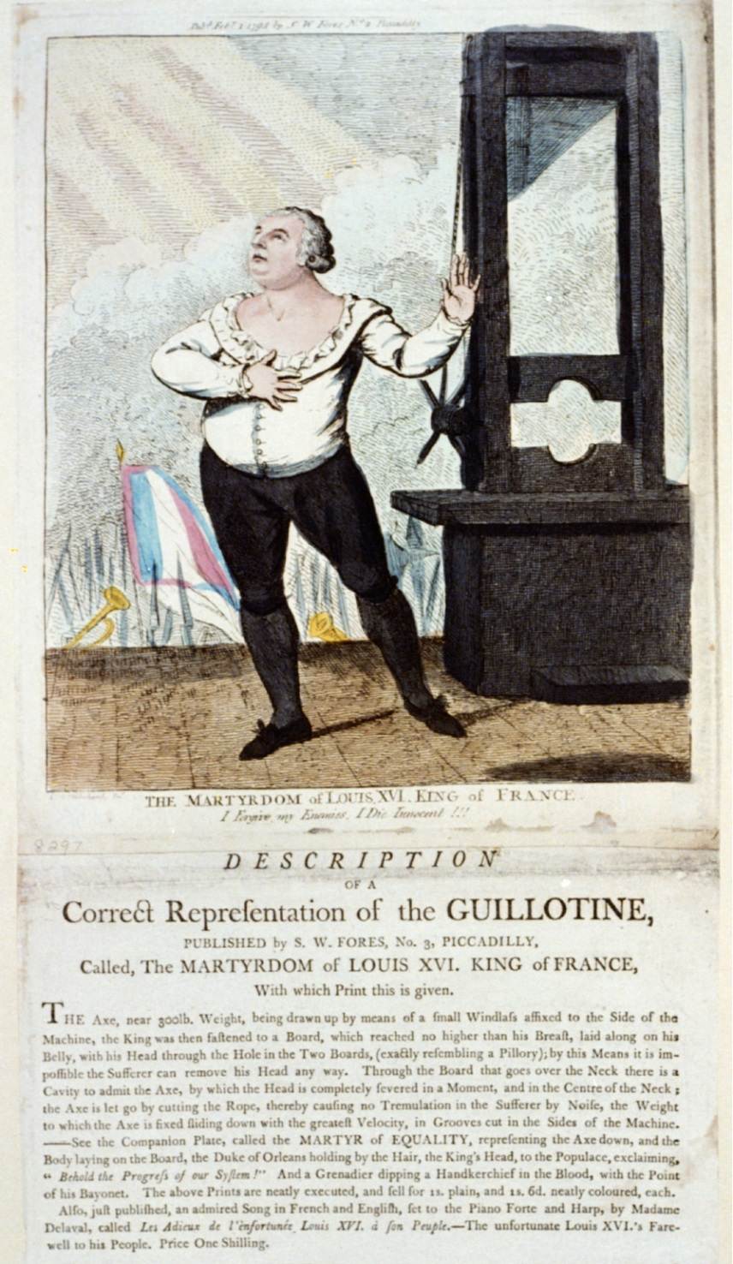
Library of Congress Prints and Photographs Division [LC-DIG-ppmsca-05528]

27. Which of the following best describes the basic underlying cause of conflict between Louis XVI and the French people?  (A) Long held economic and social grievances among the lower classes  (B) Legislative attempts by Louis XVI to reform the guild system  (C) Continuing resistance by the middle classes regarding taxation  (D) Louis XVI’s support of the lower classes against the nobles  28. The execution of Louis XVI could best be viewed as a turning point in the history of the French Revolution in which of the following ways?  (A) Legislative measures designed to repress the privileged classes began to be passed.  (B) The Jacobins reversed the policy of enacting economic controls to lower prices and raise wages.  (C) The Jacobins began to harshly repress opposition through arrest and public execution of suspected enemies.  (D) At that time, equal political participation among the social classes was enabled. | 29. The image seems to convey an ambivalence toward the execution of Louis XVI, provoking sympathy but also seeming to mock the king. Which of the following best describes a development regarding the French Revolution, which can be attributed to the decision to execute Louis XVI and which is supported by the image?  (A) Following the execution, toleration for peaceful Christians was codified.  (B) The French Revolution became significantly disunified and lost the sympathy of many who might have otherwise supported it.  (C) The extremist factions of the French Revolution became united in their complete support of dechristianization.  (D) The other European powers formally reiterated their support for the French Revolution.

Now what is the fundamental principle of democratic or popular government—that is to say, the essential mainspring upon which it depends and which makes it function? It is virtue: I mean public virtue…that virtue which is nothing else but love of fatherland and its laws…
The splendor of the goal of the French Revolution is simultaneously the source of our strength and of our weakness: our strength, because it gives us an ascendancy of truth over falsehood, and of public rights over private interests; our weakness, because it rallies against us all vicious men, all those who in their hearts seek to despoil the people…It is necessary to stifle the domestic and foreign enemies of the Republic or perish with them. Now in these circumstances, the first maxim of our politics ought to be to lead the people by means of reason and the enemies of the people by terror.
- Maximilien Robespierre, Speech to the National Convention: The Terror Justified

30. Robespierre’s use of “public virtue” drew most heavily upon the writing of which French philosophe?  A. Montesquieu’s The Spirit of the Laws  B. Rousseau’s The Social Contract  C. Voltaire’s Internal Government  D. Marquis de Condorcet’s Progress of the Human Mind  31. Which action was taken in earnest pursuit of the political values of the “republic of virtue”?  A. Banning revolutionary women’s clubs  B. The summary execution of many peasants  C. The campaign of de-Christianization  D. The law of 22 Prairial, which allowed convictions without hearings | 32. In what way was the establishment of a new republican calendar consistent with the new “Republic of Virtue”?  A. The old calendar was too representative of now outdated Christian values and holidays  B. It created months that were named after prominent events in the history of the Revolution  C. It began counting years with the Storming of the Bastille in 1789  D. It continued long after Napoleon’s coup d’état  33. For support in creating the “Republic of Virtue,” Robespierre depended on the  A. The Girondists  B. The Royalists  C. The Provinces or “departments”  D. The sans culottes
Questions 34-36 refer to the song lyrics below.
“To Versailles like bragging lads,We brought with us all our guns,We had to show, though we were but women, A courage that no one can reproach us for.
Now we won’t have to go so far, When we want to see our King.We love him with a love without equal, Since he’s come to live in our Capital.” -Song of the poissardes (Paris market women), October 1789

34. The events referred to in the song led most directly to which of the following?
(A) The creation of a republican government in France
(B) The formalization of a constitutional monarchy in France
(C) The installation of Napoleon as Emperor of the French
(D) The restoration of the Bourbon monarchy

35. The poissardes and other participants in the events described in the song were motivated most strongly by which of the following?
(A) An economic crisis brought about by food shortages
(B) The desire to institute free-market principles in the French economy
(C) The failure of France to gain substantial advantages from its wars with Britain
(D) The fear that Enlightenment ideas about government would undermine the basis of monarchy

36. The participation of women such as the poissardes led to which of the following during the early phases of the French Revolution?
(A) Wage equality for women
(B) Permanent legal equality for women, but no political rights
(C) Temporary improvements in women’s legal status
(D) Loss of rights previously held by women

Question 37 & 38 refers to the image below:
Long live the King! Long Live the Nation!  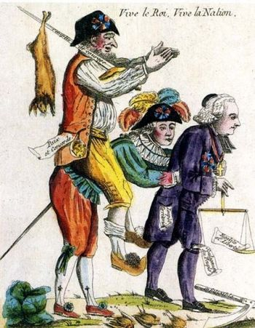 | 37. How does the image demonstrate the reversal of previously held notions about the estates in France?  A. The clergy is leading the way in a fair and balanced society that demonstrates France’s loyalty to Catholicism  B. The nobility is left to carry the financial burden of the revolution and fund the wars needed to ensure the revolution’s success  C. The rise of status of the third estate and the dissolution of former laws designed to oppress them such as taxation and feudal obligations  D. The demotion of the nobility and clergy to being beneath the former third estate who is now in control of France  38. The Declaration of the Rights of Man and Citizen were designed and written to  A. Give all people in France equal rights in law, taxation, and representation in the government  B. To grant the nobility rights above and beyond what the lower estates were asking for  C. Resemble the Declaration of Independence of the United States while using language of the Enlightenment to ensure equality  D. Demonstrate the generosity of the higher estates by granting the Third Estate a fewfreedoms in the hope of stopping the growing revolution

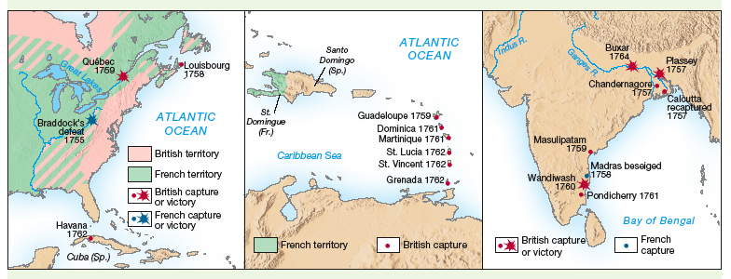
The Seven Years’ War, 1756-1783
39. What claim about the Seven Years’ War is correct?
  - The war involved only Great Britain and France
  - The war was fought exclusively in the New World and Asia
  - Great Britain dominated the war and sea while France dominated the war on land.
  - It was the greatest of the European wars of the late seventeenth and early eighteenth centuries and thus could be classified as a “world war”.

40. The Seven Years’ War was important in the European balance of power because it
- reaffirmed France as the hegemonic power of Europe.
- resulted in the merger of the French and Spanish monarchies.
- allowed Great Britain to dominate India and France to dominate the interior of North America.
- occasioned a diplomatic “revolution” that aligned Great Britain with Prussia and France with Austria.

41. The Seven Years’ War was preceded by numerous other general European wars. What best explains the role played by the European concept of “balance of power”.
- The conflicts rarely affected European civilians
- The conflicts were fought between two tightly allied groups of powers whose allegiance to each other rarely wavered.
- The conflicts were fought in order to prevent any one nation from becoming Europe’s hegemonic power.
- The conflicts arose primarily because of a religious schism between the major powers, with Protestants on one side and Catholics the other.

42. In what sense was the war associated with the American Revolution a continuation of the Seven Years’ War?
- France sought to weaken Great Britain after its triumph in 1763.
- France allied with the Americans because of their commitment to the ideals of the Enlightenment.
- Spain fought on the side of France in the Seven Years’ War but with Great Britain in the War for American Independence.
- The causes of the American Revolution were more related to balance of power than to problems in British colonial policy.

Questions 43- 45 refer to Napoleon’s comments on the state of France in his statement to the Legislative body, December 31, 1804.

The internal situation of France is today as calm as it has ever been in the most peaceful periods. There is no agitation to disturb the public tranquility, no suggestion of those crimes which recall the Revolution. Everywhere useful enterprises are in progress, and the general improvements, both public and private, attest the universal confidence and sense of security…
The civil code has fulfilled the expectations of the public; all citizens are acquainted with it; it serves as their guide in their various transactions, and is everywhere lauded as a benefaction. A draft of a criminal code has been completed for two years and has been subjected to the criticism of the courts; at this moment it is being discussed for the last time by the council of state….
New schools are being opened, aand inspectors have been appointed to see that the instruction does not degenerate into vain and sterile examinations. The lycees and the secondary schools are filling with youth eager for instruction. The polytechnic school is peopling our arsenals, ports, and factories with useful citizens. Prizes have been established in various branches of science, letters, and arts, and in the period of ten years fixed by his Majesty for the award of these prizes there can be no doubt that French genius will produce works of distinction…
Religion has resumed its sway, but exhibits itself only in acts of humanity. Adhering to a wise policy of toleration, the ministers of different sects who worship the same God do themselves honor by their mutual respect; and their rivalry confines itself to emulation in virtue. Such is our situation at home.

43. How did Napoleon benefit the French nation?
A. He undid the gains of the Revolution so that France could return to the Old Regime
B. His military victories secured peace and stability through the territory that was won
C. He entrenched the gains of the first, moderate Revolution and brought stability to France
D. He codified and entrenched the order of the Old Regime once and for all through his civil laws; the Code Napoleon

44. Napoleon has been called the “Greatest of the Enlightened Despots” by historians because
A. He conquered much of Continental Europe
B. He spread the Code Napoleon everywhere he conquered
C. His use of torture in the lands he conquered
D. His creation of a modern public school system for France

45. Which of the following Enlightenment ideas IS NOT explicitly mentioned by Napoleon in his address to the legislative body?
A. religious toleration
B. codified laws
C. promotion by merit
D. valuing organized learning

NAme ___________________________________________ MC ______/45 pts _____SAQ 12pts
DUE no extensions Thursday, DECEMBER 22-
Email panderson@albany.k12.ny.us
This is not a collaborative assignment. Any sharing of answers will result in appropriate discipline. (YOU both get ZEROS)
 | Answers |  | Answers | SAQ
 |  | 24 |  | “By anchoring France securely to the shores that the Constituent Assembly had been unwilling to leave, Bonaparte accomplished somewhat late in the day that “revolution from above” of which the old monarchy had been incapable. The political trade-off was a certain number of amputations of the immediate Revolutionary inheritance, a few backward movements, and disconcerting borrowings from the Old Regime. In a sense, the dynamism of Bonaparte and his rigorous administration revived the experiment of enlightened despotism, somewhat belatedly, since in the setting of Western Europe it was already a bit out of date…”  - Louis Bergeron, historian, France Under Napoleon, 1981  “Napoleon himself believed that his work was a kind of crowning of the Revolution, and he was remarkably honest about his friendship with Robespierre’s brother… Napoleon would never have imagined that his own career could have flourished as it did without the surgery performed on French society by the Revolution. He was born in Corsica of poor, proud, petty-noble parents, and before the Revolution he could not possibly have risen above the rank of captain in the French army. Also, he had read Rousseau and sympathized with much of the Jacobin philosophy…Napoleon was indeed a military despot, but he did not destroy the work of the Revolution; in a sense, in a wider European context, he rounded off its work.”  - George Rudé, historian, Perspectives on the European Past, 1971  1. Answer parts (a), (b), and (c) below: ON A SEPARATE SHEET OF PAPER  a. Briefly explain ONE major difference between Bergeron’s and Rudé’s historical interpretations of the reign of Napoleon.  b. Briefly explain ONE specific event, development, or circumstance in the period 1800 to 1815 that is not explicitly mentioned in the excerpts that could be used to support Bergeron’s argument.  c. Briefly explain ONE specific event, development, or circumstance in the period 1800 to 1815 that is not explicitly mentioned in the excerpts that could be used to support Rudé’s argument.
 |  | 25
 |  | 26
 |  | 27
 |  | 28
 |  | 29
 |  | 30
 |  | 31
 |  | 32
 |  | 33
 |  | 34
 |  | 35
 |  | 36
 |  | 37
 |  | 38
 |  | 39
 |  | 40
 |  | 41
 |  | 42
 |  | 43
 |  | 44
 |  | 45

