In your response you should do the following:

- Thesis: Present a thesis that makes a historically defensible claim and responds to all
parts of the question. The thesis must consist of one or more sentences and not repeat the terms of the prompt.
- Argument Development: Develop and support a cohesive argument that recognizes and accounts for historical complexity by explicitly illustrating relationships among historical evidence such as contradiction, corroboration, and/or qualification.
- Use of the Documents: Utilize the content of at least six of the documents to support the stated thesis or a relevant argument.
- Sourcing the Documents: Explain the significance of the author's point of view, author's purpose, historical context, and/or audience for at least four documents.
- Contextualization: Situate the argument by explaining the broader historical events, developments, or processes immediately relevant to the question.
- Outside Evidence: Provide an example or additional piece of specific evidence beyond those found in the documents to support or qualify the argument.
- Synthesis: Extend the argument by explaining the connections between the argument and one of the following.

  - A development in a different historical period, situation, era, or geographical area.
  - A course theme and/or approach to history that is not the focus of the essay (such as political, economic, social, cultural, or intelectual history).
  - A different discipline or field of inquiry (such as economics, government and politics, art history, or anthropology)

Question: Assess the extent to which the attitudes toward the poor in Europe changed between 1450 – 1700. (HTS: CCOT)

Document 1

Source: Catholic priest, sermon, France, fifteenth century

Whoever gives a penny to the poor for God while in good health, it will be worth 240 pennies after death. To give a penny in sickness is worth 20 pennies. To bequeath money after death, that is worth a leaden penny, because there is no great value in giving what one cannot hold on to.

Document 2
Source: Juan Luis Vives, Spanish humanist, On Assistance to the Poor, Bruges, Spanish Netherlands, 1526
When the general funds have been expended, those without means of subsistence are driven to robbery in the cities and on the highways; others commit theft stealthily. Women of eligible age put modesty aside, and, no longer holding to chastity, put it on sale. Old women run brothels and take up sorcery. Children of the needy receive a deplorable upbringing. Together with their offspring, the poor are shut out of churches and wander over the land. We do not know by what law the poor live, nor what their practices or beliefs are.
Some know that they have a duty of charity to the poor, yet they do not perform what has been commanded. Others are repelled by the unworthiness of the applicants. Still others withdraw because their good intention is embarrassed by the great number, and they are uncertain where first or most effectively top bestow their money.

Document 3
Source: Town council, meeting minutes, Rouen, France 1542
-Those unwilling to work should indeed be expelled from the city, but those who are unable to find work should not be treated thus. Instead they should be put to work on sites in the city in exchange for food until such time they succeed in finding work in their trades.
-Idleness is harmful to the public good and should not be tolerated. Idlers should not be considered poor.
-Before expelling the poor from the city we must consider whether our defensive capacity would not suffer from such a measure. After all, it is the people, and not the judges and councilors, who will fight when the need arises.

Document 4
Source: Poorhouse regulations, Suffolk county, England, 1588
Every strong rogue, at his or her first entrance into the house, shall have 12 stripes with the whip on bare skin and every young rogue or idle loiterer shall have 6 stripes in the same manner. All unruly or stubborn persons shall be corrected oftener and given heavier shackles, a thinner diet, and harder labor until they are brought to reasonable obedience and submission to the master of the poorhouse.

Document 5
Source: Cardinal Richelieu, royal councilor, unofficial statement on poverty, France, 1625
Instead of working as they should to earn a living, vagabonds and good-for-nothings have turned to begging, taking the bread from the sick and deserving poor to whom it is due. We desire that in every town in our kingdom rules and regulations for the poor should be established, so that not only those of the said town but of the neighboring areas should be confined and fed, and those who are able to do so should be employed on public works.

Document 6
Source: Rembrandt van Rijn, Beggars Receiving Alms at the Door of a House, 1648
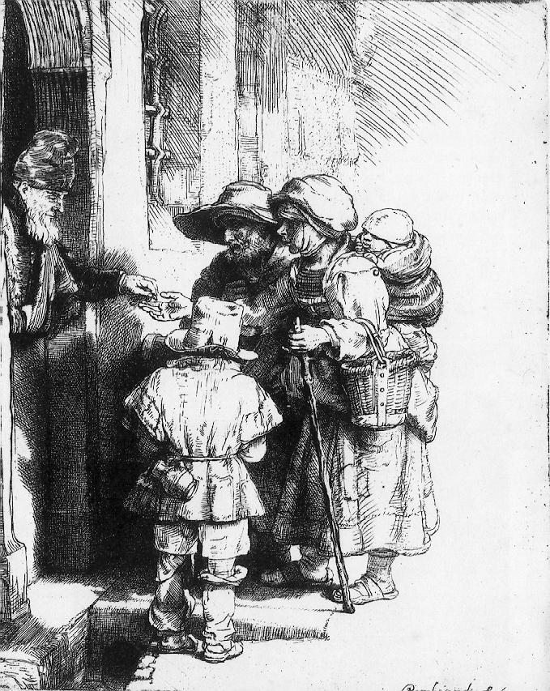

Document 7
Source: Jean Maillefer, wealthy merchant, letter to his children, Reims, France, 1674
I have heard the poor talk and learned that those who have grown accustomed to this life cannot leave it. They have no cares, pay no rents or taxes, have no losses to fear. They are independent, they warm themselves by the sun, sleep and laugh as long as they like, are at home everywhere, have the sky for a blanket, the earth for a mattress. In a word, they have no worries.

