At the end of the period please save this document
Media Bias and Fake News
Using the chart and websites provided, choose a topic that has occurred in the last 30 days. Compare how different media outlets chose to cover that story. You must choose 1 media outlet from each category. Answer the questions below and with complete sentences. If you cannot find a topic in a group, explain why you think they would chose not to cover it. Make sure you are using facts in your answer and not overly biased opinions.

Do you live in a MEDIA BUBBLE?
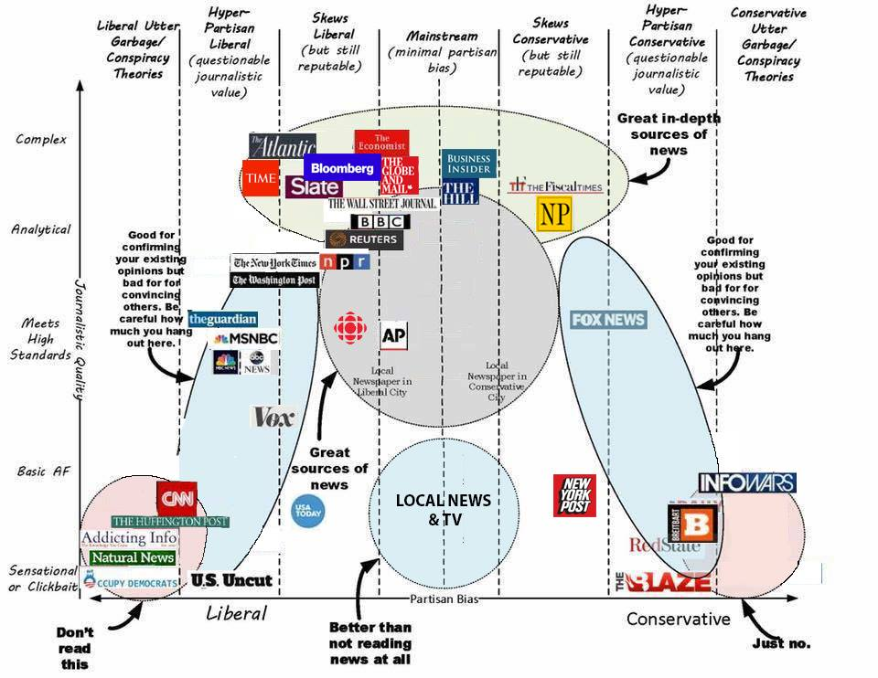
Very Liberal :  Jezebel, Buzzfeed,  Salon, The Huffington  Post, Media Matters,  Moveon.org | Leans Liberal:  Daily Mirror, MSNBC,  NBC News, New York  Times, CNN, The  Washington Post,  Newsweek,  FiveThirtyEight, NPR | Leans Conservative:  New York Post, Forbes  Magazine, Fox News,  National Review, Wall  Street Journal, Real  Clear Politics | Very Conservative  Breitbart, Drudge Report,  National Review, The WeeklyStandard

 | Very Liberal | Leans Liberal | Leans Conservative | Very Conservative
Source Used

Article Title with link
Identify 2-3 words
the article uses that
shows bias and
explain why you
think the author
used them.
What is the main
point that the article
is trying to make:
Do you find this
source trustworthy?
Why or why not?
Would you use this
site again?
Each of the following should be explained in 3-5 sentences?

Overall, how biased do you think the media is? Explain.

What can be done to address bias and mis-information in the media?

Where do you normally get your news from? Did this assignment change that?

