Name__________________ AP European History Ch 17 Reading Study Kagan P. 550-567
Enlightenment  Deism  John Locke, Two Treatises of Civil Gov’t  Essay Concerning Human Understanding  tabula rasa  philosophes  Voltaire  “ecracsez l’infame” | Baron de Montesquieu, Spirit of Laws  checks and balances  Jean-Jacques Rousseau  Social Contract, 1762  general will  “noble savage”  Denis Diderot, The Encyclopedia  Marquis de Beccaria  François Quesnay | physiocrats  Adam Smith, Wealth of Nations classical liberalism  salon movement  Madame de Geoffrin  Madame de Staël  Mary Wollstonecraft  Baron Paul d’Holbach  David Hume  Immanuel Kant
Directions:
- Answer all of the following question/ task as thoroughly as you can. – This WILL be handed in on Monday 11/28 in class.
- All questions will be graded 2 pts per-question (this assignment equals 3 homework assignments)
- Answers can be completed in note form but most show a through reading/ understanding of the topic.
- This should go without saying but…. This is an assignment that YOU must do. Copying or letting someone copy, including “working together on questions” will result in 0s on all three assignments.
__________________________________________________________________________________________________
A1. In addition to answer these questions, make and complete a chart of Enlightened philosophers.
- Not to be handed in!
Philosopher | Nation/ Reason for ideas | Book (year)- idea(s)
Formative Influences on the Enlightenment (p. 552 – 558)
- What was The Enlightenment?
- Chart ( Causes/ CCOT) would work- How did the Enlightenment change basic Western attitudes toward reform, faith, and reason?
- How were Newton and Locke forerunners of the (18th Century) Enlightenment?
- In what ways was Britain tolerant and stable? Impact. (3-5 characteristics)
- Describe the characteristics of “Print Culture.”/ Impact. (PEERSIA) Chart would work well here!
- Read “Coffeehouses & Enlightenment” be prepared to discuss in class.
- Page 556-557- Why were the bourgeoisie/ middle class fans of the philosophes?
- Read “Immanuel Kant Defines Enlightenment” MUST READ!!! (556) Chart: Kanat- Philosopher/ reason/ ideas
- What authorities should the liberated intellect have the courage to question?
- Why does he believe intellectual liberation requires effort?
- Why does Kant link enlightenment with freedom?
- Why was Voltaire the most influential of the philosophes? Chart: Voltaire- Philosopher/ reason/ ideas
The Enlightenment and Religion (p. 558-563)
- Why did the philosophes consider organized religion to be their greatest enemy? (important)
- What were the basic tenets of deism? (important)
- How did Jewish writers contribute to Enlightenment thinking about religion? Chart: Spinoza- Philosopher/ reason/ ideas
The Enlightenment and Society (p. 564-566)
- Who created the Encyclopedia? What was it? Chart: Denis Diderot Philosopher/ reason/ ideas (important)
- Marquis Cesare Beccaria- Philosopher/ reason/ ideas
- What did the physiocrats believe?
- How did the views of the mercantilists about the earth’s resources differ from those of Adam Smith in his book The Wealth of Nations? Chart: Adam Smith: Philosopher/ reason/ ideas (important)
- Montesquieu- Philosopher/ reason/ ideas (important)
Use the map below to answer all parts of the question that follows.
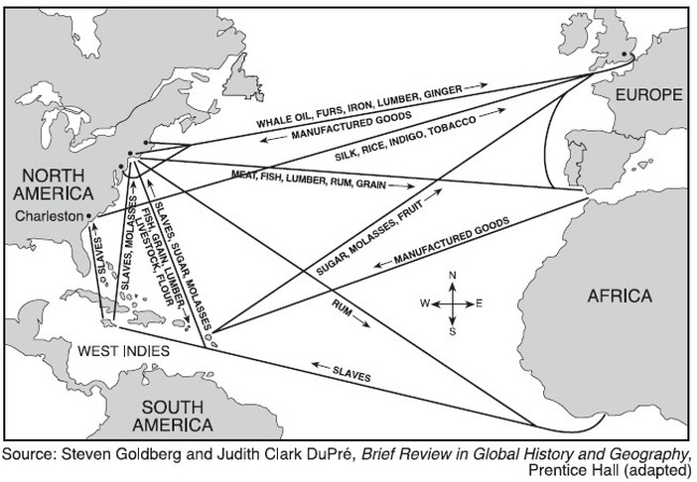
A. Briefly explain TWO effects the trade network above had on European societies during the
seventeenth century.
B. Briefly explain ONE effect the trade network above had on a non-European society during the
seventeenth century.
_____________________________________________________________________________________________________________________________________________________________________________________________________________________________________________________________________________
_____________________________________________________________________________________________________________________________________________________________________________________________________________________________________________________________________________
_____________________________________________________________________________________________________________________________________________________________________________________________________________________________________________________________________________
_____________________________________________________________________________________________________________________________________________________________________________________________________________________________________________________________________________
_____________________________________________________________________________________________________________________________________________________________________________________________________________________________________________________________________________
__________________________________________________________________________________________

Examples of responses to Part A and B that would earn credit:
The Price Revolution led to inflation and urbanization.
The Columbian Exchange led to increased food supply which supported a larger population.
More luxury goods led to more consumerism.
The middle class grew as more people did not rely on farming to support themselves.
Joint-stock companies and banking institutions were created to facilitate enlarged world
trade.
Syphilis was introduced to the European continent.
Inequality in the distribution of wealth grew.
Atlantic states rose in prominence to the detriment of Mediterranean economies.
Mercantilism and economic competition among European states.
Examples of responses to Part C that would earn credit:
European diseases decimated Native American populations.
European governments, religions, and social structures were imposed on indigenous
populations.
New rigid racial hierarchies were imposed on the Americas.
The slave trade & the middle passage decimated African populations.
New cultures (ie, Creole) were created from the blending of different cultures.

