Name __________________________ Two Point Activity
16. Cornell notes of a section of our textbook or other source (AP books extra). (see Mr. Anderson for approval ) (Handout
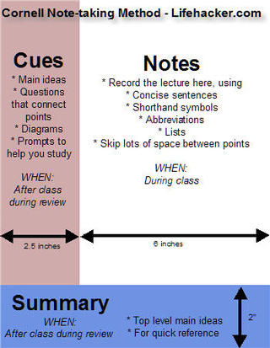

Name __________________ Book__________________________ Pages ____________________________

Title of Section _____________________________
____________________________________________________________________________
_____________________________________________________________________________
_____________________________________________________________________________
_____________________________________________________________________________
_____________________________________________________________________________
_____________________________________________________________________________
_____________________________________________________________________________
_____________________________________________________________________________
_____________________________________________________________________________
_____________________________________________________________________________
_____________________________________________________________________________
_____________________________________________________________________________
_____________________________________________________________________________
_____________________________________________________________________________
_____________________________________________________________________________
_____________________________________________________________________________
_____________________________________________________________________________
_____________________________________________________________________________
_____________________________________________________________________________
_____________________________________________________________________________
_____________________________________________________________________________

______________________________________________________________________________________________________________________________________________________________________________________________________________________________________________________________________________________________________
316

